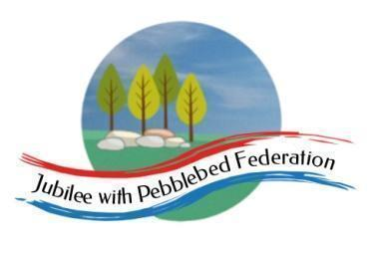

Class 1 Home Learning for the week beginning 10th May 2021
 | Phonics & Spelling (30 mins) | Reading - This book links with phonics and spelling and will be read for guided reading sessions  (30 mins) | Maths  (30 mins) | Literacy  (30 mins) | PE  (15 minutes)  Leap into Life | Afternoon Work  (45 mins) | Mental Health  Emotions & Feelings
This week’s learning behaviour:
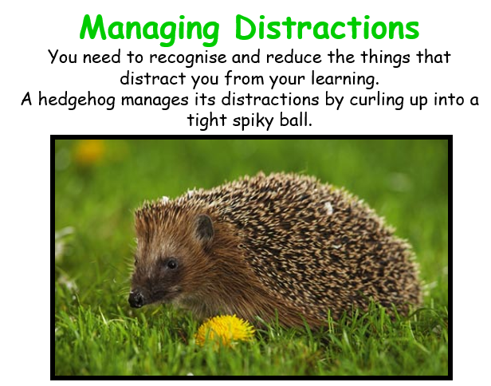
This week Class 1 will be continuing to think about managing distractions as they work. To be productive in your learning, you sometimes need to recognise and reduce the things that distract you. A hedgehog rolls itself up into a ball tightly. Maybe if we try to be like the hedgehog, we can shut out the parts of the day which prevent us from giving our all to our learning - whatever that may be.

Monday | Orange Group  Phase 3  Unit 8  Language Session  Reception  Phase 3  Unit 11  /ur/ as er  Year 1  Unit 26  Assessment  Year 2  NNS  Block 6 Week 4 | Orange Group  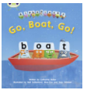  Reception  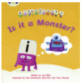  Year 1  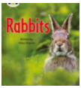  Year 2 | Orange Group/ Reception  https://classroom.thenational.academy/lessons/counting-up-to-15-objects-and-putting-them-in-order-part-2-cdj38e  Year 1/ Year 2  https://classroom.thenational.academy/lessons/counting-up-to-15-objects-and-putting-them-in-order-part-3-60v6cc | Orange Group/ Reception  https://classroom.thenational.academy/lessons/to-step-and-speak-the-story-6dh30d  Year 1/Year 2  https://classroom.thenational.academy/lessons/to-explore-problems-that-matter-6mwkgt | Physical Education KS1 / KS2: Obstacle Challenge - Trust and Teamwork | RE  https://www.bbc.co.uk/bitesize/clips/z3yr87h | Friendship ppt - I will upload  What I want in a friend sheet  Friendship scenario cards - I will upload this week.
Tuesday | Orange Group  Phase 3  Unit 9  /ai/ as ai  Reception  Phase 3  Unit 11  Language Session  Year 1  Unit 27  ch as tch  Year 2  NNS  Block 6 Week 4 | Orange Group  Reception  Year 1  Year 2 | Orange Group/ Reception  https://classroom.thenational.academy/lessons/to-recognise-and-describe-repeating-patterns-6hjk4c  Year 1/ Year 2  https://classroom.thenational.academy/lessons/to-consolidate-learning-6tgk8r | THELMA HULBERT GALLERY IN SCHOOL TODAY |  | Science  https://classroom.thenational.academy/lessons/what-are-the-parts-of-trees-and-plants-called-c9h6cr
Wednesday | Orange Group  Phase 3  Unit 9  /ee/ as ee  Reception  Phase 3  Unit 11  Assessment  Year 1  Unit 27  alternatives for sh  Year 2  NNS  Block 6 Week 4 | Orange Group  Reception  Year 1  Year 2 | Orange Group/ Reception]  https://classroom.thenational.academy/lessons/comparing-sets-without-counting-cgvpac  Year 1/ Year 2  Elicitation  I will upload to Google Classroom | Orange Group/ Reception  Read the story of The Disgusting Sandwich - I will post  Year 1/Year 2  Elicitation - I will put up |  | PSHE  https://classroom.thenational.academy/lessons/stop-look-listen-6rr68e
Thursday | Orange Group  Phase 3  Unit 9  /igh/ as ‘igh’  Reception  Phase 3  Unit 11  Recap  Year 1  Unit 25  e as ea  Year 2  NNS  Handwriting | Orange Group  Reception  Year 1  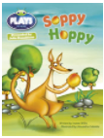  Year 2  Inference Reading | Orange Group/ Reception  https://classroom.thenational.academy/lessons/creating-patterns-with-shapes-ctj3gc  Year 1/ Year 2  Find a half  Make equal parts  https://classroom.thenational.academy/lessons/to-identify-one-half-of-a-shape-60up2c | Orange Group/ Reception  /Year 1/Year 2  Read the story of The Disgusting Sandwich.  Make a map of the park to help you to remember the story. |  | Music / Art  https://www.tate.org.uk/kids/explore/kids-view/explore-georgia-okeeffe  Uploaded ppt about Georgia O’Keeffe  Jack and the Beanstalk. 2: Jack went to market
Friday | Orange Group  Phase 3  Unit 9  /oa/ as ‘oa’  Reception  Phase 3  Unit 11  Recap  Year 1  Unit 27  /w/ /o/ as wa  Year 2  NNS  Handwriting | Orange Group  Reception  Year 1  Year 2  Inference Reading | Orange Group/ Reception  https://classroom.thenational.academy/lessons/sorting-2d-shapes-cdh3et  Year 1/ Year 2  Find a half  Recognise a half  https://classroom.thenational.academy/lessons/to-find-half-of-a-quantity-6nhpct | Orange Group/ Reception  Year 1/Year 2  I will put up ome photos. Can you write short sentences about what the images provide evidence of. |  | Geography  Lesson 3 What affects where people live? 23m video

Rec done oi
Nnsdone
6 wke 2
1 unit 26
Orange
x

