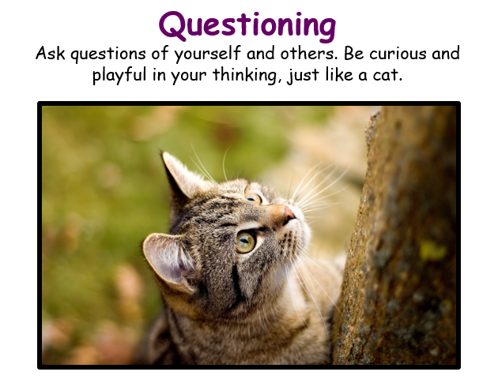
Class 2 Weekly Home Learning Timetable 1.2.21 - LIVE GOOGLE MEETS
Learning animal of the week - see topic on google classroom for more information - please fill in a slip each week to let me know how you are learning at home.
Timings | 9.10am  LIVE | 1 hour (45 mins then 15 mins TT) | 1 hour | 1 hour | 15 mins | 30 mins | 15 mins | 3.10pm  LIVE
Monday  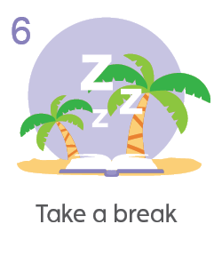10 a day mental health of the day | Daily Dashboard and Collective Worship | Piano Room Children  To make tally charts.  https://whiterosemaths.com/homelearning/year-2/ Spring Week 5  Then google classroom sheet.  2B pg 48  Year 4  To understand fractions greater than 1.  https://classroom.thenational.academy/lessons/using-mixed-numbers-61hkad  Then google classroom sheet.  4B pg 116  Year 5/6  To compare and order fractions more than 1.  https://whiterosemaths.com/homelearning/year-6/week-9-number-fractions/  Then google classroom sheet.  5B pg 76 6A 140 | LITERACY STORY  WRITING WEEK.  This week, everyone will be writing their stories, by using their plans.  Each day, I will put a video up on google classroom to show me practising writing each section of my story. | RE  L.O. To compare the views of Christians and Humanists.  See google classroom | Bug Club Grammar | Bug Club reading with  Quiz | Spelling | End of day story  Anglo Saxon Boy
Tuesday  10 a day mental health of the day | Daily Dashboard and Collective Worship | Piano Room Children  To draw pictograms.  https://whiterosemaths.com/homelearning/year-2/ Spring Week 5  Then google classroom sheet.  2B pg 52  Year 4  To count in fractions.  https://classroom.thenational.academy/lessons/reasoning-with-fractions-c4vkje  Then google classroom sheet.  4B pg 100  Year 5/6  To add and subtract fractions.  https://whiterosemaths.com/homelearning/year-6/week-9-number-fractions/  Then google classroom sheet.  5B pg 92 6A pg 144 | LITERACY STORY  WRITING WEEK. | Topic - Music  To understand standard musical notation symbols for dynamics, such as mp, p, pp, ppp, mf, f, ff, fff.  To understand King Alfred the Great’s character.  See google classroom | Bug Club Grammar | Bug Club reading with  Quiz | Spelling | End of day story  Anglo Saxon Boy
Wednesday  10 a day mental health of the day | Daily Dashboard and Collective Worship | Piano Room Children  To draw pictograms using 2s, 5s and 10 times tables.  https://whiterosemaths.com/homelearning/year-2/ Spring Week 5  Then google classroom sheet.  2B pg 56  Year 4  To add 2 or more fractions.  https://classroom.thenational.academy/lessons/add-fractions-cnk3ar  Then google classroom sheet.  Year 5/6  To add fractions within 1.  https://whiterosemaths.com/homelearning/year-6/week-10-number-fractions/  Then google classroom sheet.  5B pg 96 | LITERACY STORY  WRITING WEEK. | Topic - Music  To understand King Alfred the Great’s character.  To write a new verse to the tune ‘When Good King Arthur Ruled This Land’  See google classroom | Bug Club Grammar | Bug Club reading with  Quiz | Spelling | End of day story  Anglo Saxon Boy
Thursday  10 a day mental health of the day  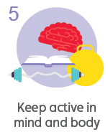 | Daily Dashboard and Collective Worship | Piano Room Children  To interpret pictograms.  https://whiterosemaths.com/homelearning/year-2/ Spring Week 5  Then google classroom sheet.  2B pg 60  Year 4  To subtract 2 fractions.  https://classroom.thenational.academy/lessons/subtract-fractions-6hh66r  Then google classroom sheet.  4B pg 132  Year 5/6  To add 3 or more fractions.  https://whiterosemaths.com/homelearning/year-6/week-10-number-fractions/  Then google classroom sheet.  5B pg 100 6A pg 148 | LITERACY STORY  WRITING WEEK. | PE  At school, PE at the moment is socially distanced fitness activities.  Premier sports have made some videos for you to follow at home for PE.  https://www.youtube.com/channel/UCLNV8D56t6RV0wbsPnbnYeA  Please do any of the fitness videos on their channel.  You could also go out in the garden and get some fresh air or go for a walk with a grownup.  There are also some great videos to do on https://www.bbc.co.uk/teach/supermovers | Bug Club Grammar | Bug Club reading with  Quiz | Spelling | Read your own book today :)
Friday  10 a day mental health of the day | Daily Dashboard and Collective Worship | Science  L.O. To describe the differences in the life cycles of a mammal and an amphibian. | French - 30 mins  Go to this link  https://www.bbc.co.uk/bitesize/topics/zjcbrj6/articles/zcqsxbk  Google classroom sheet to complete.  TT Rockstars - 15 mins  Bug Club reading with  Quiz 15 mins | PSHE 30 mins  Today we will sum up all of our learning on ‘The Working World’  Google classroom sheet to complete.  Mental Health 30 mins  Take this time to go onto the mental health section of google classroom. | Bug Club Grammar | Bug Club reading with  Quiz | Spelling | LIVE  SHARING ASSEMBLY

