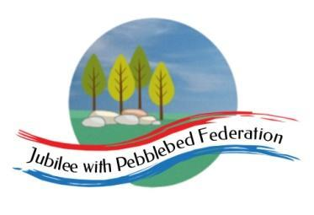

Class 2 Home Learning
For activities in purple, please visit google classroom where you will find specific work related to each subject to complete and ‘turn in’.
Timings | 15 mins | 30 mins | 15 mins | 15 mins | 1 Hour | 1 Hour | 1 Hour
Monday | https://www.edshed.com/en-gb/login | Reading  https://www.activelearnprimary.co.uk/login?c=0 | https://ttrockstars.com/ | 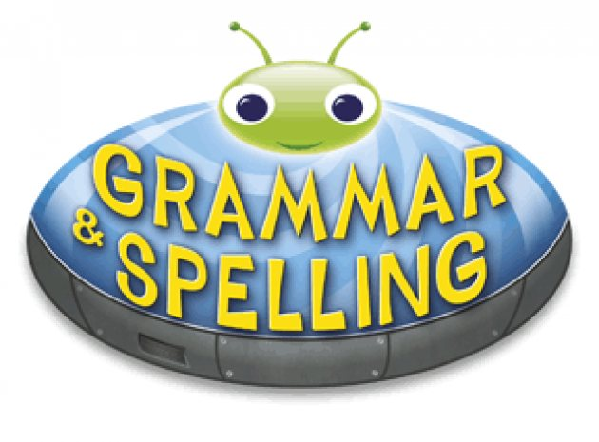  https://www.activelearnprimary.co.uk/login?c=0 | Maths  Follow the link for your year group for videos in the most current week. Then complete the worksheet provided on google classroom.  Children that do maths in the piano room  https://whiterosemaths.com/homelearning/year-2/  Year 3  https://whiterosemaths.com/homelearning/year-3/  Year 4  https://whiterosemaths.com/homelearning/year-4/  Year 5/6  https://whiterosemaths.com/homelearning/year-5/ | Science  L.O. To classify different types of rock.  https://www.bbc.co.uk/bitesize/topics/z9bbkqt/articles/zsgkdmn | Topic  L.O. To sequence the four main stages of the water cycle. Water cycle song on gonoodle  https://www.bbc.co.uk/programmes/p01152mn  https://www.bbc.co.uk/programmes/p0115djb  https://www.dkfindout.com/uk/earth/water-cycle/  https://www.bbc.co.uk/bitesize/topics/zkgg87h/articles/z3wpp39
Tuesday | https://www.edshed.com/en-gb/login | https://www.activelearnprimary.co.uk/login?c=0 | https://ttrockstars.com | https://www.activelearnprimary.co.uk/login?c=0 | Maths  Follow the link for your year group for videos in the most current week. Then complete the worksheet provided on google classroom.  Children that do maths in the piano room  https://whiterosemaths.com/homelearning/year-2/  Year 3  https://whiterosemaths.com/homelearning/year-3/  Year 4  https://whiterosemaths.com/homelearning/year-4/  Year 5/6  https://whiterosemaths.com/homelearning/year-5/ | Literacy  L.O. To understand how the author of ‘One Well’ portrays their opinion. | RE  L.O. To understand what Pentecost was and the Christian belief about the Kingdom of God.
Wednesday | https://www.edshed.com/en-gb/login | https://www.activelearnprimary.co.uk/login?c=0 | https://ttrockstars.com | https://www.activelearnprimary.co.uk/login?c=0 | Maths  Follow the link for your year group for videos in the most current week. Then complete the worksheet provided on google classroom.  Children that do maths in the piano room  https://whiterosemaths.com/homelearning/year-2/  Year 3  https://whiterosemaths.com/homelearning/year-3/  Year 4  https://whiterosemaths.com/homelearning/year-4/  Year 5/6  https://whiterosemaths.com/homelearning/year-5/ | Literacy  L.O. To identify ‘One Well’ text type and its overall structure. | Topic  L.O. To identify key features of a river.  Explore rivers of the world  https://www.bbc.co.uk/bitesize/guides/zyt9q6f/revision/4  https://www.bbc.co.uk/programmes/p00y824g/clips
Thursday | https://www.edshed.com/en-gb/login | https://www.activelearnprimary.co.uk/login?c=0 | https://ttrockstars.com | https://www.activelearnprimary.co.uk/login?c=0 | Maths  Follow the link for your year group for videos in the most current week. Then complete the worksheet provided on google classroom.  Children that do maths in the piano room  https://whiterosemaths.com/homelearning/year-2/  Year 3  https://whiterosemaths.com/homelearning/year-3/  Year 4  https://whiterosemaths.com/homelearning/year-4/  Year 5/6  https://whiterosemaths.com/homelearning/year-5/ | Literacy  L.O. To understand how structure helps readers understand tricky subjects. | PE  Premier sports have made some videos for you to follow at home for PE.  https://www.youtube.com/channel/UCLNV8D56t6RV0wbsPnbnYeA  Please do any of the ball skills on their channel.  You could also go out in the garden and get some fresh air or go for a walk with a grownup.  There are also some great videos to do on https://www.bbc.co.uk/teach/supermovers
Friday | https://www.edshed.com/en-gb/login | https://www.activelearnprimary.co.uk/login?c=0 | https://ttrockstars.com | https://www.activelearnprimary.co.uk/login?c=0 | Maths  Follow the link for your year group for videos in the most current week. Then complete the worksheet provided on google classroom.  Children that do maths in the piano room  https://whiterosemaths.com/homelearning/year-2/  Year 3  https://whiterosemaths.com/homelearning/year-3/  Year 4  https://whiterosemaths.com/homelearning/year-4/  Year 5/6  https://whiterosemaths.com/homelearning/year-5/ | Literacy  L.O. To collect information on environmental issues. | PSHE  One Decision  Baseline assessment activity  L.O. To understand what healthy living consists of.  French  L.O. To be able to say “I like” a food in French.

