6th October 2023

Dear Parents,

I can’t quite believe that we are in October already and that the children are settling in so well. Class 1 is a really lovely environment to be in. As you know, Jenny left us last week to move on to a new challenge and we a really lucky to have Stella, Vicky and Clare in Class 1 supporting Mrs Symonds. I’m sure that you will see them in the mornings when you drop off the children. Please introduce yourselves to Vicky, Stella and Claire when you see them.

The children are beginning to settle and are becoming so much more independent coming in and putting their things away ready for the day. This means that we can get started more quickly and the children are ready to learn. With this in mind, could we please ask that you drop your children off at the side door of Class 1 rather than bringing them into class via the front door. There will be an adult there to meet them from 8.40am and they will be able to come into the classroom and settle to an activity. This ensures that Mrs Symonds is able to greet all of the children and knows who is in and who has yet to arrive. Thank you for your support in helping your children develop their independence and confidence.

There are still having a lot of soft toys and precious objects such as rings, necklaces and keyrings being brought into the Class 1 each day. Please can you ensure that the children leave their toys with you and that they don’t come into school? There have had a few incidents of precious teddies having to ‘sleep over’ in the office because they have been forgotten at the end of the day. As I am sure you understand, end of day routine is extremely busy and with the best will in the world, sometimes these toys are forgotten. Again, thank you for supporting us in this.

Class 1’s learning has really taken off this term at a super rate. Year 1 are working hard to make the transition from Reception and we am very proud of them - this is a challenge for all children moving into Key Stage 1 - well done to them! Year 2 have really stepped up their learning and are enjoying finding out about significant people in history. You may have seen our sharing assembly where we talked about the models that the children are using to discuss this.

For the end of term, we will be holding a Class 1 debate, where we will ask the children to come in dressed as their favourite character from a list that we will send home. We will then be inviting you in to hear your children debate who is the most significant character, using the models that they have learnt about in history. We will be holding this day on December 14th and you should have received a letter earlier this week with more information.

Our reception children have settled in so well - it is wonderful to see how their confidence has grown and listening to them talking to the adults and their peers is just fantastic. They are now accessing a short phonics session daily as well as a short maths and literacy session. They have been talking about families and are now thinking about the changing season, taking nature walks around the school grounds and observing changes in the environment. Thank you for your engagement with our Focus Child system - it has been lovely for me to be able to talk to you about how well your children are settling in to school life.

As always, if you have any worries or questions, about your Class 1 child please do not hesitate to pop in and see Mrs Symonds. After school is always best, but if it is something that you think I need to be aware of, pop your head around the door or you can contact her via the office at [admin@broadhembury.devon.sch.uk](mailto:admin@broadhembury.devon.sch.uk)

Class 2 have been working hard over the past month and settling into the new school year well. The children have been working hard on making sure they have high expectations in all of their learning as well as in the way they treat one another – everyone has been making a great effort. It has been really pleasing to see good improvements in handwriting, some fantastic effort to show kindness and respect to others and lots of reading from everyone.

Class 2 have been doing lots of reading each day – both independent reading and in guided groups. The children have spent time thinking about how to choose appropriate reading books that challenge them without being too tricky to understand well. They have also talked about the importance of reading books for fun as well. In their guided groups, there has been some fantastic discussion about different texts using their VIPERS reading skills. The children have particularly focused on Vocabulary (where they’ve tried to find other words that fit in a sentence to help understand tricky words), Retrieval (using keywords to search for answers to questions) and Summarising (explaining what has been read by focusing on just the key details). It has been great to see some excellent summaries in reading records, so we can see what everyone has been reading. Keep up the great effort.

In Maths, Class 2 have just finished their work on place value to start the year. Year Four have been looking at numbers in the thousands, using their parts to order and round numbers. Year Five have been working up to hundreds of thousands. Year Six have been exploring numbers in the millions and negative numbers. All of this hard work at the start of the year sets us up well to develop our calculation skills over the coming weeks. Everyone has worked really hard on these key, foundational skills and made some good progress. Alongside this, we have been applying these skills to problems and working hard on explaining our observations and strategies. All the class have begun to share some excellent explanations for their problem solving – not an easy task.

Over the past few weeks, Class 2 have been working very hard on forming simple sentences that are full of detail. The children have looked at adding interesting adjectives to nouns and using prepositions to add further description. Alongside this, they have been using a range of adverbial phrases to say when, where, how or how often the verb in the sentence has happened. There have been some fantastic examples of sentences (all beautifully punctuated) that have set the children up well to write some fantastic descriptions of a walk for their work on ‘Where My Wellies Take Me’. Over the rest of the half-term, the children will begin to turn their wonderful sentences into excellent descriptive paragraphs, carefully linking the sentences together. Again, the children’s hard work in these early weeks of the year on key skills has put them in a good position to develop some really interesting writing over the rest of the year.

As part of Class 2’s our Sow, Grow and Farm topic, the children have been exploring life on an allotment – from animal food webs to the life cycles of plants. Everyone has worked hard to learn and explain lots of key vocabulary and concepts. There have been some fantastic descriptions of corms, metamorphosis, rhizomes and embryos. The children have discussed the differences between mammal and other life cycles, as well as creating presentations on the different types of plant reproduction.

Class 2’s Sow, Grow and Farm topic also has a heavy focus on Geography. The children began by exploring arable, pastoral and mixed farming. They have explained well where and why each type of farming might take place. They also looked at grid references for maps, using this to locate farms around Broadhembury. Using the map, the children were able to work out the topography of the land and decide on the best type of farming for the area. Over the coming weeks, they will continue to learn about farming around the U.K.

In Art Class 2 have begun to look at line, light and shadow, creating continuous line drawing of objects around the classroom. They will begin to look at the life and work of Pablo Picasso to inspire their future drawings as they study different shading techniques to add shadow to their drawings. In Design and Technology Class 2 are beginning to look at how to create seasonal, healthy meals. Alongside all of this, Class 2 have practised following rhythms in Music to help them learn different songs, looked at how to be responsible in P.S.H.E. (from being on time, to standing up against unkindness), and worked on their counting and basic conversations in French. Great work everyone – keep it up!

Thank you all for your continued support.

God bless and have a lovely weekend.

*Best wishes from Katie Gray and the staff at Broadhembury CE School*

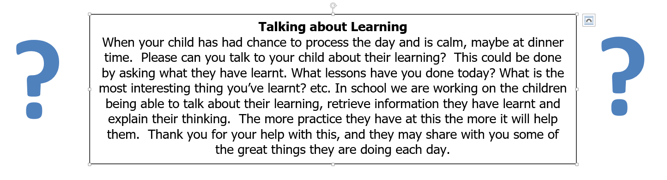

**BROADHEMBURY BRIDGES**

**Class 1:**

Well done to all the children in Class 1 this September, you have all been superstars.

**Class 2:**

River – for working hard to make a great start to the term.

Connor – for making a great start to the new term and working hard.

Phoebe – for a fantastic start to the year – working hard every day and being a great role model.

Isabel - for great effort to listen and produce good work – particularly in Science.

|  |
| --- |
| **Question of the month**  **Class 1:** Do you have to have been famous to be a significant person?  **Class 2**: What book has had the biggest impact on your life? |

**Key Dates – Autumn Term 2023**

Tuesday 10th October - Class 2 Farmwise Trip.

Thursday 14th September, 9.10am - Harvest Service at Church.

Thursday 28th September, 2.45pm - Reading Workshop.

Thursday 12th October, 3.30pm - 4pm - Parent Reading Café.

Thursday 19th October - Last day of half term.

Monday 30th October - First day back for children.

**Reminders:**

**Lunches**

Sorting out lunches each day takes up a chunk of time that we would like to be using for the children’s learning. As a result, lunches will now be ordered online. Your child will have brought a letter home explaining this. Please can you ensure that you email in by Sunday evening using the link sent. This means that we can get stuck into our learning from the moment that your children arrive in school. Thank you for your help with this.

**Photography Project**

We applied for a national competition last summer to win a bursary to buy camera equipment for the school. The rationale was ‘What is it like to be a child in a rural school?’ We were lucky enough to win! As a result of this, we have been able to purchase cameras for the school. We will be setting up workshops for the children to take photographs which represent life as a child in a rural school. This is a contemporary project where the children will need to think about what they photograph. The photographs need to tell the story of their lives as children in a rural school and will need to be ‘about, not of’. In the workshops, we will be giving the children and opportunity to think about this concept and plenty of opportunities to develop their photography skills. We will be holding a photography exhibition in the Village Hall during the summer term and details will follow as we have them. If there are any budding photographers out there who would like to help us with this project, please let us know.

**Water Bottles**

Please ensure that your child has a named water bottle as they really need to drink regularly through the day to ensure that they are hydrated and ready to learn

**School Uniform**

Please can you ensure that your child has all their uniform named. It really helps at the end of the day to ensure that the correct jumper is returned to the correct child. Also, as the weather gets colder, please can you ensure that your child has a warm coat and that any hats, gloves etc. are named. Thank you for your help.

**School Bus**

We have had a request from the bus company that brings the children to school from Dunkeswell, please can parents not park in the bus stop to enable the bus to be able to park and the children to get off the bus safely. Thank you for your co-operation. If you have any queries about the bus please contact Sarah Bishop at Devon School Transport. [Sarah.bishop@devon.gov.uk](mailto:Sarah.bishop@devon.gov.uk). Please could you also contact her if you allow your child to walk from the bus stop home on their own so she can notify the bus company. Thank you.

**Free School Meals**

If your circumstances have recently changed your child may have become eligible for free school meals. This will also bring extra funding to the school, which will be used to help your child. For an instant decision or to learn more please go online at

<https://www.devon.gov.uk/educationandfamilies/school-information/school-meals>.

**Sharing Assembly**

Sharing assembly will continue each Friday afternoon at 3pm. All parents/carers are invited to come and see the children sharing their learning.

**Advice on Covid-19**

As you may be aware, there are some concerns regarding the recent spread of Covid-19. Please see below updated guidance on what to do if you suspect a case of Covid-19 or test positive.

* For diarrhoea and vomiting, people need to be 48 hours free of symptoms to return to the setting (pupils and staff)
* Children with **mild symptoms** such as a runny nose, sore throat, or mild cough, who are otherwise well, **can continue to attend their education or childcare setting.**
* Anyone who is **unwell,** including people with a high temperature, should **stay at home** and avoid contact with others until they have recovered. They can return to the setting once they no longer have a temperature (without medication) and are well enough to do so. (pupils and staff)
* **Children** and young people under 18 years old who have a positive test for **Covid-19** should stay away from the setting for **3 days** after they took their test (and until they are well enough to return, including no temperature).

|  |
| --- |
| **Wellbeing**  *There has been much press in recent months about children’s mental health. As part of our drive to support this we are going to include something each month in the newsletter about Health and Wellbeing. We hope you find this section useful. If you have any topics you would like us to find some helpful tips about, please let us know.*  <https://healthy-kids.com.au/parents/children-hydration>    *On Wednesday 11th October we will all wear green to show our support and raise awareness* |

**Collective Worship Activity**    
This term we will be focussing in school on the value of Creativity. We hope your family will find these ideas helpful as you explore the value and have fun together. If the children bring back something that you have done at home linked to the Collective Worship activity, or can talk about a discussion they’ve had at home linked to it, then Mrs Gray will award them with a new special sticker.

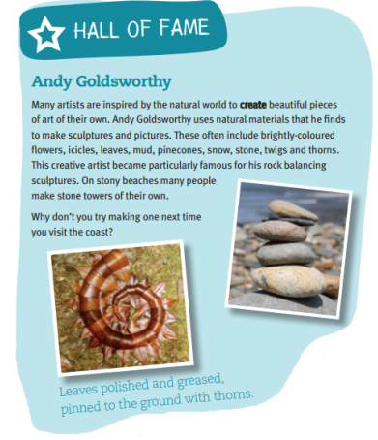

**Sidmouth Science Festival**

Sidmouth Science Festival takes place between 6th and 15th October 2023. There are lots of exciting events taking place. Please find out more at <https://www.sidmouthsciencefestival.org/>.

