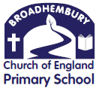

Broadhembury Church of England Primary School
Honiton
Devon
EX14 3NF
Headteacher: Mrs Katie Gray
(01404) 841304
admin@broadhembury.devon.sch.uk www.broadhembury.devon.sch.uk fax: (01404) 841778

5th November 2021
Dear Parents,

The children in Class 1 have been busy creating a royal bread roll for The Queen after their royal tea party. They have learnt how to follow instructions to make bread rolls and are now thinking about how they could adapt this to make something more royal looking.

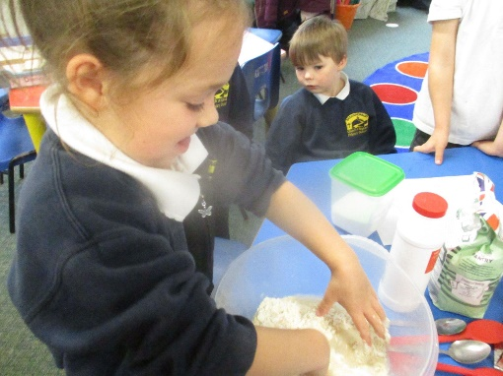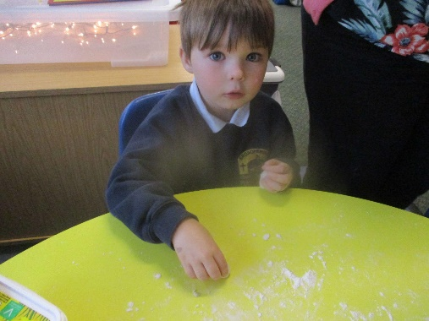

The weather is getting colder but the children are still able to enjoy our outdoor learning area. We have waterproofs to keep the children clean and dry, but please could you ensure that they have a warm coat, hat, gloves etc. If you have any spare wellies at home that they could keep in school that would also be really helpful. Please make sure that you name them. Thank you.

The children in Reception have been learning about repeating patterns in their Maths. You could help your child at home by finding patterns in the environment thinking about shape, size and different objects.

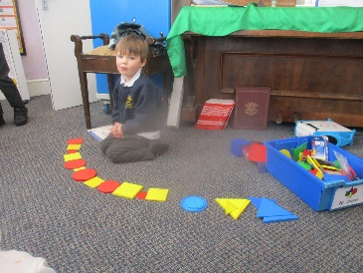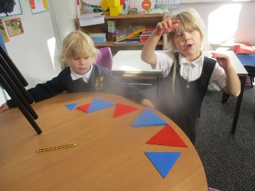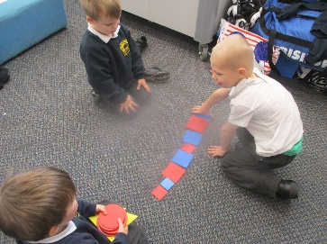

In order to support your child’s reading please make sure that your children are logging in to Bug Club. We have attached a letter for Reception children, explaining how to use it. We will give all Reception children their password this week in their home learning journal. Reception will also begin bringing home reading books with words in as they are beginning to recognise sounds and are beginning to blend short words. More details will follow.

Key Stage 1 parents will know that the children have been bringing home vocabulary that arises during the week in school. Although homework is not appropriate for children in Reception, we will be sending home a folder containing some of the words that the children have encountered during the week. Please can you have a conversation with your children about the meaning of the words. Thank you.

Class 2’s space themed learning has continued this month. In computing, they have been learning about algorithms and how they are written to programme computers. The children then built Lego satellite models and programmed them to move, flash and spin.

In science and history, Class 2 were introduced to the heliocentric theory, written by Galileo and compared this important discovery with Newton’s gravitational theory. They also learnt about the different ideas the Romans and Greeks had about our Solar System.

In the final week of last half term, Class 2 enjoyed an inspiring and informative visit to the Space Dome in Branscombe Village Hall! They were transported through the Solar System and beyond and learnt all about the shape and size of planets, the history of space travel and black holes! The children were so enthusiastic and it was great to see them recall and use their science knowledge learnt this term.

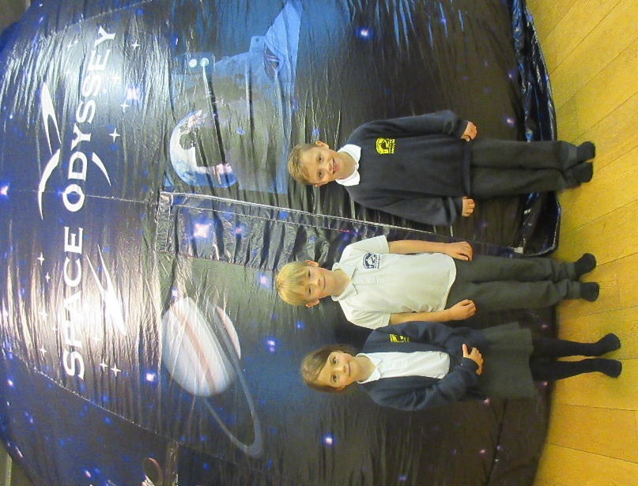

In P.E. Class 2 attended the first Honiton Learning Community sports event of this year- Cross Country. They showed great determination and spirit when running the challenging route. It was also brilliant to see the children cheering team mates on and encouraging others to try their best. A special mention must go to Joshua who won the year four boys' event and Bethany who came third in the year six girls' event. Well done to all that took part!

Thank you all for your continued support.
God bless and have a lovely weekend.
Best wishes from Katie Gray and the staff at Broadhembury CE School

Key Dates - Autumn Term 2021
11th November – Act of Remembrance 10.50am. Parents are welcome to join us at the Broadhembury War Memorial.
15th November- School Photos 9am.
15th November 12.30pm - Gym Festival for KS1. More details to follow.
19th November- Children in Need. We will focus on Mindfulness moments, helping the children to relax and feel calm whilst thinking about others. Voluntary £1 charity donation. Full school uniform.
23rd November – Parents Evening.
7th Dec - Christmas Dinner.
10th Dec - Save the Children Christmas Jumper Day. Wear your Christmas Jumper, Voluntary £1 charity donation.
15th Dec - Christmas Nativity and Carols 2.00pm. (Provisional date and time)
16th December: Flu vaccinations.
Last day of term: Friday 17th December 2021.
Christmas holiday: Monday 20th December 2021 to Monday 3rd January 2022.
BROADHEMBURY BRIDGES
Class 1:
Conor-James- For fantastic positive learning in Maths and thinking through calculations.
Myah – For always following instructions and being a good role model to those around her.

Class 2:
Michael- for his consistent positive learning attitude and respect for grown-ups.
Bethany- for her wonderful learning attitude, always challenging herself to try new things.
Alfie- for being helpful, loving and looking after other members of the school community.

Question of the month

Class 1: In class, we looked at a picture of the patterns that the frost made on the cars. Where does the frost come from? How are these patterns created?

Class 2: Who are the five inspiring astronauts we learnt about on our Space Dome trip? Who do you think was the most significant?

Reminders:
Drop off and Pick up
Please can all parents and carers remember to keep 2 metres apart at drop off and collection time? This is important for all of our safety to reduce the spread of Covid-19. If possible adults and teenagers should wear masks outside the school gate. Thank you for your help with this.

Free School Meals
If your circumstances have changed as a result of the Covid-19 crisis your child may have become eligible for free school meals. This will also bring extra funding to the school, which will be used to help your child. For an instant decision or to learn more please go online at https://www.devon.gov.uk/educationandfamilies/school-information/school-meals.

Collective Worship Activity
This term we will be focussing in school on the value of Friendship. We hope your family will find these ideas helpful as you explore the value and have fun together. If the children bring back something that you have done at home linked to the Collective Worship activity, or can talk about a discussion they’ve had at home linked to it, then Mrs Gray will award them with a new special sticker.
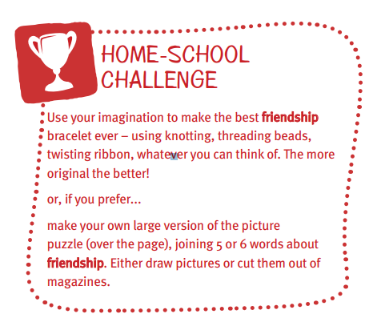
Wellbeing
There has been much press in recent months about children’s mental health. As part of our drive to support this we are going to include something each month in the newsletter about Health and Wellbeing. We hope you find this section useful. If you have any topics you would like us to find some helpful tips about, please let us know.

‘Ten a day’ - Be proud of your very being. ‘What have you done today to make you feel proud?’ Share your ideas as a family it may not just be today but over the week.
