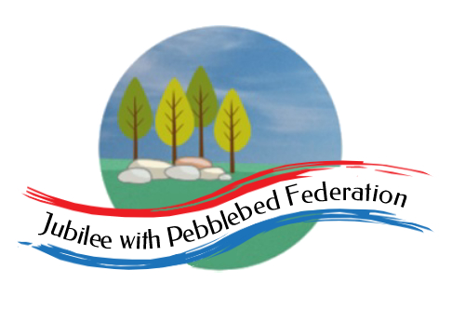
The Jubilee Hub of The Jubilee with Pebblebed Federation
Subject Intent Statement for Geography
Our Vision
‘Be who God meant you to be and you will set the world on fire.’
St Catherine of Siena
Intent
Geography lessons within the Jubilee Hub of the Jubilee with Pebblebed Federation aim to awaken children’s curiosity and generate fascination about the world and its people. We believe Geography is the way to understand, protect and make the most of the world we live in. It helps to provoke and provide answers to questions about the natural and human aspects of the world.

Children are given the opportunity to deepen their geography knowledge and develop key geography skills. To be meaningful, it is essential that learning is rooted in local geographical features and elements. Thus, outdoor learning experiences are a regular part of geography teaching. In our federation, our Geography teaching enables our children to develop an understanding of their local areas, the significance of the Jurassic Coastline and the Area of Outstanding Natural Beauty that we are situated in and to create a sense of wonder and appreciation of the world, both locally and wider. It aims to encourage a curiosity about the world in which they will spend their lives as well as inspire the children to contribute to and enjoy their local community.

Teaching will also equip children with the knowledge of physical and human geography pertaining to their Key Stage, allowing the children to progress throughout the school. In this way, it is our intent that children gain the lifelong ability to understand, describe and care for our planet in all its diversity.
Implementation
Within the Jubilee Hub, we are fortunate that each school is located within a unique, rural environment – each offering something different in terms of geographical opportunity to the children.
- At Branscombe, we are able to use the beach to enable the children to begin to understand both human and physical geographical features of our local coastline as well as allowing children to develop fieldwork skills in unique locations. Children from across the hub are able to go on joint trips to the beach. The children also have good access to the National Trust Rangers at Branscombe and The Jubilee Hub also benefits from National Trust membership.
- The area around all three schools in the hub allows the children to understand rural and farming environments and gives opportunity for geographical enquiry and fieldwork.
- Both Farway and Branscombe are involved in the conservation of Bats and as such enable the children to take active involvement in the protection of a native species of animal.
- Our Broadhembury school is set on the edge of an AONB – namely The Blackdown Hills. The children have regular contact with volunteer groups involved in the protection and conservation of this beautiful part of the country.
- All our schools are in relatively close proximity to Exmoor and Dartmoor providing access to other unique geographical features.
Geography skills and knowledge teaching is planned from projects from the Cornerstones Curriculum Maestro. Planning projects in this way ensures:
- that all objectives of the National Curriculum are taught over a period of 3 years in EYFS/KS1 and 4 years in KS2.
- projects can make use of the local environments and can be enquiry based thus allowing children to experience and gain the skills necessary to become a confident geographer in a real-life situation.
- that all aspects of geography can be built upon in the correct order and thus build linked skills sequentially using our Federation progression document.
In all our classes, children are encouraged to talk about the world around them and ask questions. This is done by:
- Daily Dashboard – children are encouraged to watch news updates to find out information and ask questions about what is happening in the world. In this way, they are able to learn about different places in the world and find out more about cultural and geographical diversity.
- Child-led learning in Class 1 – Some things are better learned than taught. It is important that when our children are taught the skills and knowledge that the curriculum dictates, they are then given opportunity to apply these skills in whichever context they wish eg a conversation with the Thatcher in the village led to an investigation into the journey of water reeds from China to the UK and on to Broadhembury.
- Depth of Learning – children are encouraged to think more deeply about the world around them.
- Extra-curricular learning – we use every opportunity to involve members of our wider community in the children’s education and work closely to make the most of each opportunity that arises. Recently, we were lucky enough to have a local resident bring his rescued hedgehogs to school to talk to the children about his conservation work and how the children could be involved.
Intended Impact
By the time children leave their school within the Jubilee Hub they will have:
- An understanding of what issues are affecting East Devon and some idea of the impact that these issues will have as the children move from childhood to adulthood
- Confidence to ask questions, focus enquiries and analyse evidence based information
- A passion for caring for their environment and an awareness of global geographic events.

