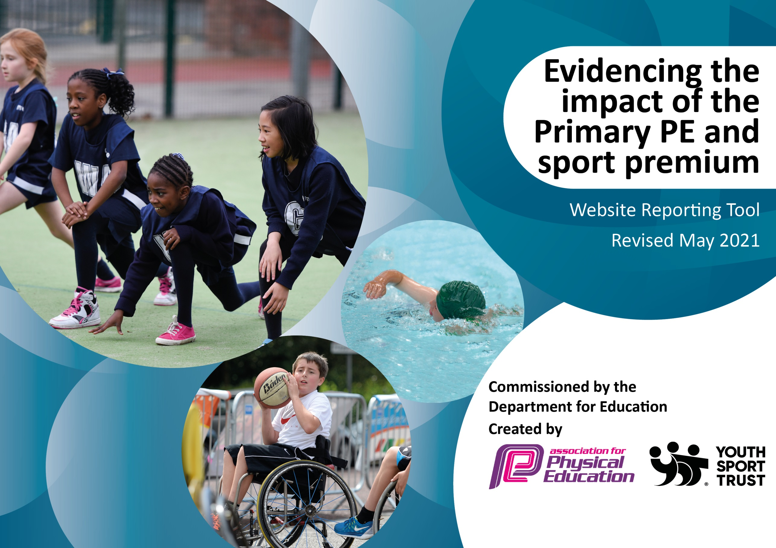

It is important that your grant is used effectively and based on school need. The Education Inspection Framework (Ofsted 2019 p64) makes clear there will be a focus on ‘whether leaders and those responsible for governors all understand their respective roles and perform these in a way that enhances the effectiveness of the school’.

Under the Quality of Education criteria (p41) inspectors consider the extent to which schools can articulate their curriculum (INTENT), construct their curriculum (IMPLEMENTATION) and demonstrate the outcomes which result (IMPACT).

To assist schools with common transferable language this template has been developed to utilise the same three headings which should make your plans easily transferable between working documents.

Schools must use the funding to make additional and sustainable improvements to the quality of Physical Education, School Sport and Physical Activity (PESSPA) they offer. This means that you should use the Primary PE and sport premium to:

- Develop or add to the PESSPA activities that your school already offer
- Build capacity and capability within the school to ensure that improvements made now will benefit pupils joining the school in future years
- The Primary PE and sport premium should not be used to fund capital spend projects; the school’s budget should fund these.
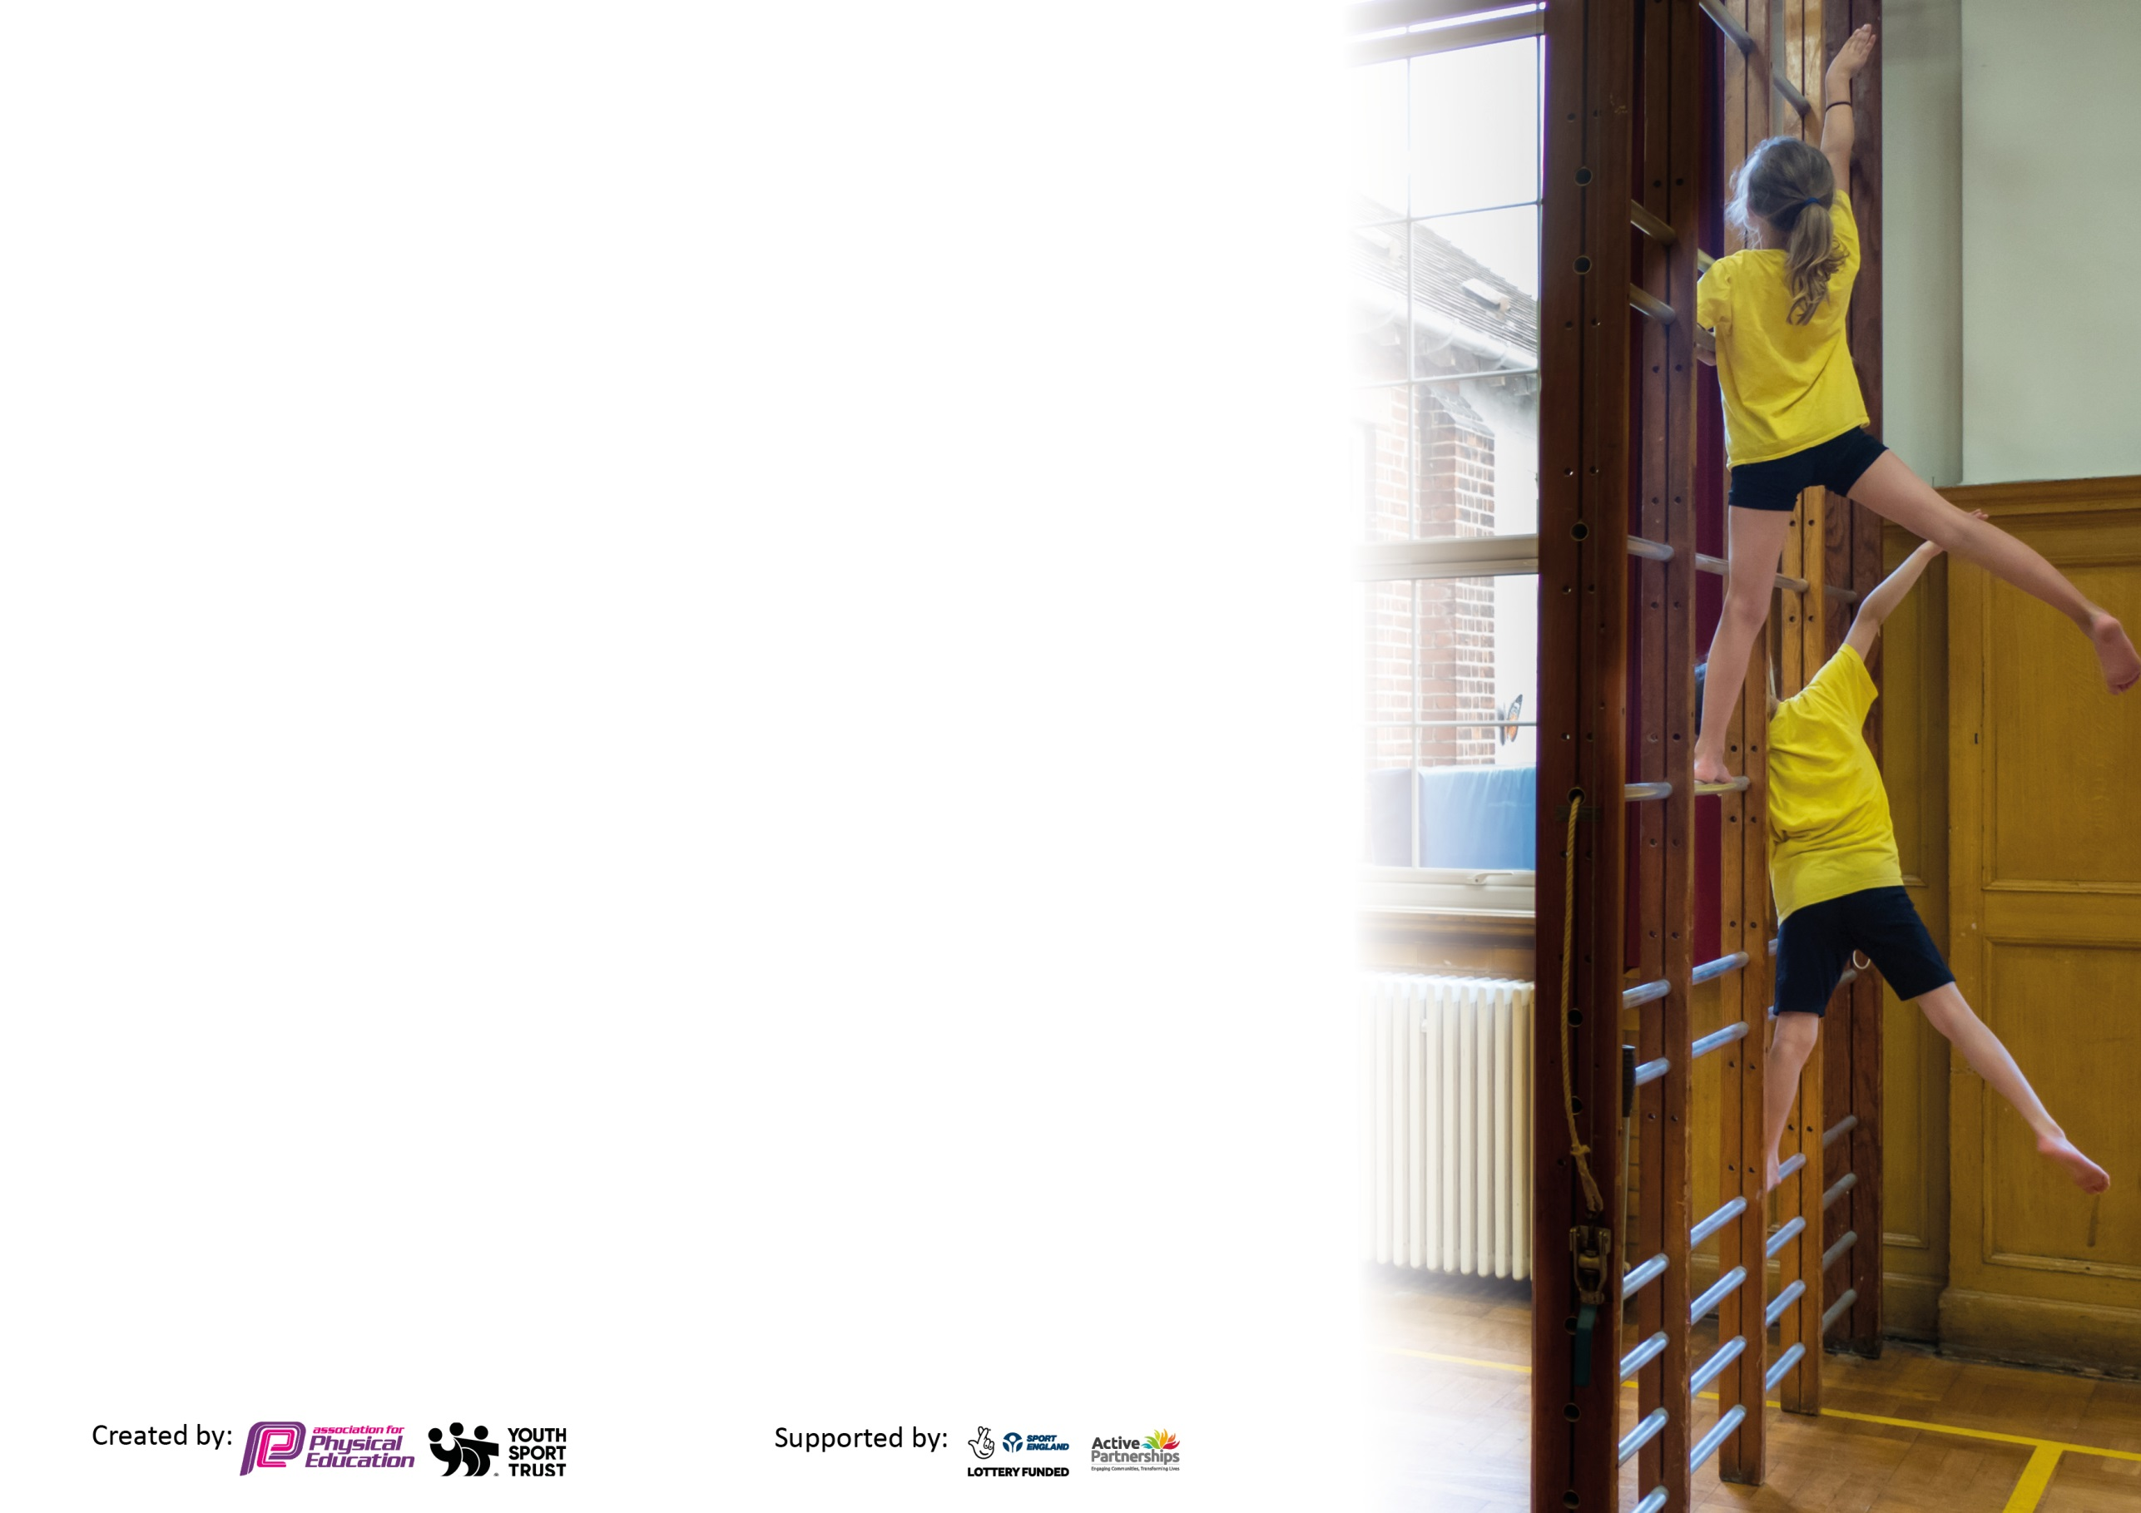
Please visit gov.uk for the revised DfE guidance including the 5 key indicators across which schools should demonstrate an improvement. This document will help you to review your provision and to report your spend. DfE encourages schools to use this template as an effective way of meeting the reporting requirements of the Primary PE and sport premium.

We recommend you start by reflecting on the impact of current provision and reviewing the previous spend.

Schools are required to publish details of how they spend this funding, including any under-spend from 2019/2020, as well as on the impact it has on pupils’ PE and sport participation and attainment by the end of the summer term or by 31st July 2021 at the latest.

We recommend regularly updating the table and publishing it on your website throughout the year. This evidences your ongoing self-evaluation of how you are using the funding to secure maximum, sustainable impact. Final copy must be posted on your website by the end of the academic year and no later than the 31st July 2021. To see an example of how to complete the table please click HERE.
Jubilee Hub of the Jubilee with Pebblebed Federation
Branscombe Church of England Primary School
Broadhembury Church of England Primary School
Farway Church of England Primary School

Please note: Although there has been considerable disruption in 2020 it is important that you publish details on your website of how you spend the funding - this is a legal requirement.
Support for review and reflection - considering the 5 key indicators from DfE, what development needs are a priority for your setting and your pupils now and why? Use the space below to reflect on previous spend and key achievements and areas for development.

N.B. In this section you should refer to any adjustments you might have made due to Covid-19 and how these will influence further improvement.
Key achievements to date until July 2020: | Areas for further improvement and baseline evidence of need:
- Increased and regular participation in Honiton and Sidmouth Learning Community sports events, coming second in hockey.  - Silver School Games Award achieved 2017 across the Federation.  - Two schools achieving Silver School Games Award achieved in 2018 and 2019 and one school achieved bronze.  - Working towards all schools achieving at lease Silver School Games Awards although this was postponed due to Covid-19  - Use of Premier Sports to support PE lessons and extra-curricular activities. Supporting staff training and children.  - Use of village halls for an enhanced space for teaching indoor PE.  - Improved PE assessment and tracking of pupil progress.  - Schools well-resourced to deliver quality PE lessons.  - Partnership with Premier Sport to support PE lessons and lunch time clubs.  - Sports leaders trained across the Federation. PPG and children who had excellent engagement were trained.  - Premier sport assess children each lesson and evidences data onto online portal.  - Some children exceeding in areas of football, tag rugby, gymnastics, health and fitness, rounders and invasion games across the federation. | - Continue staff professional development, working alongside Premier Sport coaches and PE team.  - To continue the participation in Honiton Learning Community sports events.  - To monitor the teaching and progress of PE skills throughout the Federation.  - To use sports leaders to promote sport across the Federation.  - To continue to encourage sport participation through school sports.  - Engage families and community into taking part in the Golden Mile.  - To offer a broader range of sports to engage more pupils.

Did you carry forward an underspend from 2019-20 academic year into the current academic year?
YES
Total amount carried forward from 2019/2020 £5,554.44
+ Total amount for this academic year 2020/2021 £46,452
= Total to be spent by 31st July 2021 £52,006.44

Meeting national curriculum requirements for swimming and water safety.  N.B Complete this section to your best ability. For example you might have practised safe self-rescue techniques on dry land which you can transfer to the pool when school swimming restarts.  Due to exceptional circumstances priority should be given to ensuring that pupils can perform safe self rescue even  if they do not fully meet the first two requirements of the NC programme of study. | 8/10 children 80%  100% of children at Broadhembury 3/3  50% of children at Farway 2/4  100% of children at Branscombe 3/3
What percentage of your current Year 6 cohort swim competently, confidently and proficiently over a distance of at least 25 metres?  N.B. Even though your pupils may swim in another year please report on their attainment on leaving primary school at the end of the summer term 2021.  Please see note above. | 7/10 children 70%  66.6% of children at Broadhembury 2/3  50% of children at Farway 2/4  100% of children at Branscombe 3/3
What percentage of your current Year 6 cohort use a range of strokes effectively [for example, front crawl, backstroke and breaststroke]?  Please see note above. | 9/10 children 90%  66.6% of children at Broadhembury 2/3 100% of children at Farway 4/4  100% of children at Branscombe 3/3
What percentage of your current Year 6 cohort perform safe self-rescue in different water-based situations? | 9/10 children 90%  66.6% of children at Broadhembury 2/3 50% of children at Farway 4/4  100% of children at Branscombe 3/3
Schools can choose to use the Primary PE and sport premium to provide additional provision for swimming but this must be for activity over and above the national curriculum requirements. Have you used it in this way? | Yes

Action Plan and Budget Tracking
Capture your intended annual spend against the 5 key indicators. Clarify the success criteria and evidence of impact that you intend to measure to evaluate for pupils today and for the future.

Academic Year: 2020/21 | Total fund allocated: £46,452 | Date Updated:
Key indicator 1: The engagement of all pupils in regular physical activity – Chief Medical Officers guidelines recommend that primary school pupils undertake at least 30 minutes of physical activity a day in school |  |  |  | Percentage of total allocation:
 |  |  |  | 33%
Intent | Implementation |  | Impact
Your school focus should be clear what you want the pupils to know and be able to do and about  what they need to learn and to  consolidate through practice: | Make sure your actions to achieve are linked to your intentions: | Funding allocated: | Evidence of impact: what do pupils now know and what can they now do? What has changed?: | Sustainability and suggested next steps:
To offer extracurricular multi sports clubs. | Premier sports coach employed to run lunch time and afterschool club. | £3233.60 | Children are enthusiastic about joining in with fitness and opportunity to take part in more sport and physical exercise outside of PE lessons. TA’s support children to partake in this ensuring it is fully inclusive. | This needs to be continued by both Premier Sports and TA’s. Ensure working relationship with Premier sports and quality of provision offered. Ensure TA are there at training and to support children to maintain full inclusion.
To offer a variety of lunch time sports clubs to increase engagement. | TA to run club, producing timetabled activities and a register of attendance. | £2650 | Children are exposed to a variety of sports and games every lunchtime and are encouraged to join in. Take up for these clubs has increased. | Ensure that the TAs have the correct training and equipment to continue providing this.  Maintain registers and continue to offer inclusive activities.
To include all children in sporting events on and off site. | TA to support children with physical difficulties in PE lessons.  TA to work under guidance of a physiotherapist to carry out physiotherapy sessions with targeted children. | TA’s £10,939.91 | TA’s on hand to ensure children with physical needs can access the PE curriculum.  Targeted children’s mobility and flexibility is improved. Balance is increasing. | Continue to provide children with SEND support in PE and work alongside professionals on targeted programs such as physiotherapy and occupational therapy programs from professional advice  Ensure TA’s have time with the professional to ensure they have the knowledge to carry out programs.
To develop fine and gross motor skills. | Follow Fun Fit, Leap into life and High Fives program. | See TA time. | Children are developing specific skills relating to fine and gross motor skills which they can apply during physical activity. | To continue to follow the Fun Fit and High Fives intervention to support and improve children’s movement  To ensure new staff have the training.
To encourage physical activity in all children. | Circus skills workshop | £175 | All children to develop coordination, balance and physical activity in a fun and different way. All children were engaged and involved. | To continue to find ways of enthusing children and encouraging physical activity.
Total
£16,998.51
Key indicator 2: The profile of PESSPA being raised across the school as a tool for whole school improvement |  |  |  | Percentage of total allocation:
 |  |  |  | 24%
Intent | Implementation |  | Impact
Your school focus should be clear what you want the pupils to know and be able to do and about  what they need to learn and to  consolidate through practice: | Make sure your actions to achieve are linked to your intentions: | Funding allocated: | Evidence of impact: what do pupils now know and what can they now do? What has changed?: | Sustainability and suggested next steps:
To document PE events in the newsletter to parents and on the website. | Teacher to write reports and take photos of sporting events to be included in the newsletter and on the website. | Website  £1080  Newsletter and head teacher time £6653.70 | Children enjoy sharing their sporting achievements with parents during weekly assemblies and can look back on them via website and newsletters. | Encourage the children to write sports reports for the newsletter.  Continue to share with parents the children’s PE experiences and achievements.
To purchase and replace sports equipment to improve range of school PE provision. | PE Equipment purchased. | Tag rugby £307.70  Yoga mats £48.10  Parachute £24.50  Balls £85.73  Frisbees £47.95 | PE staff and sports leaders have a wide range of equipment to enrich PE lessons and lunchtime clubs.  The children have seen the importance of respecting quality and the correct equipment when doing sporting activities. | Regularly audit and purchase PE equipment.
To maintain and keep sports and outdoor activities surfaces safe. | Service equipment | £1696 | Equipment regularly serviced to ensure it is Safe when used. | Ensure equipment is safe and fit for use.
To purchase furniture and wooden hut to organize PE and sports equipment. | Furniture purchased. | Wooden hut £1250  Shelving £69.95  Hoop rack £29.50 | Equipment is stored safely and equipment is respected to enhance PE lessons and lunch time activities. | Ensure PE storage is kept tidy and equipment is looked after.
To use TT to track PSHE. | Use of Target Tracker to asses and track children in PSHE. | £100 | Children’s progress is effectively tracked by teachers who are able to see statements to assess them by.  This has been closely linked with the PSHE resources. | To continue to track progress and coverage.  To ensure coverage across the federation and to track the progress of all children including those with SEND.
To assess and track pupils progress in PE. | Working with Premier Sport  Golden Mile. | £650 | Schools have access to online PE assessments which inform teachers of how children are developing within competence, being active and healthy, being reflective learners, how they’re engaging and their behaviour within the PE curriculum. | To engage families and community in Golden Mile.  To continue to track this data over the next academic year.  Teachers to target the less active children and ensure involvement in PE and encourage involvement in extracurricular.
To train Sports Leaders. | PPG and children who had excellent engagement were trained by TAs and Premier Sport. | £170 | Children have taken responsibility of sport across the federation and are being positive role models for reluctant children. | To continue to use sports leaders to be sport role models and lead sport in the federation.
Total
£12,213.13

Key indicator 3: Increased confidence, knowledge and skills of all staff in teaching PE and sport |  |  |  | Percentage of total allocation:
 |  |  |  | 23%
Intent | Implementation |  | Impact
Your school focus should be clear | Make sure your actions to | Funding | Evidence of impact: what do | Sustainability and suggested
what you want the pupils to know | achieve are linked to your | allocated: | pupils now know and what | next steps:
and be able to do and about | intentions: |  | can they now do? What has
what they need to learn and to |  |  | changed?:
consolidate through practice:
To have employed sports coaches from Premier sports to support quality PE lessons. | TAs to work in lesson with the sports coaches. Sharing the training with staff across the Federation. | £10,586.40 | TA’s are trained within PE lessons with support from sports coaches. This enhances PE lessons and lunchtime sports clubs for children to engage with. TA’s use skills and strategies observed to use in lunchtime clubs. | Continue to use premier sports to ensure quality of PE provision and a CPD training for TA’s.
To use Village Hall to improve the space being used to deliver PE indoor PE lessons. | Book and use Village Halls for PE lessons. | £709 | Indoor PE lessons are effective and flexible as more space is available therefore ball/outdoor games/gymnastics can be part of each lesson where this could not happen in a classroom. PE can take place in all weather. | Continue to use village halls as extended space for PE provision.
To purchase a laptop for PE champion to track children’s progress in PE across the federation. | PE champion to create assessment reports for SLT and teachers. | £525 | Teachers and SLT are kept informed of how children are getting on in all areas of their Physical Education, therefore children that are not making progress can be targeted. | Continue to assess PE in this way and ensure any children that need extra support to achieve their best are targeted.
Total
£11,820.40
Key indicator 4: Broader experience of a range of sports and activities offered to all pupils |  |  |  | Percentage of total allocation:
 |  |  |  | 1%
Intent | Implementation |  | Impact
Your school focus should be clear | Make sure your actions to | Funding | Evidence of impact: what do | Sustainability and suggested
what you want the pupils to know | achieve are linked to your | allocated: | pupils now know and what | next steps:
and be able to do and about | intentions: |  | can they now do? What has
what they need to learn and to |  |  | changed?:
consolidate through practice:
Additional achievements:  To offer KS1 children Yoga to improve balance and flexibility. | All children in KS1 to take part in weekly Yoga session. | £208.10 | Children enjoy learning new yoga poses and engage well whilst extending their flexibility and developing core strength.  They are increasingly learning calming and breathing techniques which they can use throughout the day. | To continue to seek opportunities for children to take part in a variety of physical activities and sports.
To take part in the learning community sports events in order to extend the sports we have to offer and give greater sporting experience. | Children attend a variety of Learning community events. | See below. | Children are engaged in a wide range of physical activities and coordination events during the academic year. They have the chance to meet children from other schools and compete against them developing their sports skills and being a positive part of a team. | To continue to offer as many of these opportunities to all children across the Federation as possible.
To support the swimming program across the Federation ensuring that all aspects of the new curriculum are covered including water safety. | Cancelled due to Covid 19. |  | Children of all levels enjoyed weekly swimming lessons with qualified swimming teachers. The children engaged well with lessons and all grew in water confidence.  Those with higher ability were trained in lifesaving skills and swimming at least 25 meters. | Rebooked for November 2021.
To provide outdoor education and forest School Provision. | Children to take part in outdoor  physical activities in forest school sessions. | £161.74 | Children were engaged in physical activities in an outdoor classroom whilst learning how to use the environment around them confidently. | To continue provision and use across the federation. – To encourage children to be active in the outdoors.
Total
£369.84

Key indicator 5: Increased participation in competitive sport |  |  |  | Percentage of total allocation:
 |  |  |  | 8%
Intent | Implementation |  | Impact
Your school focus should be clear | Make sure your actions to | Funding | Evidence of impact: what do | Sustainability and suggested
what you want the pupils to know | achieve are linked to your | allocated: | pupils now know and what | next steps:
and be able to do and about | intentions: |  | can they now do? What has
what they need to learn and to |  |  | changed?:
consolidate through practice:
To take part in the learning community sports events in order to compete with other schools in a range of activities and to encourage more able children in sports to compete. | Staff to use timetabled events to attend as much as possible. | HLC £3000  SLC £680 | Children are engaged in a wide range of competitive and coordination sporting events throughout the academic year. The children have some coaching in the lead up to each event so each child can take as much out of the event as possible. Children are achieving better placings in these events and also learning about being a positive competitor. | To continue to provide these competitive experiences for all children in both learning communities.
Total
£3680

Signed off by
Head Teacher: | K.Gray
Date: | 2/7/21
Subject Leader: | K. Prince
Date: | 2/7/21
Governor: | N.Westlake
Date: | 5/7/21

