Class 2 Home Learning
For activities in purple, please visit google classroom where you will find specific work related to each subject to complete and ‘turn in’.
Timings | 15 mins | 30 mins | 15 mins | 15 mins | 1 Hour | 1 Hour | 1 Hour
Monday | https://www.edshed.com/en-gb/login | Reading  https://www.activelearnprimary.co.uk/login?c=0 | https://ttrockstars.com/ | https://www.activelearnprimary.co.uk/login?c=0 | Maths  Follow the link for your year group for videos in the most current week. Then complete the worksheet provided on google classroom.  Children that do maths in the piano room  https://whiterosemaths.com/homelearning/year-2/  Year 3  https://whiterosemaths.com/homelearning/year-3/  Year 4  https://whiterosemaths.com/homelearning/year-4/  Year 5/6  https://whiterosemaths.com/homelearning/year-5/ | Literacy  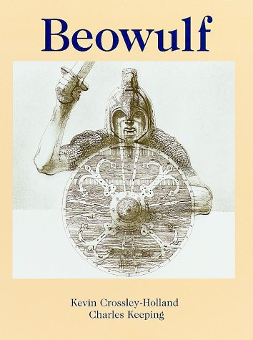  Today we will look at how the author uses the power of three and alliteration to describe characters, settings and events in the story. | RE  L.O. To compare wedding ceremonies in Christinan, Jewish and Hindu religions.  https://www.truetube.co.uk/film/christian-marriage  https://www.bbc.co.uk/teach/class-clips-video/religious-studies-ks2-my-life-my-religion-hinduism-nikki-hemal-marriage-hindu-wedding-ceremony/zmqrkmn
Tuesday | https://www.edshed.com/en-gb/login | https://www.activelearnprimary.co.uk/login?c=0 | https://ttrockstars.com | https://www.activelearnprimary.co.uk/login?c=0 | Maths  Follow the link for your year group for videos in the most current week. Then complete the worksheet provided on google classroom.  Children that do maths in the piano room  https://whiterosemaths.com/homelearning/year-2/  Year 3  https://whiterosemaths.com/homelearning/year-3/  Year 4  https://whiterosemaths.com/homelearning/year-4/  Year 5/6  https://whiterosemaths.com/homelearning/year-5/ | Literacy  Year 3/4  Today we will look at using the simple past tense and past perfect tense.  Year 5/6 Today we will look at using speech to convey character and advance the action. | Topic  L.O To create a model of a Viking home.  Today, in school we will be starting to build our Viking longhouses out of cardboard and art straws.  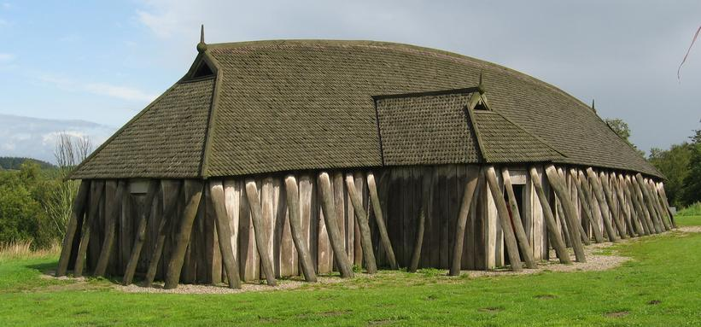
Wednesday | https://www.edshed.com/en-gb/login | https://www.activelearnprimary.co.uk/login?c=0 | https://ttrockstars.com | https://www.activelearnprimary.co.uk/login?c=0 | Maths  Follow the link for your year group for videos in the most current week. Then complete the worksheet provided on google classroom.  Children that do maths in the piano room  https://whiterosemaths.com/homelearning/year-2/  Year 3  https://whiterosemaths.com/homelearning/year-3/  Year 4  https://whiterosemaths.com/homelearning/year-4/  Year 5/6  https://whiterosemaths.com/homelearning/year-5/ | Literacy  Today we will all look at using fronted adverbials and fronted subordinate clauses. | Topic  L.O To create a model of a Viking home.  Today, in school we will be continuing to build our Viking longhouses out of cardboard and art straws.
Thursday | https://www.edshed.com/en-gb/login | https://www.activelearnprimary.co.uk/login?c=0 | https://ttrockstars.com | https://www.activelearnprimary.co.uk/login?c=0 | Maths  Follow the link for your year group for videos in the most current week. Then complete the worksheet provided on google classroom.  Children that do maths in the piano room  https://whiterosemaths.com/homelearning/year-2/  Year 3  https://whiterosemaths.com/homelearning/year-3/  Year 4  https://whiterosemaths.com/homelearning/year-4/  Year 5/6  https://whiterosemaths.com/homelearning/year-5/ | Literacy  Year 3/4 Today we will continue to look at using fronted adverbials and subordinate clauses. We will also look at proof-reading and editing our work.  Year 5/6 Today we will look at using hyphens and proofreading and editing our work. | PE  Premier sports have made some videos for you to follow at home for PE.  https://www.youtube.com/channel/UCLNV8D56t6RV0wbsPnbnYeA  Please do any of the ball skills on their channel.  You could also go out in the garden and get some fresh air or go for a walk with a grownup.  There are also some great videos to do on https://www.bbc.co.uk/teach/supermovers
Friday | https://www.edshed.com/en-gb/login | https://www.activelearnprimary.co.uk/login?c=0 | https://ttrockstars.com |  | Science  L.O. To understand how plants reproduce.  https://www.bbc.co.uk/bitesize/topics/zgssgk7/articles/zyv3jty | French 30 mins  L.O. To talk about your hobbies in French.  https://www.bbc.co.uk/bitesize/topics/z6d98xs/articles/zy9dg7h  PSHE 30 mins  L.O. To understand how best to manage difficult feelings. | Mental Health  For this hour, choose something which meets one of your 10 a day for mental health. You could also visit our mental health section on the school website.  