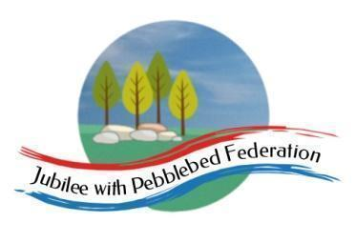

Class 1 Home Learning for the week beginning 19th April 2021
 | Phonics & Spelling (30 mins) | Reading - This book links with phonics and spelling and will be read for guided reading sessions  (30 mins) | Maths  (30 mins) | Literacy  (30 mins) | PE  (15 minutes)  Leap into Life | Afternoon Work  (45 mins) | Mental Health  Emotions & Feelings
This week’s learning behaviour:
This week we will be thinking about revising your learning. You need to be flexible and able to change and adapt your plans if they are not working. Think about your learning as you are doing it. Review it - what is working well? What is not working well?
When an American sea otter is unable to open a clam it finds two stones and puts one on its tummy then the clam on top and then it bashes it with the second stone. It is then able to eat the clam.
Monday | Orange Group  Phase 3  Unit 6  j  Reception  Phase 5  Unit 9  Ai as ia  Year 1  Unit 25  J as g(e), g(i), g(y)  Year 2  NNS - Block 6 Week 1 Lesson 1 | Orange Group  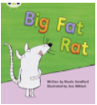  Reception  Year 1  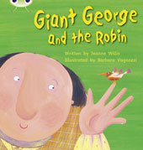  Year 2  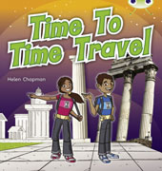 | Orange Group/ Reception  https://classroom.thenational.academy/lessons/counting-up-to-9-objects-reliably-74v38d  Year 1  https://classroom.thenational.academy/lessons/to-recognise-name-and-describe-3d-shapes-cnjkcd  Year 2  https://www.bbc.co.uk/bitesize/articles/zfqt2v4 | Orange Group/Reception  Year 1/Year 2  https://classroom.thenational.academy/lessons/to-listen-and-join-in-with-a-story-c8rkjc | Physical Education KS1 / KS2: Dance Zone - Simple Movement Patterns | RE  The Story of Ascension Day - see ppt | Lesson summary: Feeling good
Tuesday | Orange Group  Phase 3  Unit 6  v  Reception  Phase 5  Unit 9  Ee as ee  Year 1  Unit 25  J as g(e), g(i), g(y)  Year 2  NNS - Block 6 Week 1 Lesson 2 | Orange Group  Reception  Year 1  Year 2 | Orange Group/ Reception  https://classroom.thenational.academy/lessons/counting-up-to-10-objects-reliably-ccw32e  Year 1  https://classroom.thenational.academy/lessons/to-recognise-name-and-describe-3d-shapes-cnjkcd  Year 2  https://www.bbc.co.uk/bitesize/articles/zfqt2v4 | Orange Group/ Reception  Year 1/ Year 2  https://classroom.thenational.academy/lessons/to-map-and-speak-the-story-6rr68t |  | Science  https://classroom.thenational.academy/lessons/how-do-i-plant-a-bean-cgwp6e
Wednesday | Orange Group  Phase 3  Unit 6  w  Reception  Phase 5  Unit 9  Igh as igh  Year 1  Unit 25  J written as dge  Year 2  NNS - Block 6 Week 1 Lesson 3 | Orange Group  Reception  Year 1  Year 2 | Orange Group/ Reception  https://classroom.thenational.academy/lessons/exploring-one-more-within-10-74v3cc  Year 1  https://classroom.thenational.academy/lessons/naming-and-describing-3d-shapes-c9gkec  Year 2  https://classroom.thenational.academy/lessons/identifying-shapes-by-the-number-of-vertices-and-sides-6djp2e | Orange Group/ Reception  Year 1/ Year 2  https://classroom.thenational.academy/lessons/to-step-and-speak-the-story-65jk6d |  | Geography  Villages, Towns and Cities - Oak National Academy
Thursday | Orange Group  Phase 3  Unit 6  X  Reception  Phase 5  Unit 9  Oa as oa  Year 1  Unit 25  J written as dge  Year 2  NNS - Block 6 Week 1 Lesson 4 | Orange Group  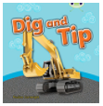  Reception  Year 1  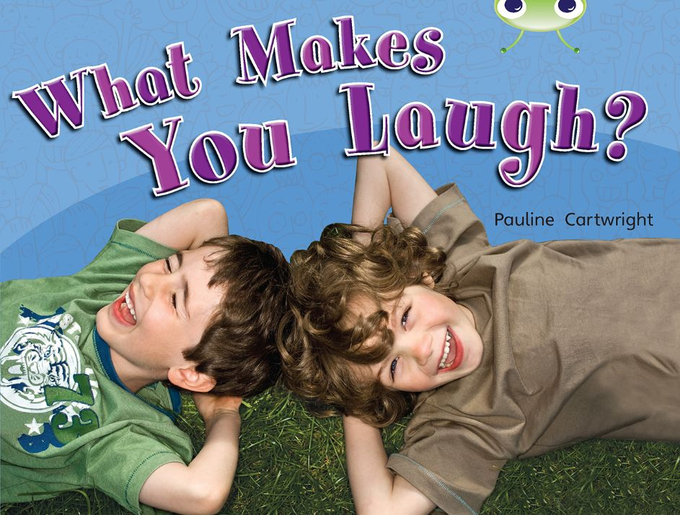  Year 2  Inference | Orange Group/ Reception  https://classroom.thenational.academy/lessons/exploring-one-less-within-10-cgtk0c  Year 1  https://classroom.thenational.academy/lessons/to-describe-and-classify-3d-shapes-70u3cc  Year 2  https://classroom.thenational.academy/lessons/identifying-right-angles-in-shapes-65jp2r | Orange Group/ Reception  Year 1/ Year 2  https://classroom.thenational.academy/lessons/to-dance-a-story-ctk38d |  | Computing/ PSHE  What is a computer?
Friday | Orange Group  Phase 3  Unit 6  X  Reception  Phase 5  Unit 9  Oo as oo (long)  Year 1  Unit 25  Language Session  Year 2  NNS - Block 6 Week 1 Lesson 5 | Orange Group  Reception  Year 1  Year 2  Inference | Orange Group/ Reception  https://classroom.thenational.academy/lessons/placing-numbers-within-ten-in-or  Year 1  https://www.bbc.co.uk/bitesize/articles/zkrpm39  Year 2  https://www.bbc.co.uk/bitesize/articles/zdjtjsg | Orange Group/ Reception  Year 1/ Year 2  https://classroom.thenational.academy/lessons/to-role-play-action-in-a-story-cnh62t |  | Art/ Music  Lesson summary: Observational drawing  Jack and the Beanstalk. 1: What shall we do?

