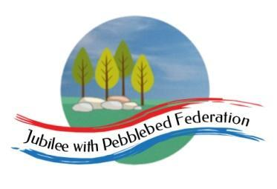

Class 2 Home Learning
For sessions in purple, please visit google classroom where you will find specific work related to each subject to complete and ‘turn in’.
Timings | 15 mins | 30 mins | 15 mins | 15 mins | 1 Hour | 1 Hour | 1 Hour
Monday | https://www.edshed.com/en-gb/login | Reading  https://www.activelearnprimary.co.uk/login?c=0 | https://ttrockstars.com/ | 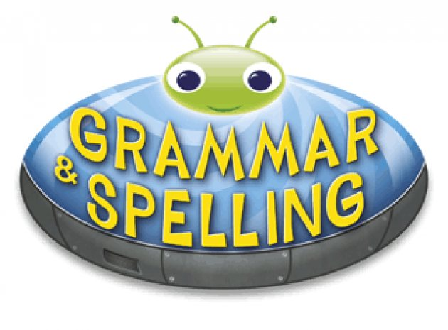  https://www.activelearnprimary.co.uk/login?c=0 | Maths  Follow the link for your year group for videos in the most current week. Then complete the worksheet provided on google classroom.  Children that do maths in the piano room  https://whiterosemaths.com/homelearning/year-2/  Year 3  https://whiterosemaths.com/homelearning/year-3/  Year 4  https://whiterosemaths.com/homelearning/year-4/  Year 5/6  https://whiterosemaths.com/homelearning/year-5/ | Literacy  L.O. End of Sequence writing – research and write about an environmental issue. | Science  L.O. To investigate cliffs in the local area.
Tuesday | https://www.edshed.com/en-gb/login | https://www.activelearnprimary.co.uk/login?c=0 | https://ttrockstars.com | https://www.activelearnprimary.co.uk/login?c=0 | Maths  Follow the link for your year group for videos in the most current week. Then complete the worksheet provided on google classroom.  Children that do maths in the piano room  https://whiterosemaths.com/homelearning/year-2/  Year 3  https://whiterosemaths.com/homelearning/year-3/  Year 4  https://whiterosemaths.com/homelearning/year-4/  Year 5/6  https://whiterosemaths.com/homelearning/year-5/ | Creative Cabin  Today at school, we are having a visit from the Creative Cabin https://www.thelmahulbert.com/?q=creative-cabin-0 | Topic  L.O. To experiment with contrasting colours in sketchbooks.
Wednesday | https://www.edshed.com/en-gb/login | https://www.activelearnprimary.co.uk/login?c=0 | https://ttrockstars.com | https://www.activelearnprimary.co.uk/login?c=0 | Maths  Follow the link for your year group for videos in the most current week. Then complete the worksheet provided on google classroom.  Children that do maths in the piano room  https://whiterosemaths.com/homelearning/year-2/  Year 3  https://whiterosemaths.com/homelearning/year-3/  Year 4  https://whiterosemaths.com/homelearning/year-4/  Year 5/6  https://whiterosemaths.com/homelearning/year-5/ | PSHE  L.O. To explain the risks of drinking alcohol. | RE  L.O. To think about how Christians try to make the world more like the Kingdom of God.
Thursday | https://www.edshed.com/en-gb/login | https://www.activelearnprimary.co.uk/login?c=0 | https://ttrockstars.com | https://www.activelearnprimary.co.uk/login?c=0 | Maths  Follow the link for your year group for videos in the most current week. Then complete the worksheet provided on google classroom.  Children that do maths in the piano room  https://whiterosemaths.com/homelearning/year-2/  Year 3  https://whiterosemaths.com/homelearning/year-3/  Year 4  https://whiterosemaths.com/homelearning/year-4/  Year 5/6  https://whiterosemaths.com/homelearning/year-5/ | Literacy  L.O. End of Sequence writing – research and write about an environmental issue. | PE  Premier sports have made some videos for you to follow at home for PE.  https://www.youtube.com/channel/UCLNV8D56t6RV0wbsPnbnYeA  Please do any of the ball skills on their channel.  You could also go out in the garden and get some fresh air or go for a walk with a grownup.  There are also some great videos to do on https://www.bbc.co.uk/teach/supermovers
Friday | https://www.edshed.com/en-gb/login | https://www.activelearnprimary.co.uk/login?c=0 | https://ttrockstars.com | https://www.activelearnprimary.co.uk/login?c=0 | Maths  Follow the link for your year group for videos in the most current week. Then complete the worksheet provided on google classroom.  Children that do maths in the piano room  https://whiterosemaths.com/homelearning/year-2/  Year 3  https://whiterosemaths.com/homelearning/year-3/  Year 4  https://whiterosemaths.com/homelearning/year-4/  Year 5/6  https://whiterosemaths.com/homelearning/year-5/ | Literacy  L.O. End of Sequence writing – research and write about an environmental issue. | PSHE  L.O. To know how to stay safe on a bike.  French  L.O. To say different mealtimes in french.

