**March Newsletter**

Dear Parents,

**Class 1**

In Science the children have been continuing to learn about habitats and the animals and plants that live in them. They have started to think about the impact that they have on their own surrounding environment and have been very knowledgeable about this. The Class One children are also beginning to think about how they can improve the local environment and when the weather improves, the children will start to plant some seeds and think about how they can help the wildlife in the school grounds.

Nursery and Reception children have been thinking about the seasons and looking for signs of spring and will also be planting seeds to enhance the outside area.

In computing this term, the children in Class One started off by thinking about how they can keep themselves safe online as part of Safer Internet Day. Following on from this the children have been thinking about different types of digital technology and what they use both at school and at home.

**Class 2**

The children in Class Two have been very busy since returning from half term.

They have written persuasive letters to a person of their choice and last week they wrote to Henry VIII, and for example they have written letters to the Prime Minister to persuade him to do more to help the planet.

In Maths the children are working on fractions and percentages and will be doing lots more work towards this in the coming days.

In Science, the children have started work on space by making a moving model of the sun, moon and earth to understand how they move around each other.

God bless and have a lovely weekend.

*Best wishes from Katie Gray and the staff at Broadhembury CE School*

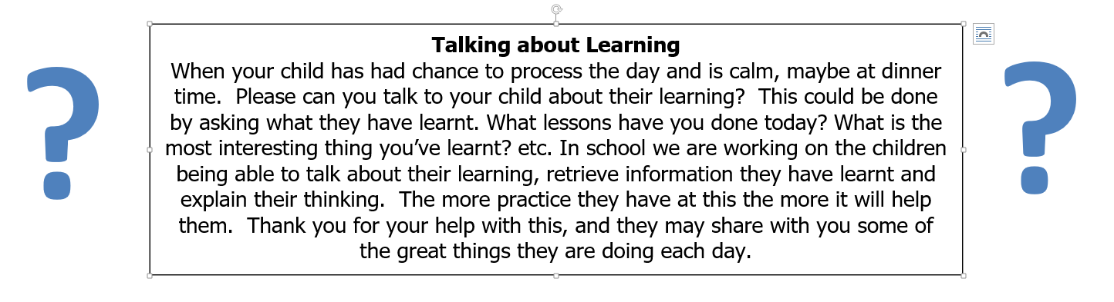

|  |
| --- |
| **Question of the month**  **Class 1:**  What is your favourite book at the moment and why?  **Class 2**: Is there life in another galaxy? |

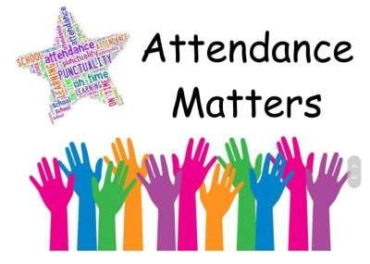

**January Attendance**

Class 1 – 87%

Class – 90%

Whole School – 88%

Being in school is important to your child’s achievement, wellbeing, and wider development.

**BROADHEMBURY BRIDGES**

**Broadhembury Bridge awards**:

**Ava, Max and Albie**

**Key Dates – Spring Term 2024**

Thursday 7th March - World Book Day

Friday 8th March - Mothering Sunday Service

Tuesday 19th March - Parents Evening

Thursday 21st March - Year 3 and 4 Girls Football

Friday 22nd March - Experience Easter Service 1pm in Church

Thursday 28th March - Last Day of Half Term

Monday 15th April – Return to school

**World Book Day 7th March**

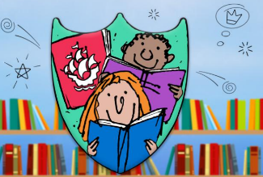World Book Day is on 7th March 2024, due to our continued focus on creating a

love of reading, children can come to school dressed as their favourite book character. During the day, the children will take part in activities linked to reading. One of these activities is going to be the Blue Peter Reading Book Badge competition. The entries will be sent off and the children will win a Blue Peter Badge! The badge gives free entry to some of the countries’ top attractions. You should have received a form, please speak to the school office if you need another one.

**L & F Multisports Easter Camp**

Please make all bookings through www.lfmultisports.co.uk



**Book Recommendations March**

With our continuing focus on reading culture in school, we would like to start recommending books to our families. With a view to trying to widen pupils’ interest in different genres and authors, supporting parents to know new authors and as ideas for gifts. If your child reads one of these books, it would be great if they could make a comment on the book and we can share it on Facebook.

|  |  |  |  |  |  |
| --- | --- | --- | --- | --- | --- |
| **EYFS** | Why, Oh Why, Am I a Crocodile? By Alex Brooks & Hannah Worsley |  | **Lower KS2** | Future Hero: Race to Fire Mountain by Remi Blackwood |  |
| **KS1** | The Bear and her Book by Frances Tosdevin & Sophia O'Connor |  | **Upper KS2** | Mia and the Lightcasters by Janelle McCurdy & Ana Latese |  |

**Collective Worship Activity**

This term we will be focussing in school on the value of Trust. We hope your family will find these ideas helpful as you explore the value and have fun together. If the children bring back something that you have done at home linked to the Collective Worship activity or can talk about a discussion they’ve had at home linked to it, then Mrs Gray will award them with a new, special sticker.

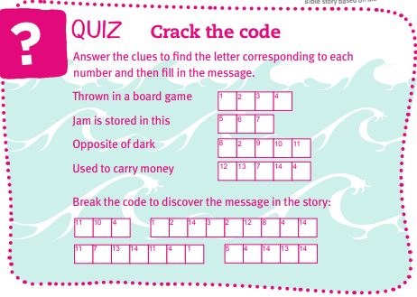

|  |
| --- |
| **Wellbeing**  *There has been much press in recent months about children’s mental health. As part of our drive to support this we are going to include something each month in the newsletter about Health and Wellbeing. We hope you find this section useful. If you have any topics you would like us to find some helpful tips about, please let us know.*    The Parent+ Support Hub is for Caregivers who support family, friends or colleagues with mental health issues. Our volunteers have all supported family & friends with mental health issues. We also have an advisory board of professionals and work closely with local and national mental health services and [networks](https://www.parentalminds.org.uk/links/).  https://www.parentalminds.org.uk/ |

**Important Notices**

**Healthy Snacks**

Class 1 have a healthy snack each morning with fruit provided. As we never know what fruit we will be given if your child doesn’t like a particular fruit, they are welcome to bring in a healthy fruit or vegetable snack from home.

**Cold Weather**

Now the weather seems to be getting a little colder please make sure your child brings a warm/waterproof coat to school each day. We do go outside to play every day unless it is absolutely pouring with rain so coats are vital. I’ve already started to see some lovely woolly hats and gloves appearing, keeping the children warm and cosy during playtime.

**Free School Meals**

If your circumstances have recently changed your child may have become eligible for free school meals. This will also bring extra funding to the school, which will be used to help your child. For an instant decision or to learn more please go online at

[*https://www.devon.gov.uk/educationandfamilies/school-information/school-meals*](https://www.devon.gov.uk/educationandfamilies/school-information/school-meals).

**Advice on Covid-19**

As you may be aware, there are some concerns regarding the recent spread of Covid-19. Please see below updated guidance on what to do if you suspect a case of Covid-19 or test positive.

* For diarrhoea and vomiting, people need to be 48 hours free of symptoms to return to the setting (pupils and staff)
* Children with **mild symptoms** such as a runny nose, sore throat, or mild cough, who are otherwise well, **can continue to attend their education or childcare setting.**
* Anyone who is **unwell,** including people with a high temperature, should **stay at home** and avoid contact with others until they have recovered. They can return to the setting once they no longer have a temperature (without medication) and are well enough to do so. (pupils and staff)
* **Children** and young people under 18 years old who have a positive test for **Covid-19** should stay away from the setting for **3 days** after they took their test (and until they are well enough to return, including no temperature).