For our work on bats in Broadhembury, I would like you to look out for any moths that you might spot either during the day or when it begins to get dark.
Ask your grown up to help you to create a moth trap. All you need is a torch and a white sheet or piece of fabric. For more details, look at this link.
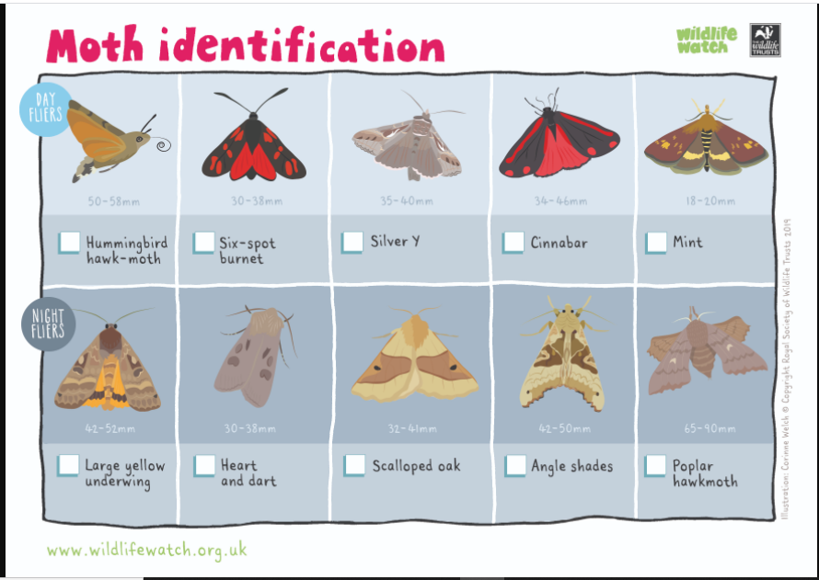
https://www.bbc.co.uk/blogs/natureuk/entries/bd7c6a4e-dad9-384a-89a0-1b7a93660d72

