**May Newsletter**

Dear Parents,

**Class 1**

Welcome to the Summer Term and what an exciting start we have had so far! The EYFS/KS1 children have been enjoying exploring and being creative in our outside area, particularly our new mud kitchen, for which we would like to say an enormous thank you to our very generous parents – Martha and Tom - who kindly donated their time, resources and skills to make this for us! Over the Easter break Martha and Tom, along with their children, have been busy up at the school, tidying, trimming, building, planting and much more, to support the staff in ensuring that there is fantastic provision for our pupils. Do come and take a look at their hard work – they really have gone above and beyond and we are all so very grateful! On another note, there is also a lot of excitement about our class caterpillars which are getting bigger by the day!

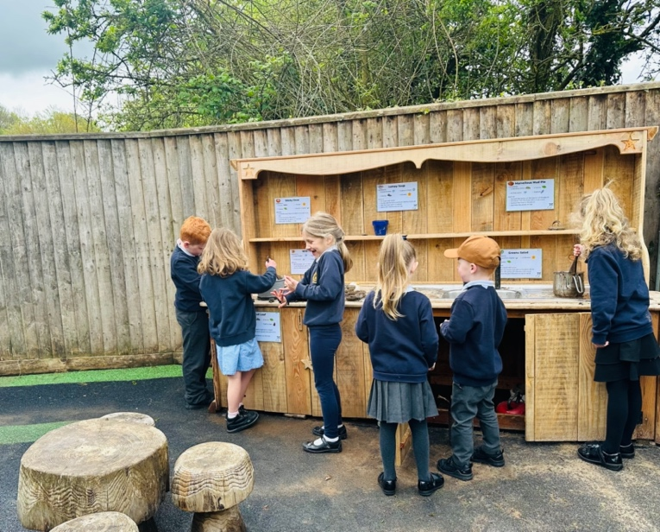

For the course of the Summer Term, our topic is Coastlines. The children in class 1 are exploring physical and human features, compass directions, the United Kingdom and our local villages and towns; using the information and variety of maps and to help grow their knowledge and understanding of our local Geography, including the effects of erosion and how to stay safe when visiting the coast. They will have the opportunity to learn about the work of the RNLI, what happened to the SS Rohilla and about the coastal town of Whitby, including how Captain Cook is linked to the town. The children will then research the tourism industry and consider what features make a place a successful tourist destination.

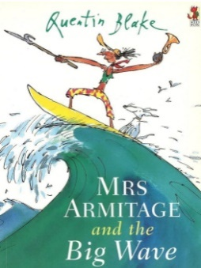In Key Stage 1, our topics within Maths are Fractions, followed by Measurement. Across Class 1, the children continue to use their ‘stem sentences’ to help them strengthen and develop their reasoning skills. Miss Harvey-Jones has been really impressed with the children’s ability to explain how they have found out what a quarter of a total is.

In Literacy the class have been reading the fiction text, *Mrs Armitage and the Big Wave*. The children in Key Stage 1 are working towards writing their own humorous story using cumulative structure. They are currently enjoying the excitement and range of activities that they have been able to explore as a result. We are seeing real progress in terms of our stamina for writing in Literacy, as well as across other subjects. Well done everyone!

In DT, the children will be focusing on beach huts and learning about making and strengthening structures, including different ways of joining materials. The class has enjoyed looking at different beach huts last week, talking about what we did or didn’t like about the different styles. They are all very excited about the fact that later on in the term we are going to have a go a building our own model beach hut. The Art project this term is called, ’Flower Head’. This project teaches children about the visual elements of flowers, including shape, texture, colour, pattern and form. The children will explore various artistic methods, including drawing, printmaking and 3-D forms, using paper and clay.

**Class 2**

In Maths, the children in Class 2 have continued to explore the relationship between fractions, decimals and percentages and have learnt how to find percentages of amounts. They have learnt how to multiply fractions with Year 6 children learning how to divide a fraction. With their learning on fractions almost complete for this year, the children have been busy solving problem questions where they have used their new fraction knowledge to find the best solution! They have enjoyed using resources to help them reason and overcome new challenges. They have really impressed me with their understanding and the progress that they have made in explaining how they have found the solution to a problem!

Since coming back in the new term, Class 2 have started their new Literacy unit where the children have developed their understanding and use of complex sentences, relative clauses and modal verbs.

In Science this term the children will be developing their knowledge of properties and uses of different materials.

As Pentecost is just around the corner, our learning during our RE lessons will involve learning about the story of Pentecost and the impact of the Pentecost on Christians today.

Well done to our year 5 and 6 children who competed at a recent ‘Quad Kids’ sport event at Honiton. Events included long jump, throwing and running (75m and 600m). Their commitment but, most of all wonderful team spirit was a credit to them all.



Miss Harvey-Jones’ recommended read for this month: Safiyyah’s War by Hiba Noor Khan

This is a tale of tolerance, unthinkable bravery, and heart-in-mouth true events!

God bless and have a lovely weekend.

*Best wishes from Katie Gray and the staff at Broadhembury CE School*

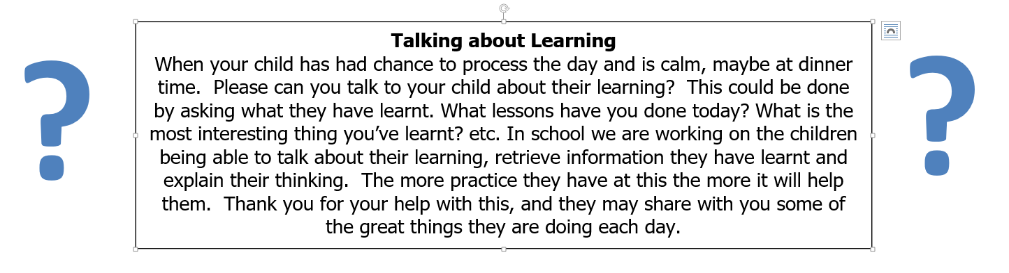

|  |
| --- |
| **Question of the month**  **Class 1:**  What do you know about the United Kingdom?  **Class 2**: Are you a leader or follower? |

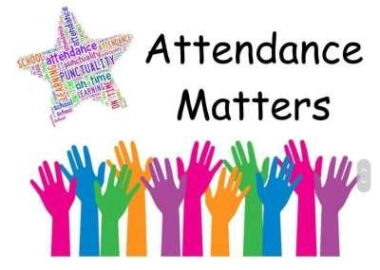

**March Attendance**

Class 1 – 89%

Class – 84%

Whole School – 87%

Being in school is important to your child’s achievement, wellbeing, and wider development.

**Key Dates – Summer Term 2024**

Monday 6th May - Bank Holiday

Friday 10th May - Year 3 & 4 Quad Kids

Monday 13th May - KS2 SATs week

Thursday 23rd May - May Day

Friday 24th May – Year 5 & 6 Hand Ball

Friday 24th May - Last day of half term

Thursday 6th June - School Photos

Friday 14th June – Year 2, 3 & 4 Dartmoor 3ball

28th June – KS2 Games @ HCC

Thursday 11th July - Sports Day

**May Day Celebrations**

The PTFA would like to kindly ask if anyone would be able to donate cakes for the cake stall (including a list of ingredients) for our May Day celebration. Please advise the school if you would be willing to support us with this and bring your baked goods on the morning of 23rd May. Don't forget to bring pennies on the day to support our new PTFA! Thank you.

**Collective Worship Activity**

This term we will be focussing in school on the value of Justice. We hope your family will find these ideas helpful as you explore the value and have fun together. If the children bring back something that you have done at home linked to the Collective Worship activity or can talk about a discussion they’ve had at home linked to it, then Mrs Gray will award them with a new, special sticker.

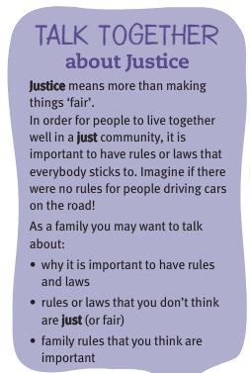

**Important Notices**

**Healthy Snacks**

Class 1 have a healthy snack each morning with fruit provided. As we never know what fruit we will be given if your child doesn’t like a particular fruit, they are welcome to bring in a healthy fruit or vegetable snack from home.

**Cold Weather**

Now the weather seems to be getting a little colder please make sure your child brings a warm/waterproof coat to school each day. We do go outside to play every day unless it is absolutely pouring with rain so coats are vital. I’ve already started to see some lovely woolly hats and gloves appearing, keeping the children warm and cosy during playtime.

**Free School Meals**

If your circumstances have recently changed your child may have become eligible for free school meals. This will also bring extra funding to the school, which will be used to help your child. For an instant decision or to learn more please go online at

[*https://www.devon.gov.uk/educationandfamilies/school-information/school-meals*](https://www.devon.gov.uk/educationandfamilies/school-information/school-meals).

**Advice on Covid-19**

As you may be aware, there are some concerns regarding the recent spread of Covid-19. Please see below updated guidance on what to do if you suspect a case of Covid-19 or test positive.

* For diarrhoea and vomiting, people need to be 48 hours free of symptoms to return to the setting (pupils and staff)
* Children with **mild symptoms** such as a runny nose, sore throat, or mild cough, who are otherwise well, **can continue to attend their education or childcare setting.**
* Anyone who is **unwell,** including people with a high temperature, should **stay at home** and avoid contact with others until they have recovered. They can return to the setting once they no longer have a temperature (without medication) and are well enough to do so. (pupils and staff)
* **Children** and young people under 18 years old who have a positive test for **Covid-19** should stay away from the setting for **3 days** after they took their test (and until they are well enough to return, including no temperature).

