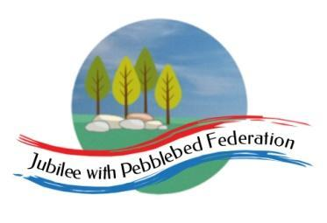

Class 2 Home Learning
For activities in purple, please visit google classroom where you will find specific work related to each subject to complete and ‘turn in’.
Timings | 15 mins | 30 mins | 15 mins | 15 mins | 1 Hour | 1 Hour | 1 Hour
Monday | https://www.edshed.com/en-gb/login | Reading  https://www.activelearnprimary.co.uk/login?c=0 | https://ttrockstars.com/ | 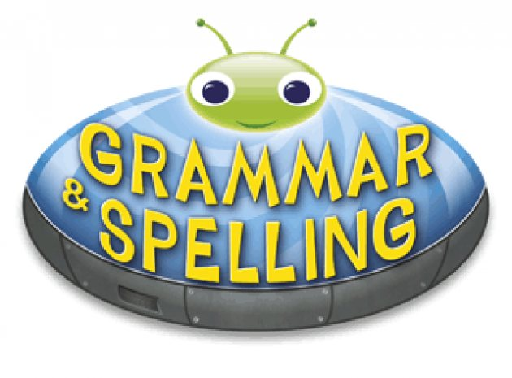  https://www.activelearnprimary.co.uk/login?c=0 | Maths  Follow the link for your year group for videos in the most current week. Then complete the worksheet provided on google classroom.  Children that do maths in the piano room  https://whiterosemaths.com/homelearning/year-2/  Year 3  https://whiterosemaths.com/homelearning/year-3/  Year 4  https://whiterosemaths.com/homelearning/year-4/  Year 5/6  https://whiterosemaths.com/homelearning/year-5/ | Literacy  Today we are drawing detailed pictures of our mythical creatures for your final piece of information writing.  Please draw this at home carefully on plain paper, use a ruler for the lines when labelling it. | Mental Health  At school, we are thinking about welcoming everyone back and looking after ourselves.  Watch this video https://www.youtube.com/watch?v=S-8WezbUkq4  How do you manage big or small emotions?  What helps you to do this?
Tuesday | https://www.edshed.com/en-gb/login | https://www.activelearnprimary.co.uk/login?c=0 | https://ttrockstars.com | https://www.activelearnprimary.co.uk/login?c=0 | Maths  Follow the link for your year group for videos in the most current week. Then complete the worksheet provided on google classroom.  Children that do maths in the piano room  https://whiterosemaths.com/homelearning/year-2/  Year 3  https://whiterosemaths.com/homelearning/year-3/  Year 4  https://whiterosemaths.com/homelearning/year-4/  Year 5/6  https://whiterosemaths.com/homelearning/year-5/ | Literacy  L.O. To write a story on overcoming a monster.  First of all, think about the setting of your story, what does the monster do to the place or the people?  Will there be a hero to overcome the monster? How will he/she save the day? | RE  L.O. To investigate and explain bar and bat mitzvahs.  Recap fundamentals of the Jewish faith.  Watch these:  https://www.bbc.co.uk/teach/class-clips-video/religious-studies-ks2-preparing-for-bat-mitzvah/zvgpy9q  https://www.truetube.co.uk/film/bat-and-bar-mitzvah
Wednesday | https://www.edshed.com/en-gb/login | https://www.activelearnprimary.co.uk/login?c=0 | https://ttrockstars.com | https://www.activelearnprimary.co.uk/login?c=0 | Maths  Follow the link for your year group for videos in the most current week. Then complete the worksheet provided on google classroom.  Children that do maths in the piano room  https://whiterosemaths.com/homelearning/year-2/  Year 3  https://whiterosemaths.com/homelearning/year-3/  Year 4  https://whiterosemaths.com/homelearning/year-4/  Year 5/6  https://whiterosemaths.com/homelearning/year-5/ | Literacy  L.O. To familiarise with the Beowulf story and sequence key events.  Our last sequence of this term is based on the story Beowulf. It is an Old English story, told in Saxon/Viking times.  https://www.bbc.co.uk/teach/school-radio/english-ks2-ks3-beowulf-index/zfbhpg8 | Topic  L.O. To research and compare an aspect of Anglo-Saxon and Viking life.Choose from one of these aspects:  Clothes. Food. Homes, Battle  Compare the topic for Anglo-Saxons and Vikings.
Thursday | https://www.edshed.com/en-gb/login | https://www.activelearnprimary.co.uk/login?c=0 | https://ttrockstars.com | https://www.activelearnprimary.co.uk/login?c=0 | Maths  Follow the link for your year group for videos in the most current week. Then complete the worksheet provided on google classroom.  Children that do maths in the piano room  https://whiterosemaths.com/homelearning/year-2/  Year 3  https://whiterosemaths.com/homelearning/year-3/  Year 4  https://whiterosemaths.com/homelearning/year-4/  Year 5/6  https://whiterosemaths.com/homelearning/year-5/ | Literacy  L.O. To retell the story of Beowulf and discuss LDPP.  In school, we will use widget to create a story map of Beowulf. At home, draw small pictures /symbols and write simple sentences to map out the story of Beowulf. | PE  Premier sports have made some videos for you to follow at home for PE.  https://www.youtube.com/channel/UCLNV8D56t6RV0wbsPnbnYeA  Please do any of the ball skills on their channel.  You could also go out in the garden and get some fresh air or go for a walk with a grownup.  There are also some great videos to do on https://www.bbc.co.uk/teach/supermovers
Friday | https://www.edshed.com/en-gb/login | https://www.activelearnprimary.co.uk/login?c=0 | https://ttrockstars.com |  | Science  L.O. To classify microorganisms.  What is a microorganism?  https://www.bbc.co.uk/bitesize/topics/zfxxsbk/articles/zsgtrwx Go through learner guide. (discuss links with germs - covid!)  Fungi, bacteria, virus | French 30 mins  L.O. To ask questions about hobbies in French.  https://www.bbc.co.uk/bitesize/topics/z6d98xs/articles/zy9dg7h  PSHE 30 mins  L.O. To understand and manage worries.  https://www.bbc.co.uk/programmes/articles/5QM6H01X6b3jTQF85GLgbFl/when-i-worry-about-things | Mental Health  For this hour, choose something which meets one of your 10 a day for mental health. You could also visit our mental health section on the school website.  