**June Newsletter**

Dear Parents,

Trip to Lyme Regis

We had a super time at Lyme Regis last week. The children visited the Aquarium where they learnt about starfish and how they can re-grow their legs if they fall off. They also visited the lifeboat station and continued their learning about the RNLI and also about how to spot dangers at the beach.

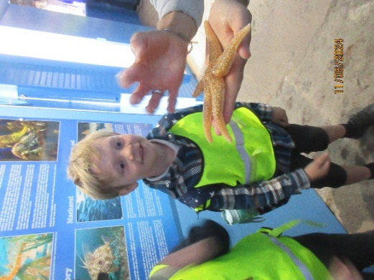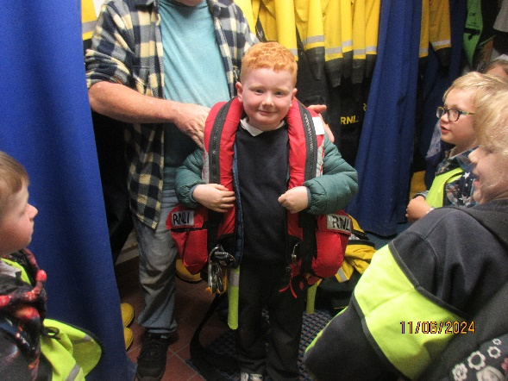

Photography Competition

The children’s photos are back! They are really good and we are so proud of the children. We are now busy mounting them and writing captions for them ready for the celebration of all the children’s hard work.

You may have seen the posters around the village, please join us at the village hall in Broadhembury on Friday July 12th from 2pm.

Year 6 SATs

Our year 6 children approached the SATs tests sensibly and we are all very proud of their perseverance and positive attitudes throughout the process. Congratulations Year 6!

May Day Celebration

What a super May Day Celebration we had this year! A huge thank you to our new PTFA for their tremendous effort decorating the playground and arranging refreshments and raffles. Thank you to everyone who donated on the day.  The weather was perfect and the children put on a flawless performance with their dancing. It was super to watch as the May King and Queen were crowned with their super floral crowns.

God bless and have a lovely weekend.

*Best wishes from Katie Gray and the staff at Broadhembury CE School*

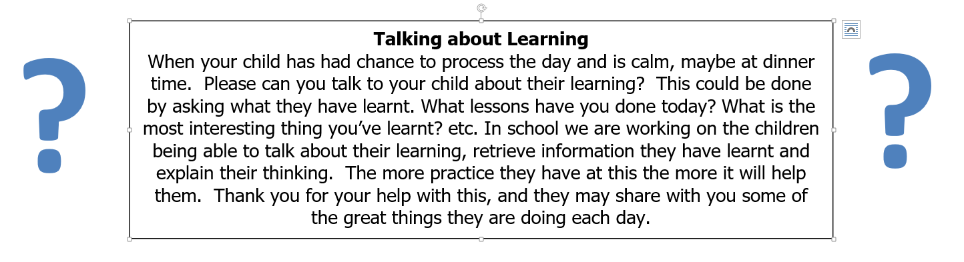

|  |
| --- |
| **Question of the month**  **Class 1:**  What materials are best for building a beach hut? Why?  **Class 2**: Why did the Ancient Greeks use cylindrical shapes for their buildings’ columns? Can you find out the names of the 3 main types of column? |

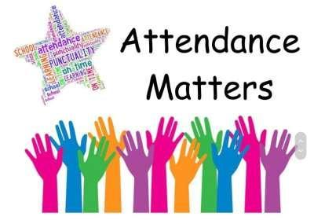

**April Attendance**

Class 1 – 89%

Class – 93%

Whole School – 91%

Being in school is important to your child’s achievement, wellbeing, and wider development.

**Key Dates – Spring Term 2024**

28th June - HLC Games KS2

3rd - 5th July - Year 5 & 6 Residential

8th July - HCC Transition Week

11th July – Sports Day Picnic 12pm

11th July - Sports Day 1.15pm

12th July - School Photography Exhibition 2-4pm Village Hall

21st July – PTFA Summer Fair 10.30am – 2.30pm

22nd July - Summer Play

**Broadhembury Sports Day – Thursday 11th July 1.15pm**

Sports day will take place on Thursday 11th July**.** All children will need their P.E kit; black or blue shorts and trainers or pumps. If possible could the children wear a t-shirt in the colour of their team, if not their PE t-shirt will be fine.

**Beam – Red        Clapper – Blue        Draw – Green        Arch - Yellow**

Your child should know which team they are in, however, if they are unsure please ask their class teacher or look at the team lists in the library.

**Sports’ Day Picnic – Thursday 11th July 12pm**

As sports day will be starting after lunch parents are welcome to bring a picnic to eat with the children.

**Collective Worship Activity**

This term we will be focussing in school on the value of Truthfulness. We hope your family will find these ideas helpful as you explore the value and have fun together. If the children bring back something that you have done at home linked to the Collective Worship activity or can talk about a discussion they’ve had at home linked to it, then we will award them with a new, special sticker.

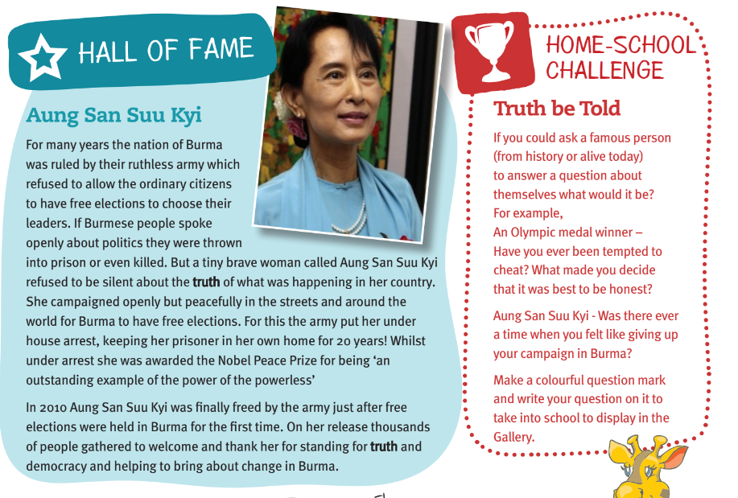

**Book Recommendations June**

With our continuing focus on reading culture in school, we would like to start recommending books to our families. With a view to trying to widen pupil’s interest in different genres and authors, supporting parents to know new authors and as ideas for gifts. If your child reads one of these books, it would be great if they could make a comment on the book and we can share on Facebook.

|  |  |  |  |  |  |
| --- | --- | --- | --- | --- | --- |
| **EYFS** | The Friendly Mammoth by Anna Terreros-Martin |  | **Lower KS2** | Anisha, Accidental Detective: Holiday Adventure by Serena Patel & Emma McCann |  |
| **KS1** | The Most Exciting Eid by Zeba Talkhani & Abeeha Tariq |  | **Upper KS2** | How to be More Hedgehog by Anne-Marie Conway |  |

**Important Notices**

**Healthy Snacks**

Class 1 have a healthy snack each morning with fruit provided. As we never know what fruit we will be given if your child doesn’t like a particular fruit, they are welcome to bring in a healthy fruit or vegetable snack from home.

**Free School Meals**

If your circumstances have recently changed your child may have become eligible for free school meals. This will also bring extra funding to the school, which will be used to help your child. For an instant decision or to learn more please go online at

[*https://www.devon.gov.uk/educationandfamilies/school-information/school-meals*](https://www.devon.gov.uk/educationandfamilies/school-information/school-meals).

**Advice on Covid-19**

As you may be aware, there are some concerns regarding the recent spread of Covid-19. Please see below updated guidance on what to do if you suspect a case of Covid-19 or test positive.

* For diarrhoea and vomiting, people need to be 48 hours free of symptoms to return to the setting (pupils and staff)
* Children with **mild symptoms** such as a runny nose, sore throat, or mild cough, who are otherwise well, **can continue to attend their education or childcare setting.**
* Anyone who is **unwell,** including people with a high temperature, should **stay at home** and avoid contact with others until they have recovered. They can return to the setting once they no longer have a temperature (without medication) and are well enough to do so. (pupils and staff)
* **Children** and young people under 18 years old who have a positive test for **Covid-19** should stay away from the setting for **3 days** after they took their test (and until they are well enough to return, including no temperature).

**Summer Reading Challenge at your local library**



