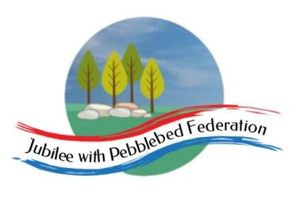

Class 2 Home Learning for the week beginning 16th November
Each Day | Spelling  15 mins | 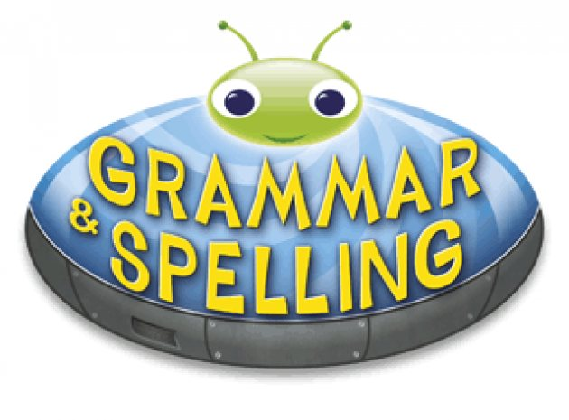  Grammar  15 mins | Reading  30 mins | Literacy 1 hour  Science 1 hour on Fridays |  | Maths (45 mins) when finished (15 mins)  Please follow the white rose maths links, complete any work on paper at home - do not buy the workbooks.  If your child is off for longer than 14 days - we can arrange for their power maths practise books to be collected.  PE (1 hour on Fridays) |  |  | Afternoon Project (1 hour)
Monday | Literacy Links:  Children normally with Miss Watts and Stella  https://classroom.thenational.academy/lessons/to-listen-to-a-story-c5h32r  Children normally with Miss Watts and Miss Richards  https://classroom.thenational.academy/lessons/to-develop-an-understanding-of-key-characters-from-the-borrowers-cgt36c |  |  |  |  | Maths links for the week:  Children that do maths in the piano room  https://whiterosemaths.com/homelearning/year-2/week-9-number-addition-subtraction/  Year 3  https://whiterosemaths.com/homelearning/year-3/week-8-number-addition-subtraction/  Year 4  https://classroom.thenational.academy/units/multiplication-and-division-6dbb  Lessons 1, 2, 3 and 4  Year 5  https://whiterosemaths.com/homelearning/year-5/week-8-number-multiplication-division/  Year 6  https://whiterosemaths.com/homelearning/year-6/week-5/ |  |  | RE  https://classroom.thenational.academy/lessons/what-is-the-sacred-text-of-christianity-c8r6cd
Tuesday | Literacy Links:  Children normally with Miss Watts and Stella  https://classroom.thenational.academy/lessons/to-tell-a-story-from-memory-71gkgr  Children normally with Miss Watts and Miss Richards  https://classroom.thenational.academy/lessons/to-investigate-suffixes-ary-ery-68w6ce |  |  |  |  |  |  |  | Topic  https://classroom.thenational.academy/lessons/how-did-the-romans-change-britain-60r3gt
Wednesday | Literacy Links:  Children normally with Miss Watts and Stella  https://classroom.thenational.academy/lessons/to-explore-the-middle-of-a-story-6wukgd  Children normally with Miss Watts and Miss Richards  https://classroom.thenational.academy/lessons/to-revise-our-knowledge-of-word-class-c9k6ct |  |  |  |  |  |  |  | Topic  RESEARCH - Exeter was a Roman town. It was surrounded by a city wall, some of which still stands today. Create a poster/information sheet about its history.  You could do this on the computer and email it into school.
Thursday | Literacy Links:  Children normally with Miss Watts and Stella  https://classroom.thenational.academy/lessons/to-vary-sentence-length-for-effect-c4rk6e  Children normally with Miss Watts and Miss Richards  https://classroom.thenational.academy/lessons/to-generate-vocabulary-for-character-description-71h66d |  |  |  |  |  |  |  | PSHE  https://classroom.thenational.academy/lessons/hazards-in-the-home-6mt68c  French  https://www.youtube.com/watch?v=xRsr6wOIhgg
Friday | SCIENCE LINK:  https://classroom.thenational.academy/lessons/what-is-a-synthetic-material-74wk8c |  |  |  |  | PE  Here is a link to some videos a PE company (that Mr R comes from) has made for you.  https://www.youtube.com/channel/UCLNV8D56t6RV0wbsPnbnYeA  https://app.gonoodle.com/ Have a go at some fun dance/workout videos.  If you can: go outside and get some fresh air in the garden! What can you see, hear or smell? |  |  | 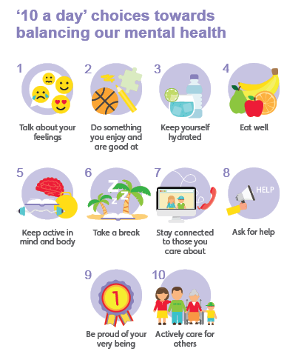  Mental Health  Have you done each of your ‘10 a day’?  Do something which makes you feel good :)

Well done for learning at home this week!

Please email into school anything you are proud of!

Miss Watts :)

