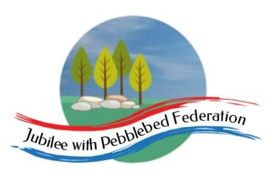

Class 2 Home Learning for the week beginning 30th November
Each Day | Spelling  15 mins | Grammar  15 mins | Reading  30 mins | Literacy 1 hour  Science 1 hour on Fridays |  | Maths (45 mins) when finished (15 mins)  Please follow the white rose maths links, complete any work on paper at home - do not buy the workbooks.  If your child is off for longer than 14 days - we can arrange for their power maths practise books to be collected.  PE (1 hour on Fridays) |  |  | Afternoon Project (1 hour)
Monday | Literacy Links:  Children normally with Miss Watts and Stella  https://classroom.thenational.academy/lessons/to-make-predictions-ccwk0r  Children normally with Miss Watts and Miss Richards  https://classroom.thenational.academy/lessons/to-generate-vocabulary-for-character-description-71h66d |  |  |  |  | Maths links for the week:  Children that do maths in the piano room  https://whiterosemaths.com/homelearning/year-2/week-11-measurement-money/  Year 3  https://whiterosemaths.com/homelearning/year-3/week-10-number-multiplication-division/  Year 4  https://whiterosemaths.com/homelearning/year-4/week-11-number-multiplication-division/  Year 5  X2 prime number lessonshttps://whiterosemaths.com/homelearning/year-5/week-8-number-multiplication-division/  and square and cube numbers lessons https://whiterosemaths.com/homelearning/year-5/week-9-number-multiplication-division/  Year 6  https://whiterosemaths.com/homelearning/year-6/week-7-number-addition-subtraction-multiplication-division/ |  |  | RE  Watch this: https://www.truetube.co.uk/film/christian-marriage  What symbols of marriage do you know about/can spot in the video?
Tuesday | Literacy Links:  Children normally with Miss Watts and Stella  https://classroom.thenational.academy/lessons/to-box-up-for-a-purpose-6gukcc  Children normally with Miss Watts and Miss Richards  https://classroom.thenational.academy/lessons/to-develop-a-rich-understanding-of-words-associated-with-large-objects-6ru68d |  |  |  |  |  |  |  | Topic  DT- Cooking!  https://thegreatbritishbakeoff.co.uk/recipes/all/kate-roman-spelt-bread/  Follow the recipe above to make Roman spelt bread! GROWN UP SUPERVISION REQUIRED!
Wednesday | Literacy Links:  Children normally with Miss Watts and Stella  https://classroom.thenational.academy/lessons/to-explore-how-a-writer-builds-drama-6nj6cr  Children normally with Miss Watts and Miss Richards  https://classroom.thenational.academy/lessons/to-analyse-and-interpret-a-setting-description-from-an-extract-c9k3jr |  |  |  |  |  |  |  | Topic  END OF TOPIC  -What have you learnt about the Romans this term?  Think back over our topic learning and write a paragraph to explain what you know now about the Romans.
Thursday | Literacy Links:  Children normally with Miss Watts and Stella  https://classroom.thenational.academy/lessons/to-write-a-story-with-a-dramatic-middle-part-1-74w68e  Children normally with Miss Watts and Miss Richards  https://classroom.thenational.academy/lessons/to-plan-the-opening-6rrk0e |  |  |  |  |  |  |  | PSHE  https://classroom.thenational.academy/lessons/king-of-the-road-6mu36t  French  https://www.youtube.com/watch?v=xRsr6wOIhgg
Friday | SCIENCE LINK:  https://classroom.thenational.academy/lessons/how-is-paper-made-68t38r |  |  |  |  | PE  Here is a link to some videos a PE company (that Mr R comes from) has made for you.  https://www.youtube.com/channel/UCLNV8D56t6RV0wbsPnbnYeA  https://app.gonoodle.com/ Have a go at some fun dance/workout videos.  If you can: go outside and get some fresh air in the garden! What can you see, hear or smell? |  |  | 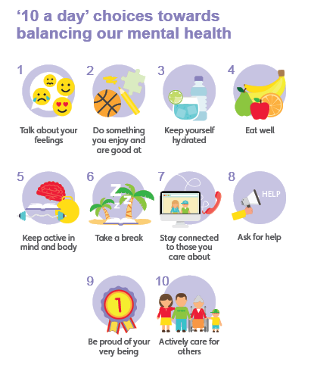  Mental Health  Have you done each of your ‘10 a day’?  Do something which makes you feel good :)

Well done for learning at home this week!

Please email into school anything you are proud of!

Miss Watts :)

