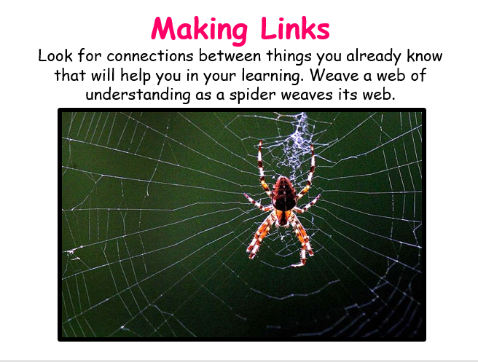
Class 2 Timetable 1.3.21 Learning animal of the week Mental Health 10 a day of the week

 | 9.10am  LIVE | 9:40-10.45  Maths lesson  then TT Rockstars | Break! | 11-12.15 Literacy  then Spelling Shed | Lunch  12:15-1:15 | 1:15-1:45  30 mins  Guided Reading | 1.45-2.10  SPAG | 2.10-3.10  Afternoon lesson | 3.10pm  LIVE
Mon | Daily Dashboard and Collective Worship | Piano Room Children  To draw 2d shapes.  https://whiterosemaths.com/homelearning/year-2/spring-week-7-geometry-properties-of-shapes/  White rose activity in maths books.  Year 3  Elicitation/Measure length.  Yellow sheets in books then 3C pg 116.  Year 4  Elicitation/To recognise tenths and hundredths.  https://classroom.thenational.academy/lessons/tenths-and-hundredths-6nj68c  Yellow sheets in books then 4B pg 164  Year 5/6  To multiply mixed numbers.  https://whiterosemaths.com/homelearning/year-6/week-11-number-fractions/  5B pg 152 | 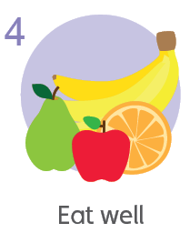  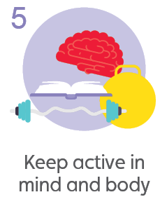  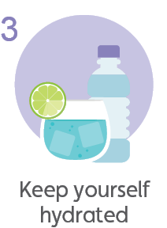  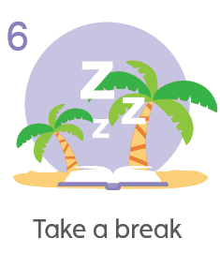 | 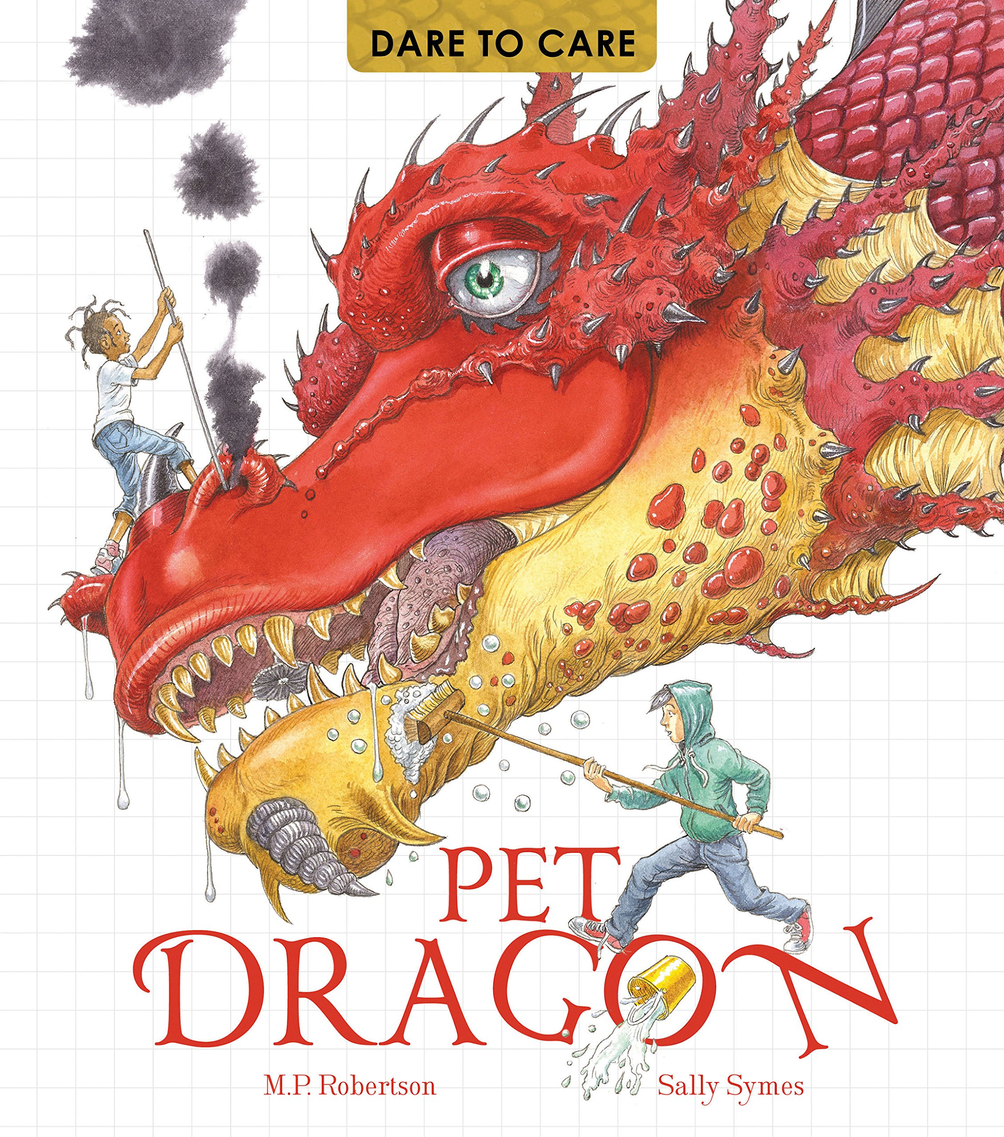  L.O. To box up the text and begin to think about writing about another animal.  Today we will look at how the dragon text is structured on each page and how we can plan a page about our creature. |  | Bug Club reading with  Quiz | Bug Club Grammar | RE  L.O. To understand the rituals of Christian baptism and confirmation.  https://www.bbc.co.uk/programmes/p02mwy4d | End of day story
Tues | Daily Dashboard and Collective Worship | Piano Room Children  To understand lines of symmetry.  https://whiterosemaths.com/homelearning/year-2/ Week 8  2B pg 120  Year 3  To understand equivalent lengths (m and cm).  3C pg 124  Year 4  To recognise tenths and hundredths.  https://classroom.thenational.academy/lessons/tenths-and-hundredths-6nj68c  4B pg 168  Year 5/6  To calculate fractions of a quantity.  https://whiterosemaths.com/homelearning/year-6/week-12-number-fractions/  5B pg 160 |  | L.O. To draft the first page of creature information.  Today, you will write the first draft of your page of information about your creature. |  | Bug Club reading with  Quiz | Bug Club Grammar | Topic - History  L.O. To understand Alfred and Great and Viking King Guthrum’s agreement.  Today we will find out about the agreement between Alfred the Great and the Viking King Guthrum. In AD 878, the Anglo-Saxon king, Alfred the Great, made peace with the Vikings, who settled in Danelaw in the east of England. Over time, the Anglo-Saxons defeated the remaining Viking rulers and the Vikings in England agreed to be ruled by an Anglo-Saxon king.  https://www.bbc.co.uk/bitesize/topics/zxsbcdm/articles/z9tdq6f | End of day story
Wed | Daily Dashboard and Collective Worship | Piano Room Children  To draw lines of symmetry.  https://whiterosemaths.com/homelearning/year-2/ Week 8  White rose activity in maths books.  Year 3  To understand equivalent lengths (mm and cm).  3C pg 128  Year 4  To recognise tenths as decimals.  https://classroom.thenational.academy/lessons/fractions-and-decimals-70tp4c  4B pg 172  Year 5/6  To calculate fractions of an amount.  https://whiterosemaths.com/homelearning/year-6/week-12-number-fractions/  White rose questions in books |  | L.O. To draft the first page of creature information.  Today, you will look at yesterday’s work and see if you can improve it in any way. Have each of your sentences got a FANBOYS, WABUB or fronted adverbial? Can you add adjectives to improve description? |  | 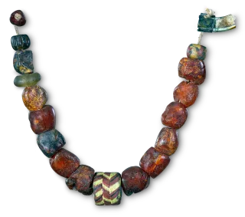  Bug Club reading with  Quiz | Bug Club Grammar | Topic - Geography  L.O. To write a report on the Battle of Pinhoe.  The Battle of Pinhoe was a battle between the Danes and the people of Pinhoe, Devon. In 1001 Vikings laid a siege to Exeter. But due to the strong defence led by Athelstan, they started pillaging nearby villages. Men from Devon and Somerset fought the Danes to stop their invasion.  But were they successful? | End of day story
Thur | Daily Dashboard and Collective Worship | Piano Room Children  To sort 2d shapes.  https://whiterosemaths.com/homelearning/year-2/ Week 8  2B pg 124  Year 3  To compare lengths.  3C pg 132  Year 4  To recognise tenths on a place value grid.  https://classroom.thenational.academy/lessons/fractions-and-decimals-70tp4c  White rose questions in books.  Year 5/6  To use unit fractions as operators.  https://whiterosemaths.com/homelearning/year-6/week-12-number-fractions/ Four rules with fractions video  5B pg 164 |  | Thursday’s lesson - world book day ‘Words and pictures - bringing books to life’ 10.30am LIVE  https://www.worldbookday.com/event/words-pictures-bring-reading-to-life/ |  | At school, PE at the moment is socially distanced fitness activities.  Premier sports have made some videos for you to follow at home for PE.  https://www.youtube.com/channel/UCLNV8D56t6RV0wbsPnbnYeA  Please do any of the fitness videos on their channel.  You could also go out in the garden and get some fresh air or go for a walk with a grownup.  There are also some great videos to do on https://www.bbc.co.uk/teach/supermovers |  |  | Read your own book today :)
Fri | Daily Dashboard and Collective Worship | Science  L.O. To classify plants.  https://www.bbc.co.uk/teach/class-clips-video/science-ks1-ks2-ivys-plant-workshop-classifying-and-grouping-plants/zh9jvk7  This lesson, we will explore different types of plants and begin to group them, just like we did with animals.  Go outside in your garden or local area to see which types of plants you can discover!  Plants can be grouped in 6 ways: Herbaceous, Woody, Trees, Grasses, Moss and Fungi. |  | French - 30 mins  L.O. To understand French regular verbs.  https://www.bbc.co.uk/bitesize/topics/z6d98xs/articles/zy9dg7h  Spelling Shed  15 mins  TTRockstars  15 mins |  | Bug Club reading with  Quiz | Bug Club Grammar | PSHE - 30 mins  L.O. To understand anger and learn how to manage it.  https://www.bbc.co.uk/bitesize/clips/zd2w2hv  Mental Health  30 mins  Take this time to go onto the mental health section of google classroom.  Think about doing something towards your 10 a day. | LIVE  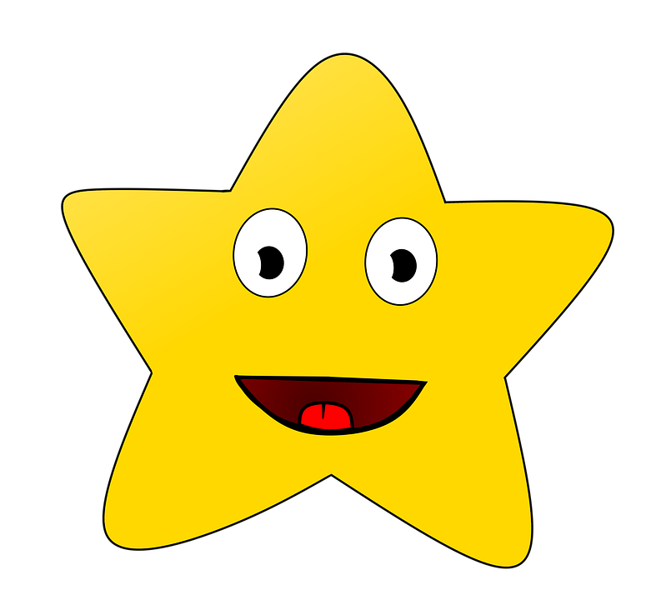  SHARING ASSEMBLY

