**December Newsletter**

Dear Parents,

**Class 1**

Well, I can’t quite believe that we are already in December but we are all really looking forward to a busy few weeks in the lead up to Christmas. The children in Class 1 are busy preparing for their Christmas Nativity service and we are all looking forward to welcoming you to share this on Tuesday 12th December.

In November the Class 1 children marked Remembrance Day by visiting the war memorial for a 2 minutes silence. We then supported Children in Need at the end of November, by eating cake!

Children in Class 1 have work hard this month to learn about Rosa Parks and how she is a significant person in history. They have then applied their learning from this to write a fact file about Michael Rosen.

In Class 1 we have continued with our ‘Movers and Shakers' and Let's Explore’ topics this term and have been focusing on world climates and exploring the similarities between England and Somalia.

In History the children have been learning about Rosa Parks and Emeline Pankhurst and are all very excited about our history day on December 14th and hope that lots of their families and friends will be able to join us to celebrate their learning this term

In Science this term the children have been thinking about what a habitat is. They are investigating different habitats, thinking about how a habitat provides everything a plant or animal needs and also thinking about how animals and plants adapt to a particular habitat.

In Music the children have been thinking how music can tell us stories about the past. They have also been spending time learning all of our songs for our Christmas play.

**Class 2**

The children in Class 2 are now well into the swing of things and are starting to show some great progress in their learning. The children have all produced some excellent work, can explain some of the big concepts we have been learning about in more detail, and are reading more and more confidently.

Please do continue to encourage your child to keep reading every day where possible and to keep filling in a little summary of what they have read in their reading record. Everyone should have a banded book at a suitable level of challenge to match their fluency and comprehension skills, but it also important to read other books (or magazines or websites or fact books or comics etc.) just for fun. To continue to support with the development of reading, we have started some additional reading fluency groups alongside a cosy reading time to keep encouraging the children to enjoying reading for pleasure and sharing what they have read confidently with others.

In Maths, the children have continued their focus on calculation methods before Years 5 and 6 move on to look at fractions. The children in Year 4 have been developing their confidence with column method for addition and subtraction as well as working on calculating and using times table facts. As ever, if you are able to practise times table facts everyday (even just for one or two minutes), it has a huge impact on children’s confidence and accuracy in the calculation work. The Year 5 and 6 children have been working on their multiplication and division. These methods can be tricky to master, particularly if times table facts are not confident, so we have spent extra time on these important skills to try and ensure all the children are as confident as possible. If you are able to support your child with any difficulties they still have with their written methods for multiplication and division, it can have a huge impact on their ability to achieve in their Maths work.

In the afternoons, Class 2 children have continued their work on our Sow, Grow and Farm topic. The children have been exploring where our food comes from, how different foods grow well in different climate zones and how the food travels to the UK. The children have also been looking at how humans develop from birth to old age (which Year 5 and 6 look at in more detail as part of their PSHE learning later in the year) and compared the human and mammal life cycle to other life cycles, explaining some of the key differences.

Class 2 have just finished their first Art project, with the children creating some interesting digital art and sketches using light and shade, before we begin looking at examples of land art. The children have also practised their cookery skills and planned recipes ready to try making some healthy, seasonal meals.

Thank you all for your continued support.

God bless and have a lovely weekend.

*Best wishes from Katie Gray and the staff at Broadhembury CE School*

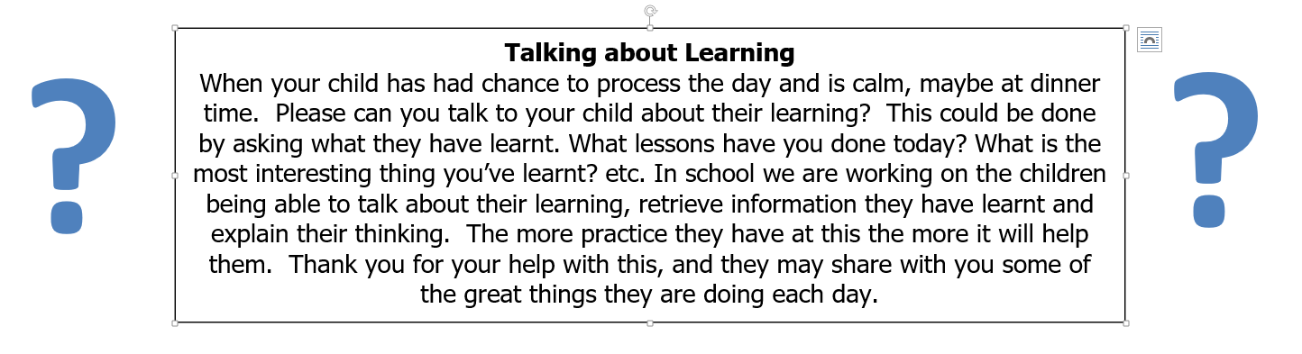

|  |
| --- |
| **Question of the month**  **Class 1:**  Which character from the Christian Nativity story do you think is the most important and why?  **Class 2**: If you could improve at any skill, what would it be? |

**BROADHEMBURY BRIDGES**

**Class 1:**

3/11/23 – Paisley for good learning

10/11/23 – George for fantastic learning this week

17/11/23 – Monty for amazing learning in class

24/11/23 – Dora for good learning this week

**Class 2:**

3/11/23 – Indie for fantastic effort with all your work and loads of amazing reading.

10/11/23 – Marley for excellent behaviour and manners and settling in so well.

17/11/23 – Max for fantastic effort with all your learning. You are really trying to challenge yourself.

24/11/23 – Joshua for quietly getting on with your excellent work and trying hard day after day.

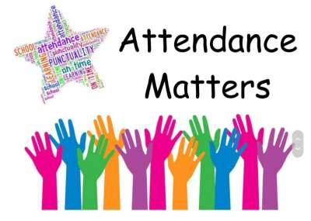

**October Attendance**

Class 1 – 97%

Class – 94%

Whole School – 96%

Being in school is important to your child’s achievement, wellbeing, and wider development.

**Key Dates – Autumn Term 2023**

7th December - Christingle Service 10am in the Church

8th December - Christmas Dinner

11th December - Brass Band Concert 11am in the Church

12th December - Christmas Play 5.30pm in the Church

14th December - KS1 History Debate

15th December - Carol Singing 2.30pm in the Square

15th December – Last day of term

**The Secret Book Quest**

The Secret Book Quest is an exciting new reading challenge for children ages 5 and up. Read a total of 50 books to collect all the stickers, decipher the code, and win a special prize. Join Pip, Zena and Libro the cat on a unique reading adventure through 10 themed worlds, beautifully illustrated by Emily Fox. Get a certificate when you reach halfway (25 books) and another when you finish (50 books), along with a finishers prize. To sign up for **FREE**, simply visit your local library and speak to a member of staff. You will receive your very own Secret Book Quest journal and first sticker in your collection. Then browse the library to find your first book, and begin the quest!

Find your local library and/or search our catalogue at devonlibraries.org.uk or visit [www.librariesunliited.org.uk/secret-book-quest](http://www.librariesunliited.org.uk/secret-book-quest)

**Book Recommendations December**

With our continuing focus on reading culture in school, we would like to start recommending books to our families. With a view to trying to widen pupils' interest in different genres and authors, supporting parents to know new authors and as ideas for gifts. If your child reads one of these books, it would be great if they could make a comment on the book and we can share it on Facebook.

|  |  |  |  |  |  |
| --- | --- | --- | --- | --- | --- |
| **EYFS** | Avocado Asks by Momoko Abe | Avocado Asks: What Am I? by Abe, Momoko | **Lower KS2** | Llama Out Loud! by Annabelle Sami and Allen Fatimaharan | Llama Out Loud! (Llama Out Loud) |
| **KS1** | The Rascally Cake by Jeanne Willis and Korky Paul | The Rascally Cake by Willis, Jeanne | **Upper KS2** | Voyage of the Sparrowhawk by Natasha Farrant | Voyage of the Sparrowhawk by Natasha Farrant | Waterstones |

**Online Safety**

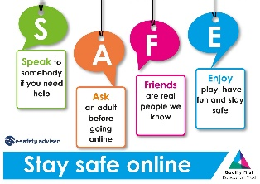Together we can make sure it’s safe for every child to go online. We’re here to support parents with online safety advice, and we’re here for children to feel safe online. Please visit the following links for help and advice

<https://www.nspcc.org.uk/keeping-children-safe/online-safety/>

<https://saferinternet.org.uk/guide-and-resource/parents-and-carers>

**Collective Worship Activity**

This term we will be focussing in school on the value of Peace. We hope your family will find these ideas helpful as you explore the value and have fun together. If the children bring back something that you have done at home linked to the Collective Worship activity or can talk about a discussion they’ve had at home linked to it, then Mrs Gray will award them with a new, special sticker.

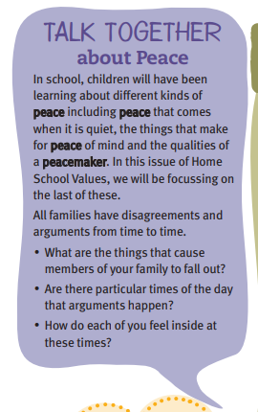 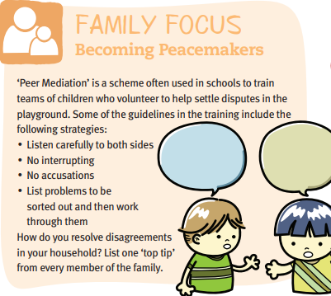

|  |
| --- |
| **Wellbeing**  *There has been much press in recent months about children’s mental health. As part of our drive to support this we are going to include something each month in the newsletter about Health and Wellbeing. We hope you find this section useful. If you have any topics you would like us to find some helpful tips about, please let us know.* |

**Important Notices**

**School Photos**

Have you ordered your school photos yet? A polite reminder that the closing date for free delivery back to school is Sunday 3rd December. Order through the Tempest website using your unique link or visit [www.tempest-orders.co.uk](http://www.tempest-orders.co.uk/). If you need any assistance in ordering your photos, feel free to contact Tempest on 01736 751555 (option 3)

**Sharing Assembly - please note change of time**

We are changing our sharing assembly to Celebration Assembly this term. We will be changing the time to a Friday morning at 9.10am. There will be a letter home this week with more details.

**Healthy Snacks**

Class 1 have a healthy snack each morning with fruit provided. As we never know what fruit we will be given if your child doesn’t like a particular fruit, they are welcome to bring in a healthy fruit or vegetable snack from home.

**Cold Weather**

Now the weather seems to be getting a little colder please make sure your child brings a warm/waterproof coat to school each day. We do go outside to play every day unless it is absolutely pouring with rain so coats are vital. I’ve already started to see some lovely woolly hats and gloves appearing, keeping the children warm and cosy during playtime.

**School Uniform**

Please can you ensure that your child has all their uniform named. It really helps at the end of the day to ensure that the correct jumper is returned to the correct child. Also, as the weather gets colder, please can you ensure that your child has a warm coat and that any hats, gloves etc. are named. Thank you for your help.

**School Bus**

We have had a request from the bus company that brings the children to school from Dunkeswell, please can parents not park in the bus stop to enable the bus to be able to park and the children to get off the bus safely. Thank you for your co-operation. If you have any queries about the bus please contact Sarah Bishop at Devon School Transport. [*Sarah.bishop@devon.gov.uk*](mailto:Sarah.bishop@devon.gov.uk). Please could you also contact her if you allow your child to walk from the bus stop home on their own so she can notify the bus company. Thank you.

**Free School Meals**

If your circumstances have recently changed your child may have become eligible for free school meals. This will also bring extra funding to the school, which will be used to help your child. For an instant decision or to learn more please go online at

[*https://www.devon.gov.uk/educationandfamilies/school-information/school-meals*](https://www.devon.gov.uk/educationandfamilies/school-information/school-meals).

**Advice on Covid-19**

As you may be aware, there are some concerns regarding the recent spread of Covid-19. Please see below updated guidance on what to do if you suspect a case of Covid-19 or test positive.

* For diarrhoea and vomiting, people need to be 48 hours free of symptoms to return to the setting (pupils and staff)
* Children with **mild symptoms** such as a runny nose, sore throat, or mild cough, who are otherwise well, **can continue to attend their education or childcare setting.**
* Anyone who is **unwell,** including people with a high temperature, should **stay at home** and avoid contact with others until they have recovered. They can return to the setting once they no longer have a temperature (without medication) and are well enough to do so. (pupils and staff)
* **Children** and young people under 18 years old who have a positive test for **Covid-19** should stay away from the setting for **3 days** after they took their test (and until they are well enough to return, including no temperature).

[**Gifts & Garlands**](https://www.thelmahulbert.com/?q=whats-on/events/gifts-garlands-family-event) **Thursday 7 December, 3 - 6pm.**

Family crafts session

Create a mini wreath to take home.

Enjoy mince pies, cookies and apple juice.

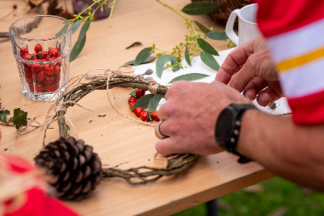

10% discount on gifts and decorations in the exhibition and shop.

Free drop in, donations welcome.

Thelma Hulbert Gallery, Dowell St, Honiton EX14 1LX, [thelmahulbert.com](https://www.thelmahulbert.com/)

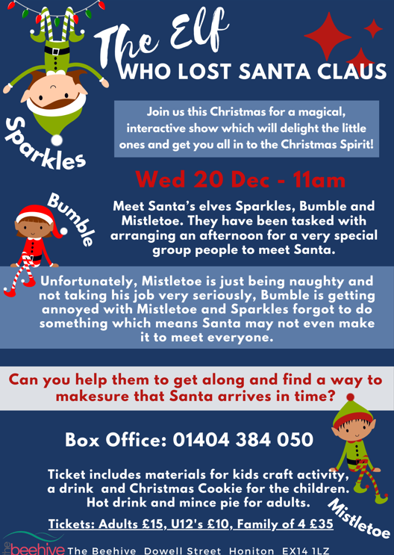 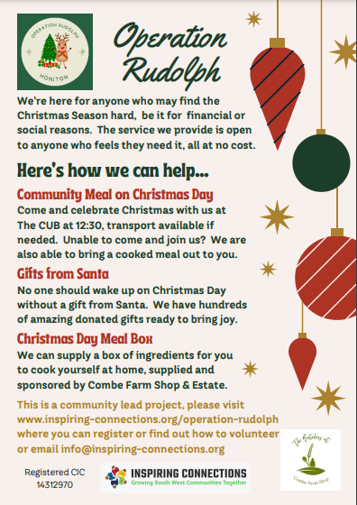

*From all the staff at Broadhembury C of E Primary School*

*We wish you all a very Merry Christmas and a Happy New Year!*

