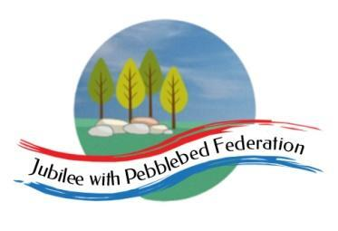

Class 2 Home Learning
For activities in purple, please visit google classroom where you will find specific work related to each subject to complete and ‘turn in’.
Timings | 15 mins | 30 mins | 15 mins | 15 mins | 1 Hour | 1 Hour | 1 Hour
Monday | https://www.edshed.com/en-gb/login | Reading  https://www.activelearnprimary.co.uk/login?c=0 | https://ttrockstars.com/ | https://www.activelearnprimary.co.uk/login?c=0 | Maths  Follow the link for your year group for videos in the most current week. Then complete the worksheet provided on google classroom.  Children that do maths in the piano room  https://whiterosemaths.com/homelearning/year-2/  Year 3  https://whiterosemaths.com/homelearning/year-3/  Year 4  https://whiterosemaths.com/homelearning/year-4/  Year 5/6  https://whiterosemaths.com/homelearning/year-5/ | Literacy  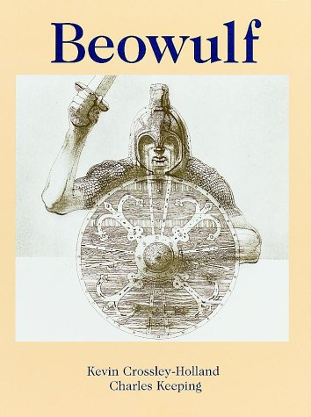  Today we are thinking about the characters of Unferth and Beowulf. | RE  L.O. To describe what happens in sacred thread Hindu ceremonies.  https://iskconeducationalservices.org/HoH/practice/rites-of-passage/initiation-the-sacred-thread-ceremony/
Tuesday | https://www.edshed.com/en-gb/login | https://www.activelearnprimary.co.uk/login?c=0 | https://ttrockstars.com | https://www.activelearnprimary.co.uk/login?c=0 | Maths  Follow the link for your year group for videos in the most current week. Then complete the worksheet provided on google classroom.  Children that do maths in the piano room  https://whiterosemaths.com/homelearning/year-2/  Year 3  https://whiterosemaths.com/homelearning/year-3/  Year 4  https://whiterosemaths.com/homelearning/year-4/  Year 5/6  https://whiterosemaths.com/homelearning/year-5/ | Literacy  Today we are looking at paragraphs and why we choose to start a new one. | Topic  L.O To investigate Viking houses were constructed.  https://www.bbc.co.uk/bitesize/clips/zrthfg8  Annotate pictures to describe materials used and the techniques used to strengthen and support.  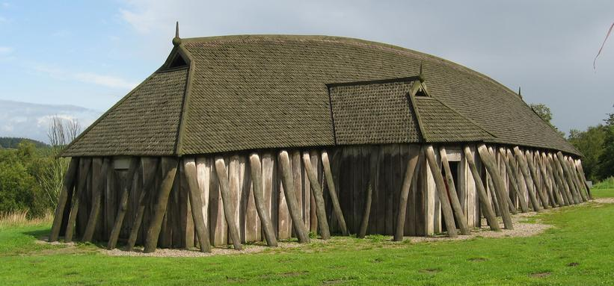
Wednesday | https://www.edshed.com/en-gb/login | https://www.activelearnprimary.co.uk/login?c=0 | https://ttrockstars.com | https://www.activelearnprimary.co.uk/login?c=0 | Maths  Follow the link for your year group for videos in the most current week. Then complete the worksheet provided on google classroom.  Children that do maths in the piano room  https://whiterosemaths.com/homelearning/year-2/  Year 3  https://whiterosemaths.com/homelearning/year-3/  Year 4  https://whiterosemaths.com/homelearning/year-4/  Year 5/6  https://whiterosemaths.com/homelearning/year-5/ | Literacy  Today we will look at sentence structure and some of us will explore semicolons. | Topic  L.O To experiment with techniques to join sticks, paper straw and card to design and create a prototype of your Viking longhouse.  https://www.imagininghistory.co.uk/post/viking-longhouses  http://www.primaryhomeworkhelp.co.uk/viking/houses.html
Thursday | https://www.edshed.com/en-gb/login | https://www.activelearnprimary.co.uk/login?c=0 | https://ttrockstars.com | https://www.activelearnprimary.co.uk/login?c=0 | Maths  Follow the link for your year group for videos in the most current week. Then complete the worksheet provided on google classroom.  Children that do maths in the piano room  https://whiterosemaths.com/homelearning/year-2/  Year 3  https://whiterosemaths.com/homelearning/year-3/  Year 4  https://whiterosemaths.com/homelearning/year-4/  Year 5/6  https://whiterosemaths.com/homelearning/year-5/ | Literacy  Today we will look at the description using noun phrases. | PE  Premier sports have made some videos for you to follow at home for PE.  https://www.youtube.com/channel/UCLNV8D56t6RV0wbsPnbnYeA  Please do any of the ball skills on their channel.  You could also go out in the garden and get some fresh air or go for a walk with a grownup.  There are also some great videos to do on https://www.bbc.co.uk/teach/supermovers
Friday | https://www.edshed.com/en-gb/login | https://www.activelearnprimary.co.uk/login?c=0 | https://ttrockstars.com |  | Science  L.O. To understand how plants reproduce.  https://www.bbc.co.uk/bitesize/topics/zgssgk7/articles/zyv3jty | French 30 mins  L.O. To talk about your hobbies in French.  https://www.bbc.co.uk/bitesize/topics/z6d98xs/articles/zy9dg7h  PSHE 30 mins  L.O. To understand how best to manage difficult feelings. | Mental Health  For this hour, choose something which meets one of your 10 a day for mental health. You could also visit our mental health section on the school website.  