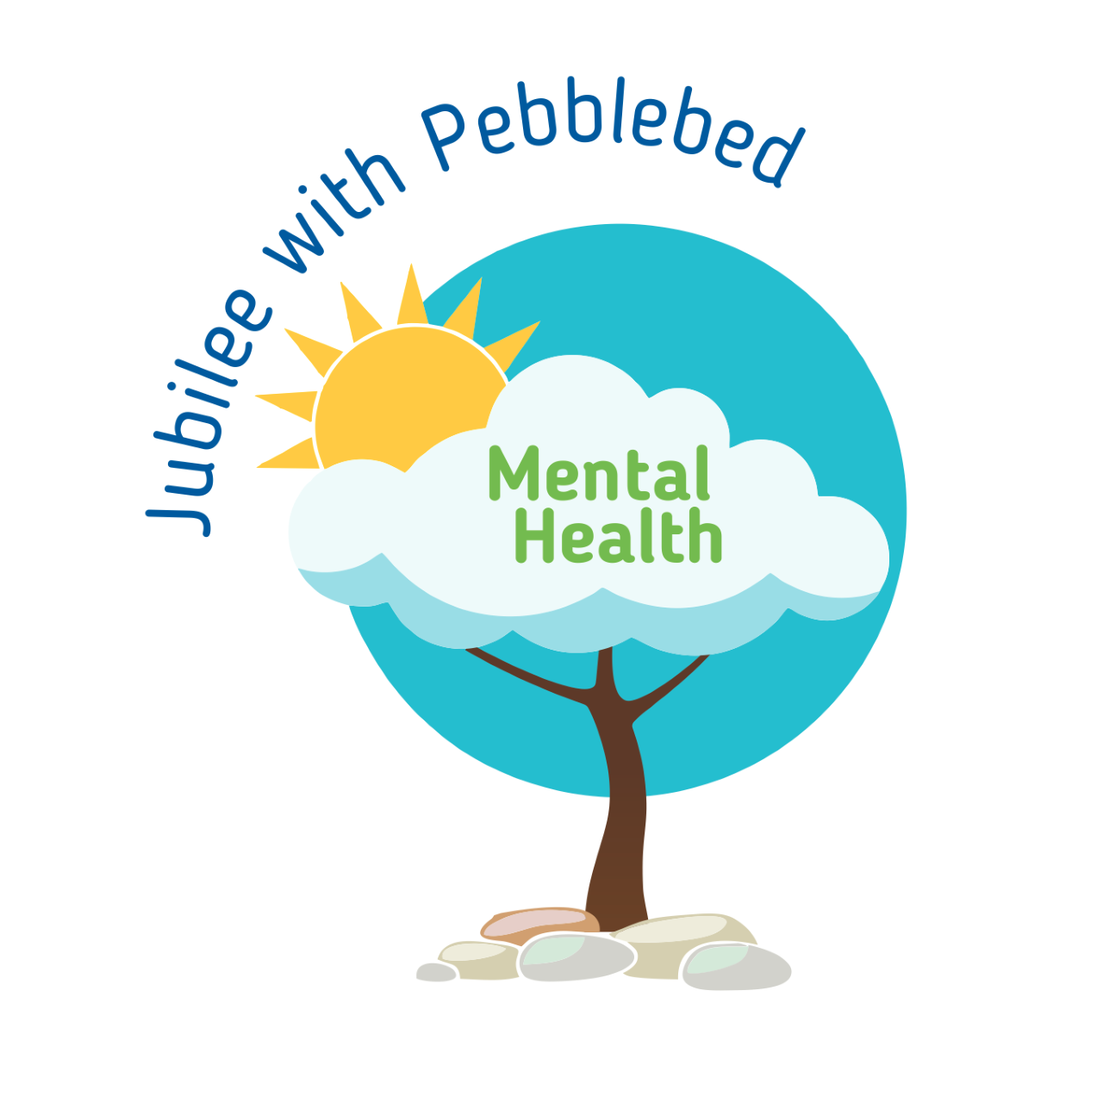
’10 a day’ for Positive Mental Health 6
While we are working from home it is important that you continue to support your mental health. One way of doing this is to continue to use the ’10 a day’.
Below are some activities to try at home this week. Each one is linked to one of our ’10 a day’. Each week some new activities are put on so you can look at numbers 1-5 for more ideas.
10 a day | Activity
The following link gives information about how to deal with emotions directly linked with the Coronavirus from Exeter Diocese.
https://exeter.anglican.org/wp-content/uploads/2020/03/Covid-19-Primary-School-Parent-Pack.pdf

https://www.childline.org.uk/toolbox/
Use these games to think and talk about how you are feeling.
Make your own feeling barometer to show how you are feeling.
‘Big Feelings Come and Go’, a story to help young children deal with their big feelings.
https://protectchildren.ca/pdfs/C3P_BigFeelingsComeAndGo_storybook_en.pdf
A nurse was worried about the effect that Coronavirus was having on children and how we can explain it to them in a ‘child friendly’ way. She has written a free to download story book called ‘Dave the dog is worried about Coronavirus’.
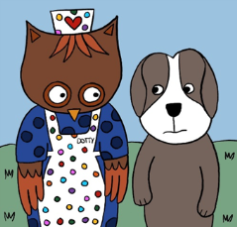
https://nursedottybooks.com/dave-the-dog-is-worried-about-coronavirus-2/
What are you really good at? Ask somebody to record a video of you doing it or take a photo. Share it with relatives or friends. Be proud!
Teach someone in your family to do something you are good at, e.g. drawing, playing an instrument, juggling, maths.

Enjoy colouring together with these relaxing patterns.
https://familyresource.eci.org.uk/download/Colouring-Book-for-Boys-Girls.pdf
Take the quiz to find out why it is important to stay hydrated.
https://www.n4hk.com.au/game/jimmysthirsty/

Infuse your water with flavour by adding fruits like berries, cucumber, lemon or lime. You could also freeze ice cube trays with berries and add this to your water to keep it extra cold.
Help prepare lunch or dinner for the family.
Maybe try some of the recipes from this websites.
https://www.nhs.uk/change4life/recipes

Challenge yourself to eat a rainbow. Think about the food you are eating, can you eat all the colours of the rainbow in one day?

Exeter diocese has set up a Family Fun Cooking Club. Look at their recipes on the following link.
https://exeter.anglican.org/resources/faith-action/family-fun-cooking-club/

Can you make a fruit kebab?
Ask a grown up to chop up lots of different fruit and put it on a kebab stick. Which fruit will you choose? How many colours are in your kebab? Can you make a pattern with the fruit?
The Plank Challenge
This is a tricky challenge. It is quite long and the timing is tricky. You have to do the plank and then the Cha Cha Slide. “slide to the left, slide to the right” etc.
https://youtu.be/bA4fFzhbHJw

Can you design an obstacle course in the garden?
You might use boxes, toys, a blanket, sticks, anything you can find to jump over/around/under. Can you see how many circuits you do? Can you challenge other members of your family.
Try some 60 second challenges
https://www.youthsporttrust.org/60-second-physical-activity-challenges

Try some Zumba
https://www.youtube.com/watch?v=doSmJ9AOA1E

Lots of indoor activities and games to get you moving.
https://www.nhs.uk/change4life/activities/indoor-activities

If you would like some help relaxing try this mindfulness meditation website.
https://www.cosmickids.com/mindfulness-meditation-videos-kids/

Practise this ‘Lazy 8’ breathing technique by drawing an 8 lying on its side.
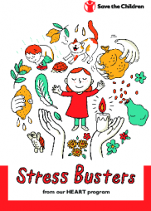
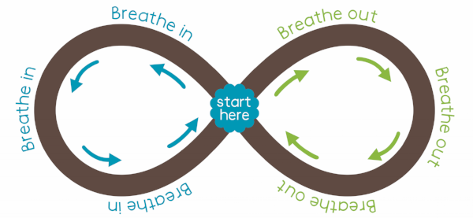
Start in the middle and go to the left breathing in, trace it around as you breathe in then go around the right breathing out. Repeat as many times as you can making sure you breathe fully in and out.
There are some lovely breathing techniques in this Save the Children booklet.
https://resourcecentre.savethechildren.net/library/stress-busters

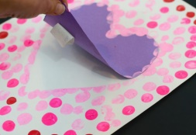
Cut out a heart and loosely attach it to some paper, then fingerprint all over the paper, peeling off the heart afterwards. Can you write a message in the heart to somebody you love and care about? What do you love about them?
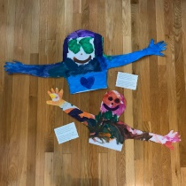
Ask a relative to teach you something, read you a story or help with you school work over a video call.
Send a relative or friend a HUG in the post. Lie down and ask a grownup to draw around your head/arms/shoulders on a large sheet of paper. Paint/draw/colour it and then cut it out. Send your hug in the post for a relative or friend.
If you are stuck on your home learning or with you feelings ask someone for help. If you can’t put it into words write it down or draw pictures.
- Remember, it's okay to ask for help. Don't be embarrassed, and don't worry about other people judging you.
- Decide what the problem is and what help you need.
- Think about who you can ask for help. Choose someone you trust and who will know how to help you.
- Think about what you'll say when you ask for help. Do it.
The mental health organisation ‘Heads Up’ have thought of some brilliant activities to help you cope with big feelings.
Have a look at the ‘Cope Cakes’ activity.
https://headsupmha.com/resources/
Ask a grown up to print out a photo of you or draw yourself. Can you ask everybody in your family to write words around the picture that describe you. put it up on your bedroom wall to remind yourself how special you are.
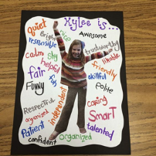
What are your star qualities? What makes you you? You can either draw around your hand and cut it out, writing your special qualities on each finger OR you could print or draw a star and write your star qualities on each point of the star.
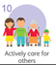 | Help in the house by doing the washing up, setting the table, tidying your room.  Keep a calendar of your acts of kindness  https://www.redcross.org.uk/-/media/documents/get-involved/teaching-resources/power-of-kindness-calendar-blank.pdf?la=en&hash=402E801F6375AAD2E662B84465004F931998A9A0  Can you make a class tree? List all of the children in your class or just your special friends. Can you write on a leaf one thing you miss about each person. Add it to a tree that you can draw yourself or download from the ‘Heads Up’ website. Look for the ‘Tree of strength’ activity.  https://headsupmha.com/resources/  Save the tree and take it into school with you when you return.

