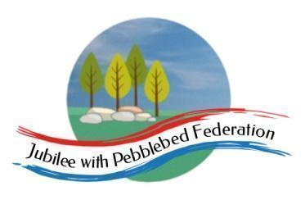

Class 1 Home Learning for the week beginning 14th December 2020
 | Phonics (30 mins) | Reading (30 mins) | Writing (30 mins) | Maths (30 mins) | Afternoon Project
Monday | Make a sandwich for you lunch and see whether you can write the instructions for it. | https://www.activelearnprimary.co.uk/login?c=0  Check your account for book allocations. | After you have watched the Christmas Story, Use the frame to make a story plan and then re-count the story. | Reception –  https://whiterosemaths.com/homelearning/early-years/activity-week/ - session 1  Year 1/2  https://whiterosemaths.com/homelearning/year-1/week-10-geometry-shape/ | RE  Watch the video of the Christmas Story  https://www.bbc.co.uk/teach/class-clips-video/religious-studies-ks1-the%20christian-story-of-the-first-christmas/z7fp382
Tuesday | 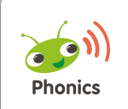  Please log into your Bug Club account where I will have allocated games for phonics.  Reception  This week, practise your phase 2 words with the activities attached.  Year 1  Or as al  Year 2  Prefix, root, suffix | https://www.activelearnprimary.co.uk/login?c=0 | https://www.bbc.co.uk/bitesize/clips/z7x76sg  Try to draw an animal camouflaged in its habitat | Reception –  https://whiterosemaths.com/homelearning/early-years/activity-week/  Year 1/2  https://whiterosemaths.com/homelearning/year-1/week-10-geometry-shape/ | Science  Watch the food chains link  https://www.bbc.co.uk/bitesize/clips/z96r82p  Now, can you use the paperchains to make your own foodchain using the words carnivore, herbivore, predator and prey.
Wednesday | Please log into your Bug Club account where I will have allocated games for phonics.  Reception  This week, practise your phase 2 words with the activities attached.  Year 1  Language Session  Year 2  Language Session | https://www.activelearnprimary.co.uk/login?c=0 | After you have watched the bbc video about Christingle, have a go at making your own paper Christingle using scissors and glue. | Reception –  https://whiterosemaths.com/homelearning/early-years/activity-week/  Year 1/2  https://whiterosemaths.com/homelearning/year-1/week-10-geometry-shape/ | Christingle  http://request.org.uk/teachers/teaching-resources/festivals-resources/christmas-festival/christingle/
Thursday | Reception  This week, practise your phase 2 words with the activities attached.  Practise Spelling Shed today  https://www.spellingshed.com/en-gb/ | https://www.activelearnprimary.co.uk/login?c=0 | Can you write a fact file about different Christmas Traditions that you enjoy? You can plan it today and then write it on the fact file sheet attached tomorrow. | Reception –  https://whiterosemaths.com/homelearning/early-years/activity-week/  Year 1/2  https://whiterosemaths.com/homelearning/year-1/week-10-geometry-shape/ | Art/DT  Can you make your own Christmas Party hat
Friday | Reception  This week, practise your phase 2 words with the activities attached.  Practise Spelling Shed today  https://www.spellingshed.com/en-gb/ | https://www.activelearnprimary.co.uk/login?c=0 |  | Reception –  https://whiterosemaths.com/homelearning/early-years/activity-week/  Year 1/2  https://whiterosemaths.com/homelearning/year-1/week-10-geometry-shape/ | Have your own Christmas Party at home today. What have you got that you could use to make a party? Maybe you could invite your cuddly toys to share your party with you. Can you make them a party hat like yours?

