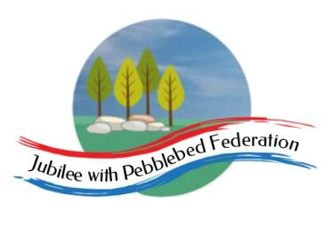

Class 2 Home Learning for the week beginning 1st January

 | 15 mins |  |  | 15 mins | 30 mins | Literacy 1 hour  Normally Science 1 hour on Fridays  This week RE on Friday |  | Maths (45 mins) when finished (15 mins)  Please follow the white rose maths links, complete any work on paper at home - do not buy the workbooks.  If your child is off for longer than 14 days - we can arrange for their power maths practise books to be collected.  PE (1 hour on Fridays) |  |  |  | Afternoon Project  (1 hour)
Monday  NON PUPIL DAY! | Spelling |  |  | Grammar | Reading | NON PUPIL DAY! |  | Maths links for the week (Just 4 days this week):  Children that do maths in the piano room  https://whiterosemaths.com/homelearning/year-2/week-1-number-multiplication-and-division/  Year 3  https://whiterosemaths.com/homelearning/year-3/week-1-number-multiplication-division/  Year 4  https://whiterosemaths.com/homelearning/year-4/week-1-number-multiplication-division/  Year 5 and Year 6  https://whiterosemaths.com/homelearning/year-6/week-5/ |  |  |  | NON PUPIL DAY!
Tuesday  Collective Worship | Spelling |  |  | Grammar | Reading | Children that do literacy in the piano room  https://classroom.thenational.academy/lessons/to-listen-to-and-respond-to-a-story-6gvpad  Everyone else  https://classroom.thenational.academy/lessons/to-engage-with-a-text-cnh62c |  |  |  |  |  | TOPIC History  To understand who the Saxons were and when they lived.  Watch the below video and any others you can find online about the Anglo-Saxons.  BBC Bitesize: Who were the Anglo-Saxons?  https://www.bbc.co.uk/bitesize/topics/zxsbcdm/articles/zq2m6sg  The Anglo-Saxons ruled Britain from 410AD to 1066AD. See if you can research 8 key events that happened during this time and record them in a timeline style.
Wednesday  Collective Worship | Spelling |  |  | Grammar | Reading | Children that do literacy in the piano room  https://classroom.thenational.academy/lessons/to-tell-a-story-from-memory-60uk2t  Everyone else  https://classroom.thenational.academy/lessons/to-answer-questions-on-a-text-part-1-6thkac |  |  |  |  |  | TOPIC Geography  To understand where the Saxons lived.  Before the Roman’s left Brittania they built Saxon shore forts to repel and defend the seaborne Saxon raiders.  Look at this picture of the main Saxon shore forts. https://www.google.com/search?q=saxon+shore+forts+ks2&rlz=1C1CHBF_en-GBGB914GB917&source=lnms&tbm=isch&sa=X&ved=2ahUKEwjmuaGppP3tAhXeQUEAHXrEBtQQ_AUoAXoECAYQAw&biw=1366&bih=624&safe=active&ssui=on#imgrc=cdoqNDTH4FuOcM  Then, using an atlas at home or google maps - find the modern locations of these forts and label any nearby towns, rivers or other geographical features.
Thursday  Collective Worship | Spelling |  |  | Grammar | Reading | Children that do literacy in the piano room  https://classroom.thenational.academy/lessons/to-explore-the-main-moods-in-the-story-61k3ac  Everyone else  https://classroom.thenational.academy/lessons/to-answer-questions-on-a-text-part-2-74u3jd |  |  |  |  |  | PSHE  https://drive.google.com/file/d/1sejL9_6q_eTUOdDml1EvklbvTQCyw5K-/view
Friday  Collective Worship | Spelling |  |  |  | French  https://www.bbc.co.uk/bitesize/topics/zjcbrj6/articles/zcqsxbk | RE - How does following God bring freedom and justice?  Watch this video which tells us of the main events in the story of Moses.  https://www.bbc.co.uk/teach/class-clips-video/religious-studies-ks1-the-jewish-story-of-moses/zmfp382 think about the rights and wrongs of the moral choices that the characters make in the story.  Then watch the story of the ten plagues of Egypt (https://www.bbc.co.uk/bitesize/clips/zbsb9j6)  How does this story show that following God brings freedom and justice? |  | PE  Here is a link to some videos a PE company (that Mr R comes from) has made for you.  https://www.youtube.com/channel/UCLNV8D56t6RV0wbsPnbnYeA  https://app.gonoodle.com/ Have a go at some fun dance/workout videos.  If you can: go outside and get some fresh air in the garden! What can you see, hear or smell? |  |  |  | Mental Health  Have you done each of your ‘10 a day’?  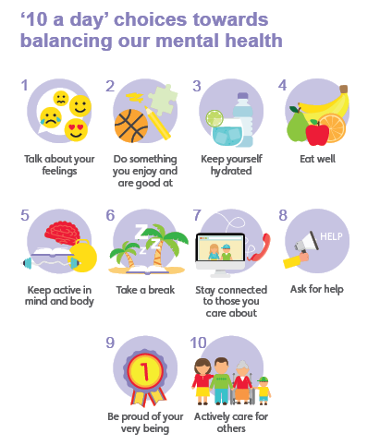  Do something which makes you feel good :)

Well done for learning at home this week!

