The Lighthouse Keepers Lunch by Rhonda and David Armitage – My Storyboard
On Monday | On Tuesday | On Wednesday
On Thursday | On Friday | On Saturday

The Lighthouse Keepers Lunch by Rhonda and David Armitage – My Storyboard
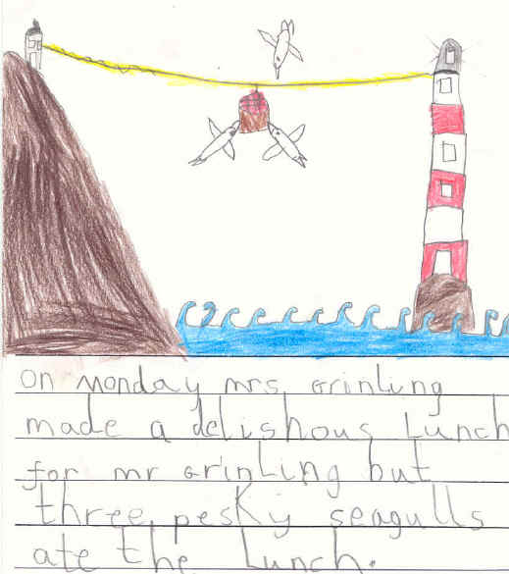 | 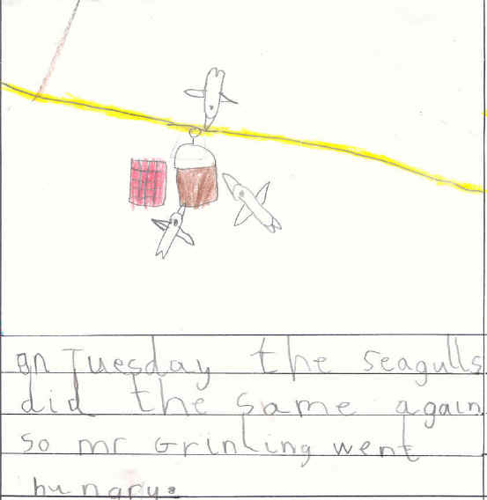  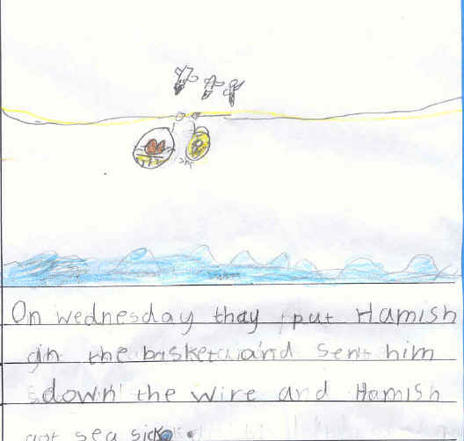
On Monday Mrs Grinling made a delicious lunch for Mr Grinling but three pesky seagulls ate the lunch. | On Tuesday the seagulls ate the lunch again Mr Grinling went hungry. | On Wednesday the Grinlings put Hamish the cat in the basket but he felt sea sick.
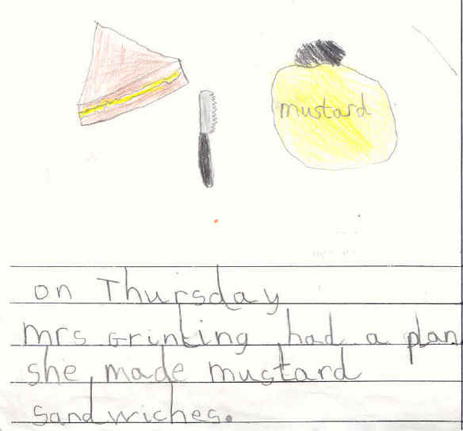 | 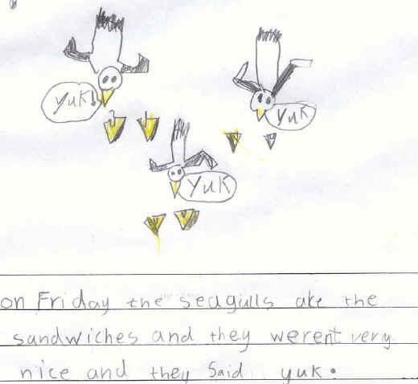 | 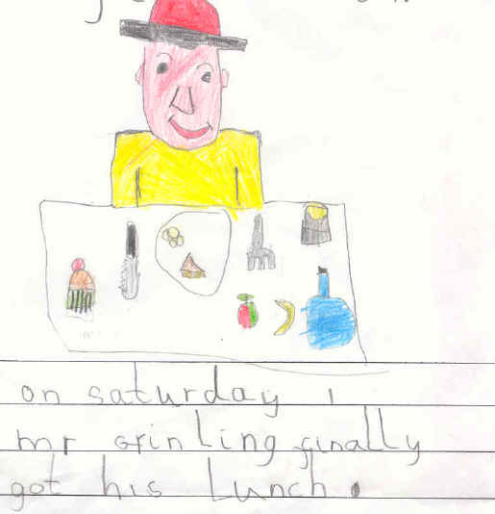
On Thursday Mrs Grinling had a plan and she put mustard in the sandwiches and sent them down the wire. | On Friday the seagulls ate the mustard sandwiches which were not very nice they said “Yuk!” | On Saturday Mr Grinling finally got his lunch with lots of lovely food to eat.

