**February Newsletter**

Dear Parents,

**Class 1**

The children in Class 1 have been working extremely hard on their reading over the last half term and I am really proud of them for the progress that they are making. Thank you for your efforts; reading at home really does make such a difference.

We are really excited for our trip next week. We have been talking to the children about it this week. If you want to find out more about it, please follow the link to the Tiny Travels website. <https://www.tinytravels.co.uk/>

**Class 2**

In Maths, the children in Year Four and Year Five have been working hard at methods for multiplication and division. These can be difficult and require lots of practice. If you can continue to support your child with times tables and calculation methods at home, this can really help them to secure a tricky topic. Year Six have been working on ratios and algebra, including forming simple equations and working backwards to find unknown values.

In English, the children in Class 2 have been using their topic work on Henry VIII to explore and begin to write biographies. This has been a great chance to deepen their knowledge about the Tudors for their Off with Her Head! Topic, and to develop more confidence using a range of writing features.

Class 2 have also been working hard at understanding key events from the reign of Henry VIII – starting with exploring Tudor timelines and the luxurious life that Henry VIII lived, then beginning to look at the lives of his six wives. In class we particularly focused on Henry’s Great Matter and the start of the Church of England.

Alongside this, children in Class 2 have continued work on forces and mechanism in Science and DT, exploring how they can use mechanisms to move big objects with small forces.

**Whole School**

On Thursday morning and Friday last week, the whole school came together to focus on what makes our school unique and special with a super ‘Values Day’. Thursday began with Reverend Nigel running a workshop for the children about the Christian Values of Kindness, Friendship and Forgiveness. The morning ended with the children discussing the overarching theme of our school values, which is Love. The children were able to take part in discussions and activities, allowing them to show their own thoughts and feelings.

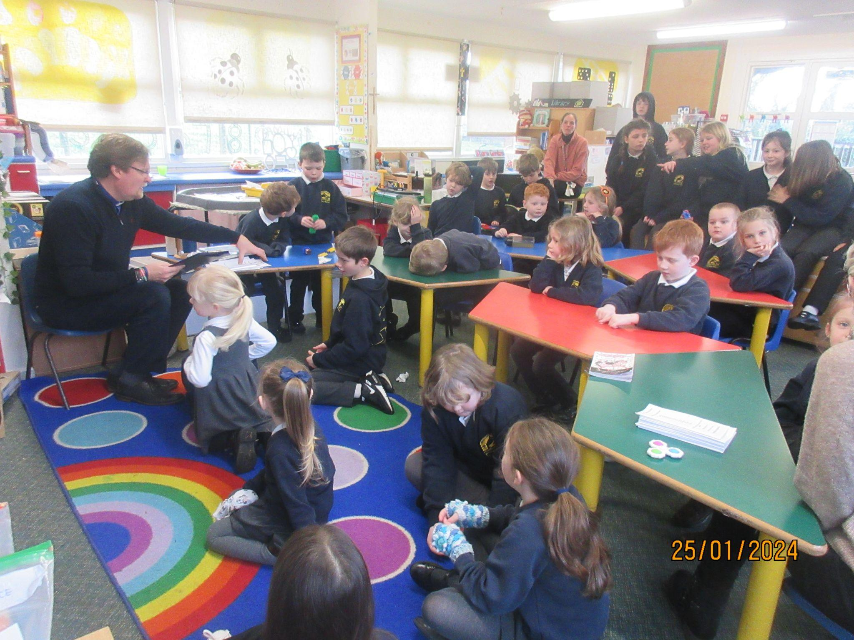

After our Celebration Assembly on Friday, the children came back to school where they worked with their Prayer Buddy to focus on one of our School Values. The children read the Bible story that is linked to the value that they were studying and identified them from our mural in the Spirituality Garden.

In the afternoon, the children worked to create an art display of our Christian Values which will be exhibited in the school entrance hall. The day had a big impact on the children in school, with many being able to talk about what these values mean to them and how they show them in their everyday lives.

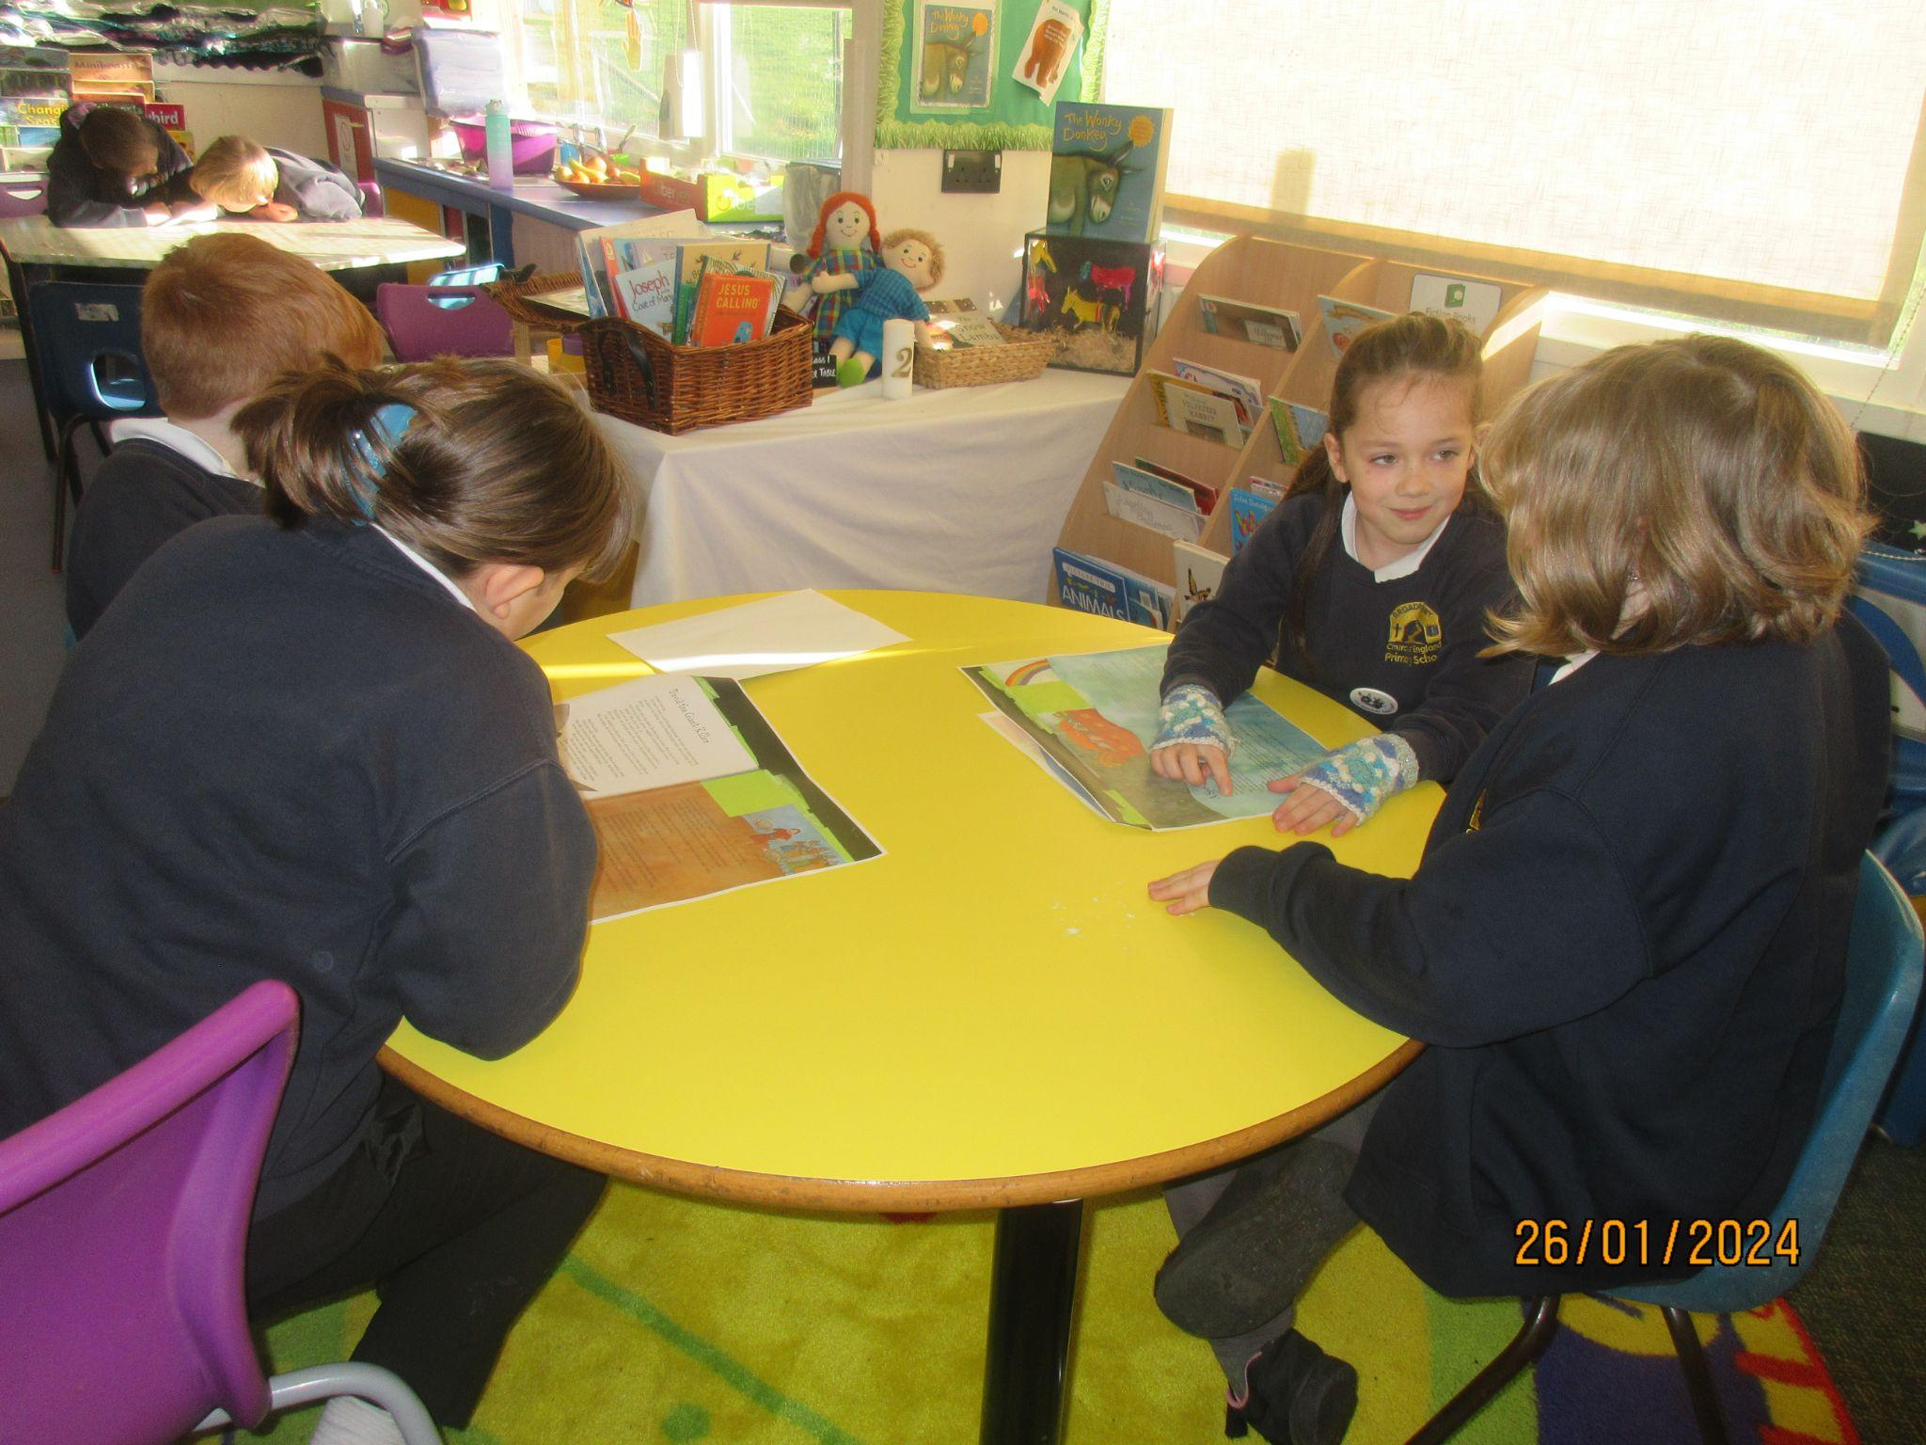 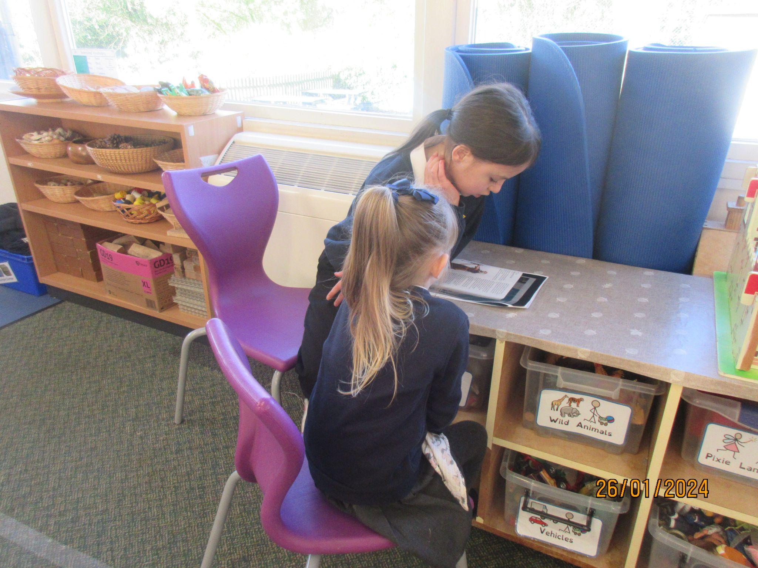 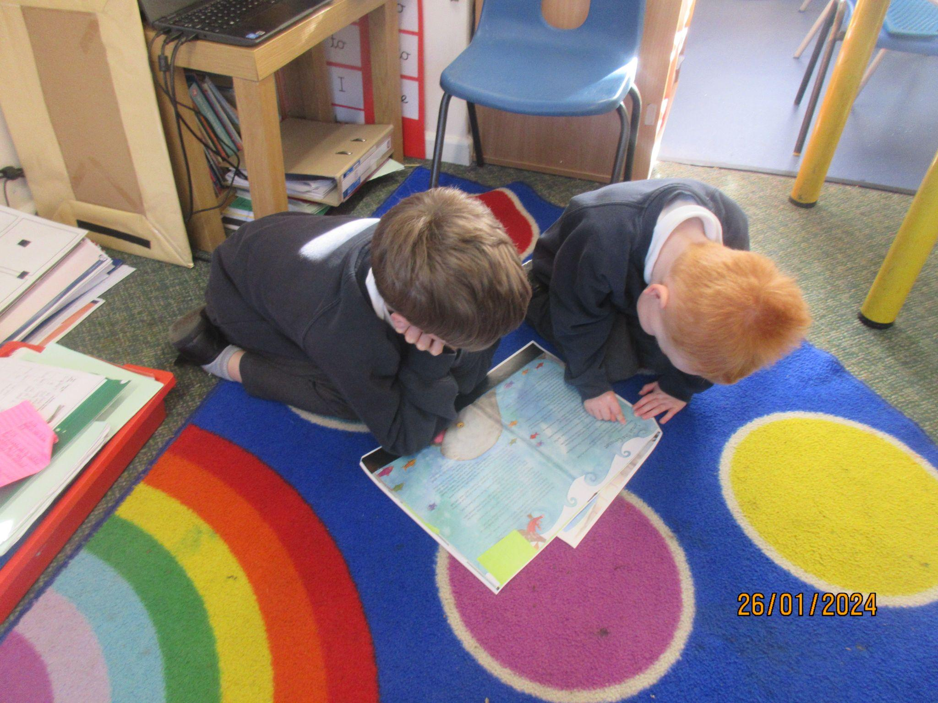

God bless and have a lovely weekend.

*Best wishes from Katie Gray and the staff at Broadhembury CE School*

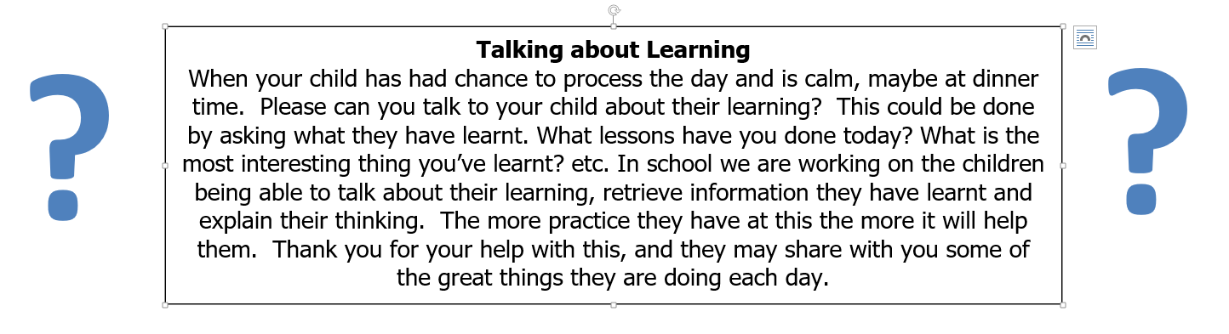

|  |
| --- |
| **Question of the month**  **Class 1:**  What is Love?  **Class 2**: What does God’s Kingdom on Earth look like? |

**BROADHEMBURY BRIDGES**

**Broadhembury Bridge awards**: Noah, Evelynn, Alice, Albie, Monty, Letty and Alisha - well done on great learning behaviours.

**Reading awards**: Indie, Summer, Lily, Lexi and Oli. Congratulations - we hope that you enjoy reading the book that you received as your prize for completing the reading challenge.

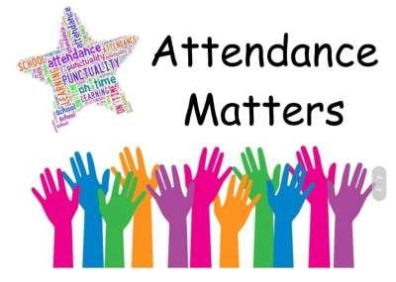

**December Attendance**

Class 1 – 92%

Class – 96%

Whole School – 92%

Being in school is important to your child’s achievement, wellbeing, and wider development.

**Key Dates – Spring Term 2024**

Tuesday 6th February - Safer Internet Day

Friday 9th February - Year 5/6 Girls Football

Monday 12th February - Friday 16th February - Half Term

Tuesday 27th February - Reception & Year 6 height & weight

Friday 1st March - KS1 Co-ordination event

Thursday 7th March - World Book Day

Monday 11th March - KS2 Dance Festival

Friday 15th March - Year 3/4 Tag Rugby

Tuesday 19th March – Parents Evening

Thursday 28th March – Break Up For Easter

**World Book Day 7th March**

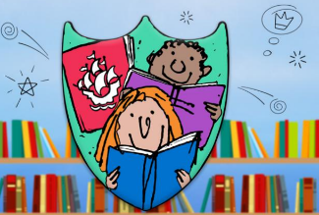World Book Day is on 7th March 2024, due to our continued focus on creating a

love of reading, children can come to school dressed as their favourite book character. During the day, the children will take part in activities linked to reading. One of these activities is going to be the Blue Peter Reading Book Badge competition. The entries will be sent off and the children will win a Blue Peter Badge! The badge gives free entry to some of the countries’ top attractions. Please keep an eye out for an entry form and permission slip

that will be sent home with your child/ren.

|  |
| --- |
| **Wellbeing**  *There has been much press in recent months about children’s mental health. As part of our drive to support this we are going to include something each month in the newsletter about Health and Wellbeing. We hope you find this section useful. If you have any topics you would like us to find some helpful tips about, please let us know.*  **Next week is Children's Mental Health Week (5-11 February 2024).**  **Across the federation we will all be taking part in mental health activities at various times through the week.**  **You can get involved at home too.**  **Place2Be is a children's mental health charity and their theme this year is ‘My Voice Matters’.**  **My Voice Matters** is about empowering children and young people by providing them with the tools they need to express themselves.  You can download the resources to use at home here www.childrensmentalhealthweek.org.uk/families/ |

**Book Recommendations February**

With our continuing focus on reading culture in school, we would like to start recommending books to our families. With a view to trying to widen pupils' interest in different genres and authors, supporting parents to know new authors and as ideas for gifts. If your child reads one of these books, it would be great if they could make a comment on the book and we can share it on Facebook.



|  |  |  |  |  |  |
| --- | --- | --- | --- | --- | --- |
| **EYFS** | The Night Flower- Lara Hawthorne |  | **Lower KS2** | Rumaysa Ever After by Radiya Hafiza & Rhaida Touny |  |
| **KS1** | The Invisible by Tom Percival |  | **Upper KS2** | Rollercoaster Boy by Lisa Thompson and Gemma Correll |  |

**Collective Worship Activity**

This term we will be focussing in school on the value of Trust. We hope your family will find these ideas helpful as you explore the value and have fun together. If the children bring back something that you have done at home linked to the Collective Worship activity or can talk about a discussion they’ve had at home linked to it, then Mrs Gray will award them with a new, special sticker.

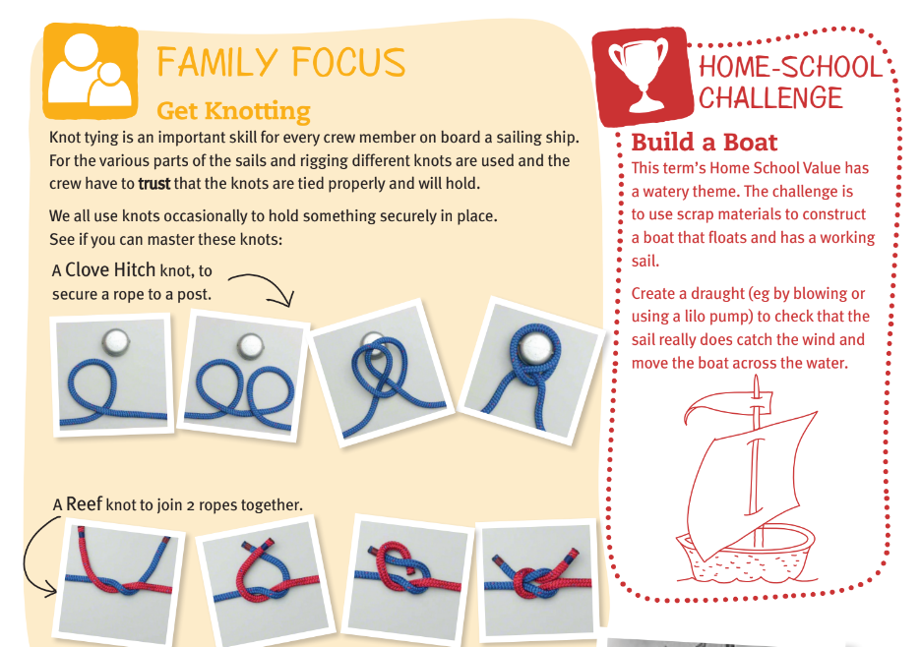

**Important Notices**

**Healthy Snacks**

Class 1 have a healthy snack each morning with fruit provided. As we never know what fruit we will be given if your child doesn’t like a particular fruit, they are welcome to bring in a healthy fruit or vegetable snack from home.

**Cold Weather**

Now the weather seems to be getting a little colder please make sure your child brings a warm/waterproof coat to school each day. We do go outside to play every day unless it is absolutely pouring with rain so coats are vital. I’ve already started to see some lovely woolly hats and gloves appearing, keeping the children warm and cosy during playtime.

**School Uniform**

Please can you ensure that your child has all their uniform named. It really helps at the end of the day to ensure that the correct jumper is returned to the correct child. Also, as the weather gets colder, please can you ensure that your child has a warm coat and that any hats, gloves etc. are named. Thank you for your help.

**School Bus**

We have had a request from the bus company that brings the children to school from Dunkeswell, please can parents not park in the bus stop to enable the bus to be able to park and the children to get off the bus safely. Thank you for your co-operation. If you have any queries about the bus please contact Sarah Bishop at Devon School Transport. [*Sarah.bishop@devon.gov.uk*](mailto:Sarah.bishop@devon.gov.uk). Please could you also contact her if you allow your child to walk from the bus stop home on their own so she can notify the bus company. Thank you.

**Free School Meals**

If your circumstances have recently changed your child may have become eligible for free school meals. This will also bring extra funding to the school, which will be used to help your child. For an instant decision or to learn more please go online at

[*https://www.devon.gov.uk/educationandfamilies/school-information/school-meals*](https://www.devon.gov.uk/educationandfamilies/school-information/school-meals).

**Advice on Covid-19**

As you may be aware, there are some concerns regarding the recent spread of Covid-19. Please see below updated guidance on what to do if you suspect a case of Covid-19 or test positive.

* For diarrhoea and vomiting, people need to be 48 hours free of symptoms to return to the setting (pupils and staff)
* Children with **mild symptoms** such as a runny nose, sore throat, or mild cough, who are otherwise well, **can continue to attend their education or childcare setting.**
* Anyone who is **unwell,** including people with a high temperature, should **stay at home** and avoid contact with others until they have recovered. They can return to the setting once they no longer have a temperature (without medication) and are well enough to do so. (pupils and staff)
* **Children** and young people under 18 years old who have a positive test for **Covid-19** should stay away from the setting for **3 days** after they took their test (and until they are well enough to return, including no temperature).