Animals including Humans

- Can you think of some animals to put into their animal groups?
mammal | bird | reptile | fish | amphibian

- What are the similarities and differences with these animals?
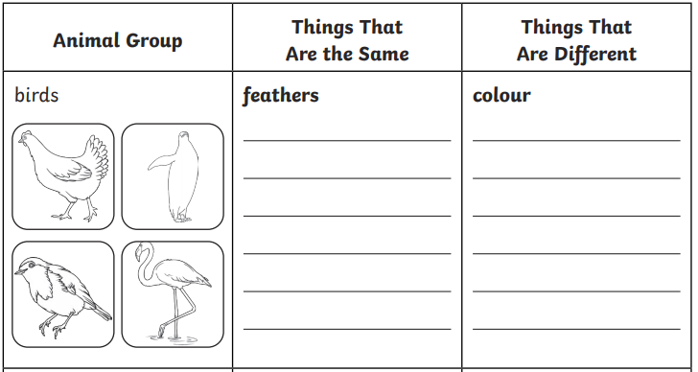

- Label the velociraptor.
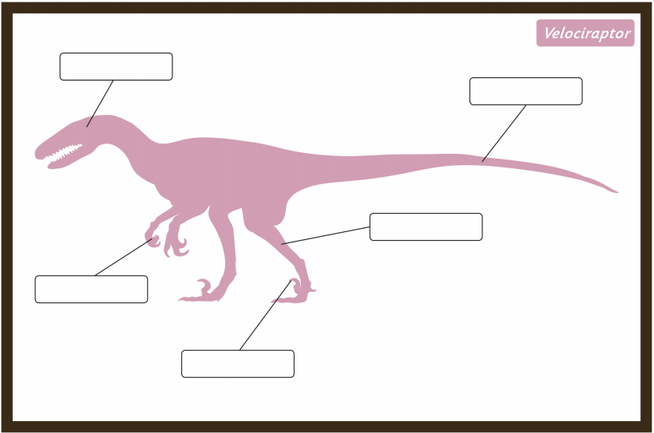
- Label different parts of the human body.

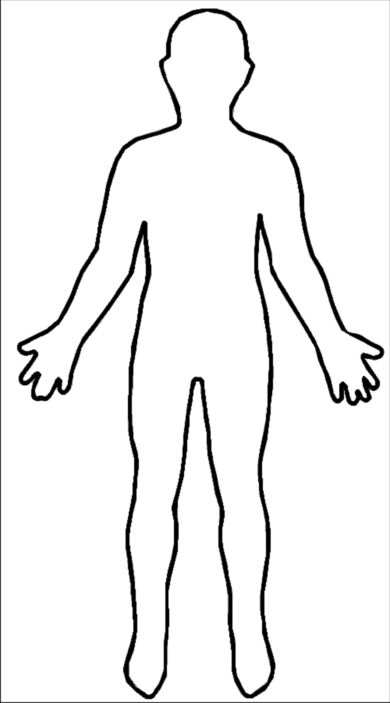

- Write about hands and what we use them for.

_____________________________________________________________________

_____________________________________________________________________

_____________________________________________________________________

_____________________________________________________________________

- Write the animals and dinosaurs into the correct column.

Carnivore | Herbivore | Omnivore

Tyrannosaurus Rex Lion Stegosaurus Cow

Human Velociraptor Horseshoe bat Chicken Sheep

- Put these into order, youngest first.
adult | toddler | elderly | baby | teenager | child

___________________________________________________________________________

- Explain how we change as we grow older.

_____________________________________________________________________

_____________________________________________________________________

_____________________________________________________________________

_____________________________________________________________________

- What would you like to find out about dinosaurs?

____________________________________________________________________

____________________________________________________________________

____________________________________________________________________

